Bathing water profile - Burntisland
Bathing water classification

Bathing water description
Burntisland bathing water is located on the northern shore of the Firth of Forth and southwest of Burntisland town. It is a 2 km long sandy bay with numerous rock pools, making it popular with families. The beach slopes gently towards the water. Depending on the tides, the approximate distance to the water’s edge can vary from 0 metres to 1.2 km.

Site details:
- Local authority: Fife Council
- Year of designation: 1999
- Water sampling location: NT 24106 85699

Risks to water quality
This bathing water is at risk of short term pollution following heavy rainfall. Bathing is not advised during or 1-2 days after heavy rainfall due to the risk to bathers’ health from water pollution.

Pollution risks include sewer overflows.

Catchment description
The catchment draining into the Burntisland bathing water extends to 3 km2. The area is mostly rural (70%) with grassland (30%) and arable agriculture (21%) the main land uses. Approximately 26% of the bathing water catchment is urban. The main population centre is the town of Burntisland.
There are no major rivers within the bathing water catchment.

Map 1: Burntisland bathing water
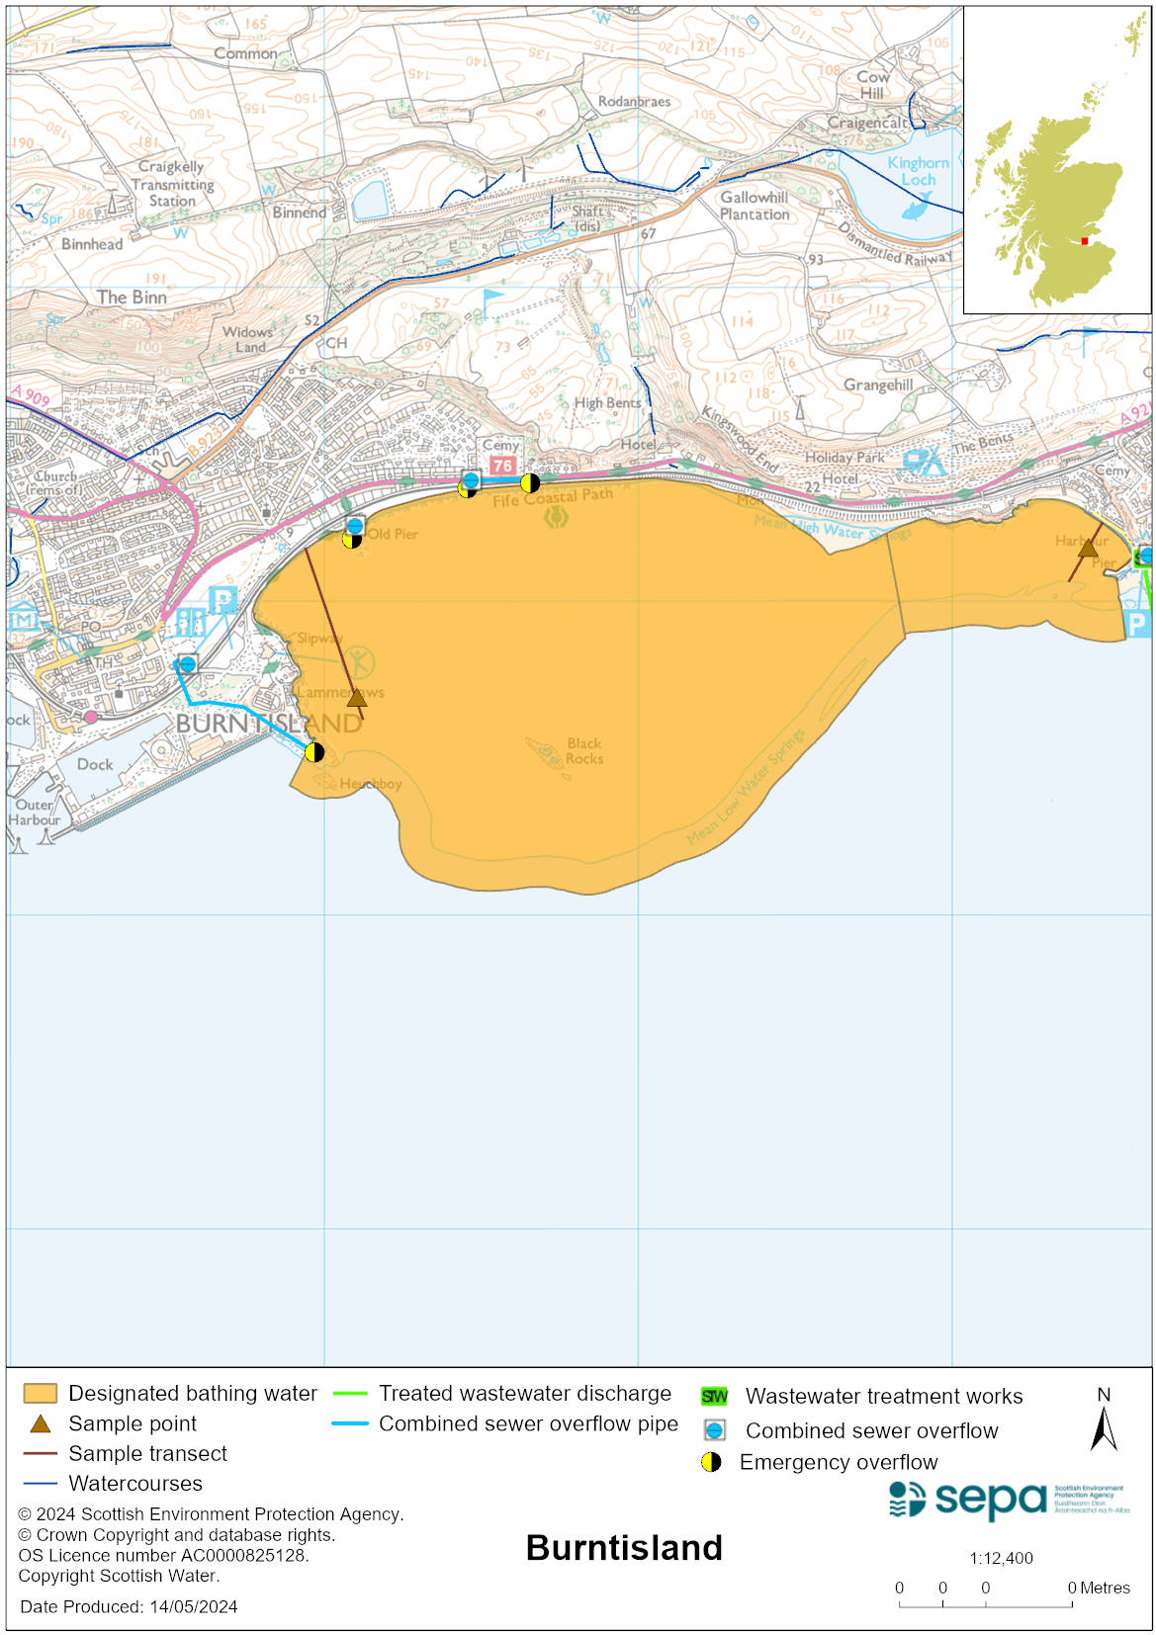

Map 2: Catchment draining into Burntisland bathing water
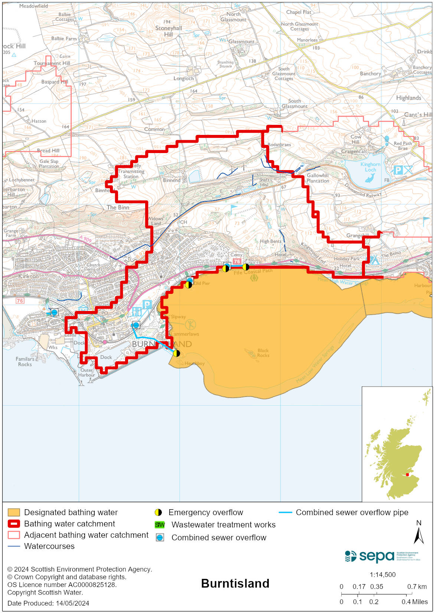

Improving bathing water quality

Sewage
Scottish Water provides most waste water collection and treatment services in Scotland.

Sewage from the area is treated at Burntisland sewage works and then is discharged to the Firth of Forth via a long sea outfall.

There is a combined sewer overflows (CSO) outfall to the western edge of the bathing water area. This may discharge and impact the bathing water during heavy rainfall.

There is also an emergency overflow (EO) to the bathing water. This EO should only discharge under rare, abnormal circumstances.

Agriculture
There are no impacts from agriculture affecting this bathing water.

Cyanobacteria (blue-green algae), algae and jellyfish
Marine waters are not at risk of cyanobacteria overproduction. This bathing water is not at risk of excessive growth of macroalgae (seaweed) or phytoplankton.

The possibility of increased jellyfish numbers in the water during summer months is a naturally occurring phenomenon. Most species common to the UK are harmless; the Marine Conservation Society advises to ‘look but don’t touch’.

Pollution incidents
Pollution can be reported via our website online form or by calling our 24 hours a day Pollution Hotline number 0800 80 70 60

If pollution is reported to us, or identified by our routine water quality monitoring program, we will investigate and where necessary work with others to remediate. We may contact other relevant organisations including the local authority, that local health board, Scottish Water and Scottish Ministers.

If there is a risk to human health the local authority is responsible for placing signs at the bathing water. Information will also be available on our website.

Everyone can help to keep the bathing water clean:
- If you visit the beach with your dog clear up any fouling
- Don’t leave litter or feed birds - this encourages unnatural behaviour, and they can pollute the water
- At home, don’t flush wipes or other inappropriate items as these can block pipes and cause sewage spills

Contact details and information sources

SEPA bathing waters homepage

SEPA rainfall data

Scottish Government protected waters homepage

Fife Council

For information on accessing this document in an alternative format or language, please contact SEPA by emailing equalities@sepa.org.uk
If you are a user of British Sign Language (BSL), the Contact Scotland BSL service gives you access to an online interpreter, enabling you to communicate with us using sign language. contactscotland-bsl.org

