Bathing water profile - Collieston
Bathing water classification

Bathing water description
Collieston bathing water is a small sandy bay surrounded by the former fishing village of Collieston and its harbour. It lies between Cruden Bay to the North and Newburgh to the South, on the east coast of Aberdeenshire. Depending on the tide, the approximate distance to the water’s edge can vary from 0 to 100m. The sandy beach slopes gently towards the water.

Site details:
- Local authority: Aberdeenshire Council
- Year of designation: 2014
- Water sampling location: NK 04080 28530

Risks to water quality
This bathing water is at risk of short term pollution following heavy rainfall. Bathing is not advised during or 1-2 days after heavy rainfall due to the risk to bathers’ health from water pollution.

Catchment description
The Collieston bathing water catchment extends to 0.225km2 and is mostly flat. The bathing water is in a small sandy bay within a coastline of steep cliffs and rocky outcrops. Sandy Loch and the small burn to the north of the village drain into the bathing water.
The area is mainly rural (95%) with arable and horticulture as the major land use, followed by heather grassland. The main population centre is the small village of Collieston.

Map 1: Collieston bathing water
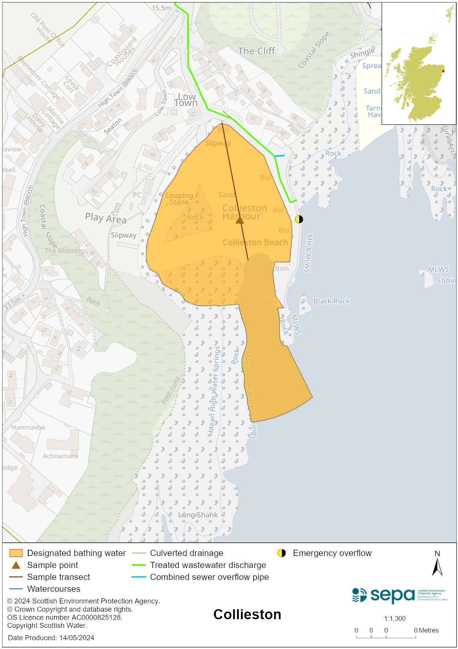

Map 2: Catchment draining into Collieston bathing water
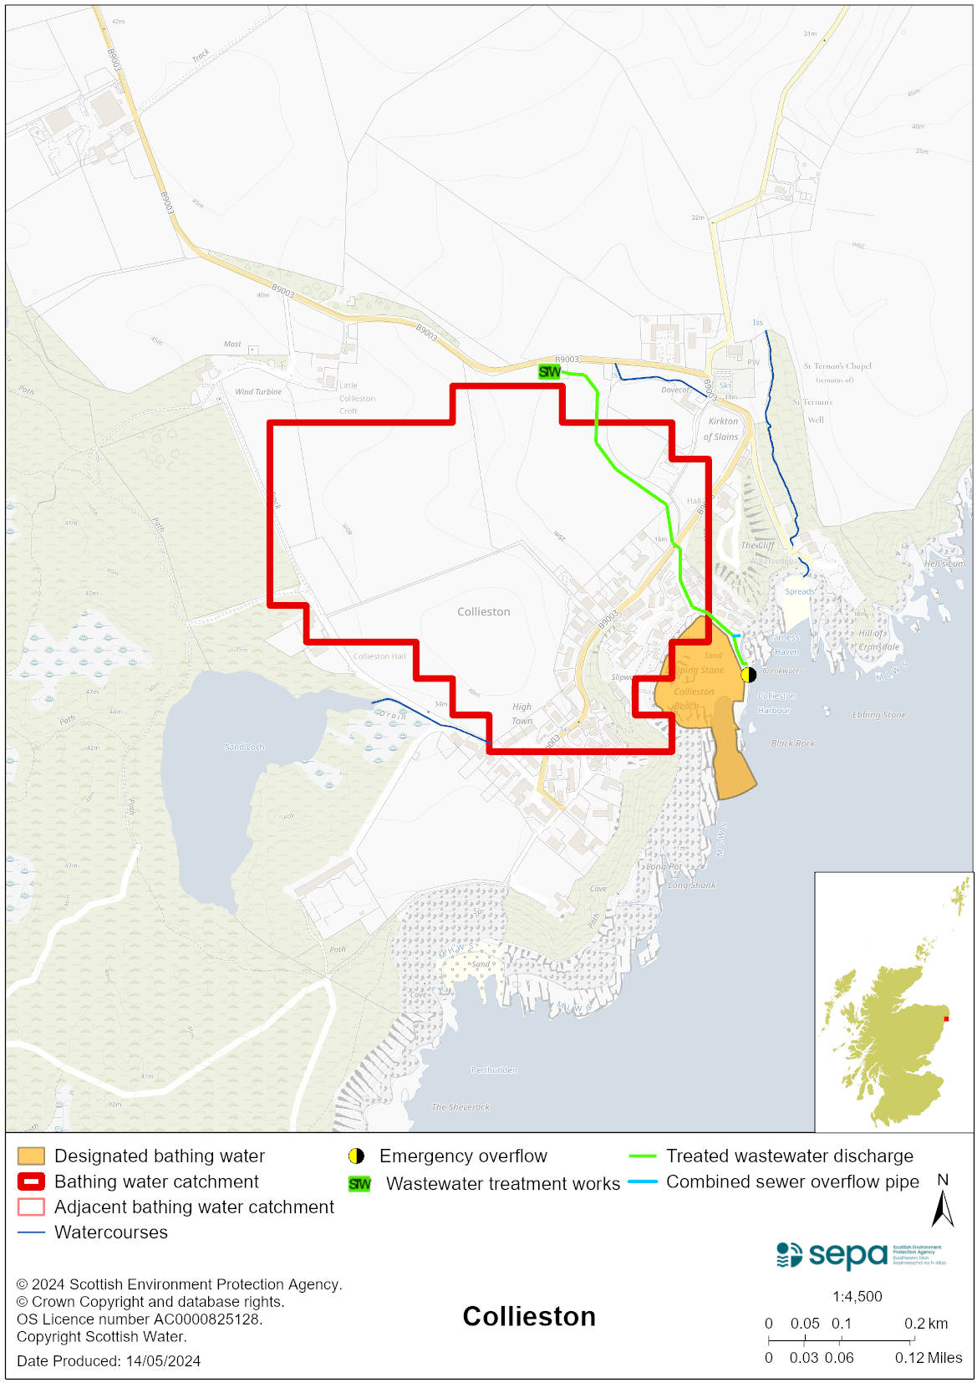

Improving bathing water quality

Sewage
Scottish Water provides most waste water collection and treatment services in Scotland.

There is a combined sewer system in Collieston, with a pumping station and combined sewer overflow (CSO) in the harbour wall. Treated effluent and the CSO discharge to the outside of the harbour wall, away from the bathing water. This combined discharge is considered to pose minimal risk to bathing water quality.

There are private septic tanks within the catchment, also considered to pose a minimal risk to bathing water quality.

Agriculture
Diffuse pollution from agricultural sources is the result of rain driven events causing cumulative inputs of pollutants to rivers and streams.

Farm visits were undertaken in the Buchan Coastal catchment during 2015. These visits looked to identify diffuse pollution sources and pathways. Mitigation measures were agreed with land managers to reduce the risk of bacterial pollution on water quality.

SEPA has observed significant changes in land management practice within the catchments and will continue to work with the farmers to reduce the risk of pollution to the bathing water.

Cyanobacteria (blue-green algae), algae and jellyfish
Marine waters are not at risk of cyanobacteria overproduction. This bathing water is not at risk of excessive growth of macroalgae (seaweed) or phytoplankton.

The possibility of increased jellyfish numbers in the water during summer months is a naturally occurring phenomenon. Most species common to the UK are harmless; the Marine Conservation Society advises to ‘look but don’t touch’.

Pollution incidents
Pollution can be reported via our website online form or by calling our 24 hours a day Pollution Hotline number 0800 80 70 60

If pollution is reported to us, or identified by our routine water quality monitoring program, we will investigate and where necessary work with others to remediate. We may contact other relevant organisations including the local authority, that local health board, Scottish Water and Scottish Ministers.

If there is a risk to human health the local authority is responsible for placing signs at the bathing water. Information will also be available on our website.

Everyone can help to keep the bathing water clean:
- If you visit the beach with your dog clear up any fouling
- Don’t leave litter or feed birds - this encourages unnatural behaviour, and they can pollute the water
- At home, don’t flush wipes or other inappropriate items as these can block pipes and cause sewage spills

Contact details and information sources

SEPA bathing waters homepage

SEPA rainfall data

Scottish Government protected waters homepage

Aberdeenshire Council

For information on accessing this document in an alternative format or language, please contact SEPA by emailing equalities@sepa.org.uk
If you are a user of British Sign Language (BSL), the Contact Scotland BSL service gives you access to an online interpreter, enabling you to communicate with us using sign language. contactscotland-bsl.org

