Bathing water profile – Dunnet Bay
Bathing water classification

Bathing water description
Dunnet Bay bathing water is on the north coast of Scotland between the towns of Castletown and Dunnet. The long sandy bay is around 3 km in length and slopes gently towards the water. Depending on the tide, the approximate distance to the water’s edge can vary from 40–300 metres.

Site details:
- Local authority: Highland Council
- Year of designation: 1999
- Water sampling location: ND 21601 70749

Risks to water quality
This bathing water is at risk of short term pollution following heavy rainfall. Bathing is not advised during or 1-2 days after heavy rainfall due to the risk to bathers’ health from water pollution.

Pollution risks include agricultural run-off and sewer overflows.

Catchment description
The Dunnet Bay bathing water catchment extends to 47 km2. It consists of some low hills in the west and low-lying plains along the coast. The area is mainly 96% rural (74% grassland, 13% arable). Agriculture the main land use, largely beef and arable. Approximately 1% of the catchment is urban. The main population centres are the coastal towns of Castletown and Dunnet. Population density outside these towns is generally low.
The main rivers in the bathing water catchment are the Burn of Garth, Stanergill Burn, Burn of Midsand and the Burn of Dunnet which flows into the northern end of the bay.
There are several protected areas either fully or partly within the catchment. This includes one Special Protection Area (SPA) and four Sites of Special Scientific Interest (SSSI).

Map 1: Dunnet Bay bathing water
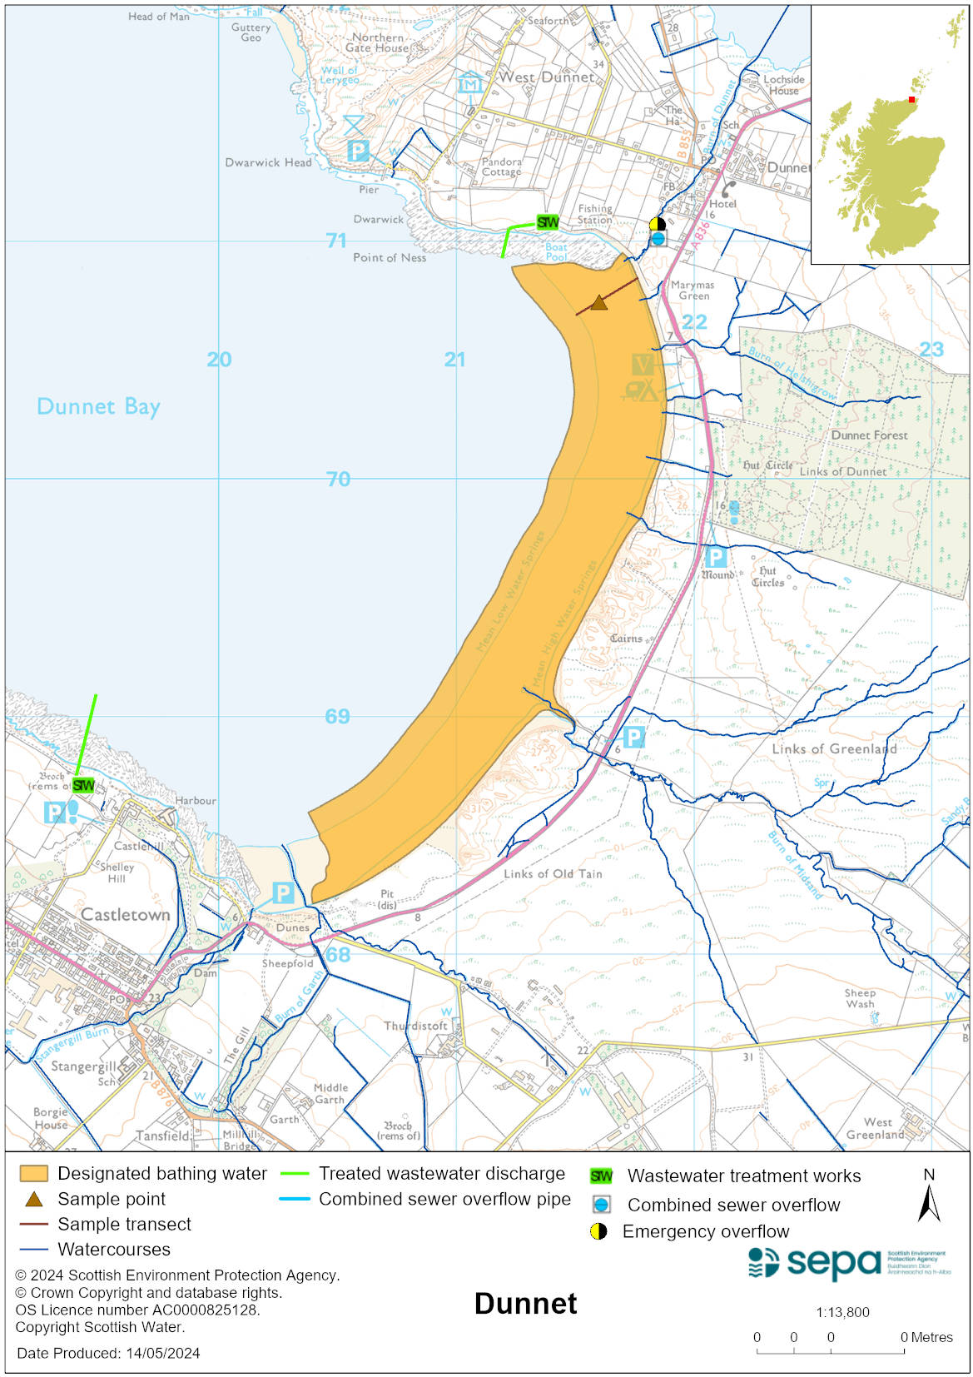

Map 2: Catchment draining into Dunnet Bay bathing water
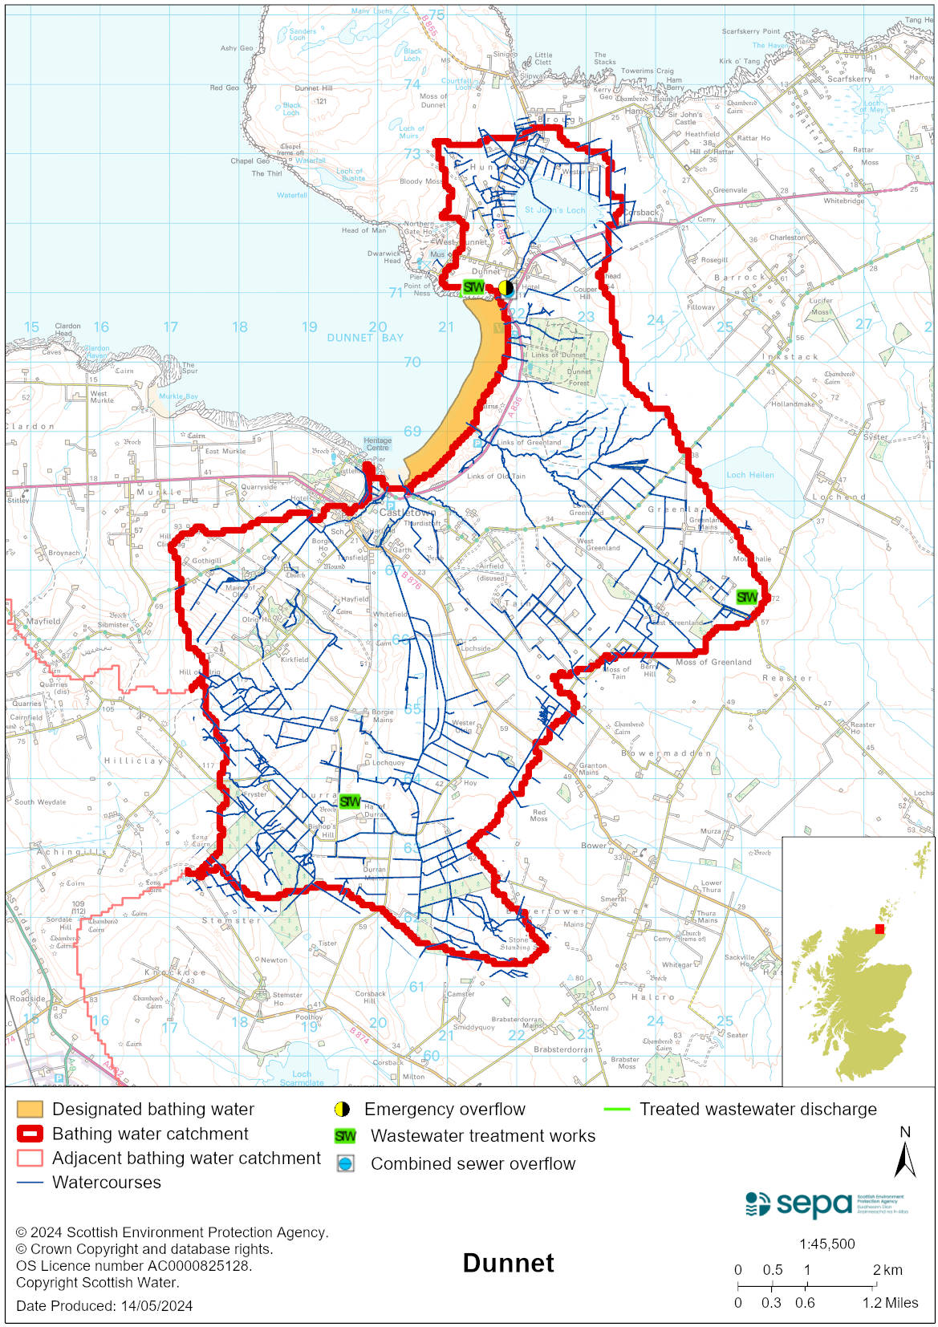

Improving bathing water quality

Sewage
Scottish Water provides most waste water collection and treatment services in Scotland.
The outfall from Castletown sewage treatment works discharges approximately 600–700 metres west of the bathing area. Its potential to affect bathing water quality is deemed minimal.
The discharge from Dunnet sewage treatment works is located immediately adjacent to the northern boundary of the designated bathing water. It has the potential to affect water quality at Dunnet Bay. There is also a pumping station at Dunnet with an emergency overflow into the Bay of Dunnet. The system is part of our inspection programme.

Agriculture
Diffuse pollution from agricultural sources is the result of rain driven events causing cumulative inputs of pollutants to rivers and streams.

There is potential for agricultural diffuse pollution to occur in the Stanergill Burn and some small burns at the eastern end of the beach. These catchments are a risk to Dunnet’s bathing water quality, particularly during periods of wet weather.

Most farms in the Dunnet Bay area support predominantly beef farming with some arable. Farm visits started in the catchments in 2020. These visits looked to identify diffuse pollution sources and pathways as well as agreeing mitigation measures with land managers to reduce the risk of bacterial pollution on water quality.

SEPA will continue to work with the farmers in these catchments to reduce the risk of pollution to the bathing water.

Urban
Urban diffuse source pollution comes from contaminated rainwater discharging to rivers and streams. Surface water from Castletown town enters the Stanergill Burn and these discharges to the burn can potentially affect bathing water quality.

Cyanobacteria (blue-green algae), algae and jellyfish
Marine waters are not at risk of cyanobacteria overproduction. This bathing water is not at risk of excessive growth of macroalgae (seaweed) or phytoplankton.

The possibility of increased jellyfish numbers in the water during summer months is a naturally occurring phenomenon. Most species common to the UK are harmless; the Marine Conservation Society advises to ‘look but don’t touch’.

Pollution incidents
Pollution can be reported via our website online form or by calling our 24 hours a day Pollution Hotline number 0800 80 70 60

If pollution is reported to us, or identified by our routine water quality monitoring program, we will investigate and where necessary work with others to remediate. We may contact other relevant organisations including the local authority, that local health board, Scottish Water and Scottish Ministers.

If there is a risk to human health the local authority is responsible for placing signs at the bathing water. Information will also be available on our website.

Everyone can help to keep the bathing water clean:
- If you visit the beach with your dog clear up any fouling
- Don’t leave litter or feed birds - this encourages unnatural behaviour, and they can pollute the water
- At home, don’t flush wipes or other inappropriate items as these can block pipes and cause sewage spills

Contact details and information sources

SEPA bathing waters homepage

SEPA rainfall data

Scottish Government protected waters homepage

Highland Council

For information on accessing this document in an alternative format or language, please contact SEPA by emailing equalities@sepa.org.uk
If you are a user of British Sign Language (BSL), the Contact Scotland BSL service gives you access to an online interpreter, enabling you to communicate with us using sign language. contactscotland-bsl.org

