Bathing water profile - Maidens
Bathing water classification

Bathing water description
Maidens bathing water is an enclosed bay situated between Maidens harbour and the rocky outcrop of Barwhin Point. The area is very popular with holiday makers during the summer, due to its proximity to caravan parks. Depending on the tide, the distance to the water’s edge can vary from 30–170 metres.

Site details:
- Local authority: South Ayrshire Council
- Year of designation: 2008
- Water sampling location: NS 21700 08501

Risks to water quality
This bathing water is at risk of short term pollution following heavy rainfall. Bathing is not advised during or 1-2 days after heavy rainfall due to the risk to bathers’ health from water pollution.

Pollution risks include agricultural run-off and sewer overflows.

Catchment description
The Maidens bathing water catchment extends to 5.5 km2. The area ranges from a maximum elevation of 125 metres in the east to the low-lying plains (elevation 5 metres) along the coast.
The catchment is mainly rural (81%) with grassland the major land use. In general, the area supports beef and sheep farming. Approximately 17% of the catchment is urban with the main population area being Maidens village.
There are no major rivers within the catchment. The catchment is drained by two burns, the Hogston Burn to the north and an unnamed burn to the south.
To the north, the bathing water extends as far as the Maidens to Doonfoot Site of Special Scientific Interest.

Map 1: Maidens bathing water
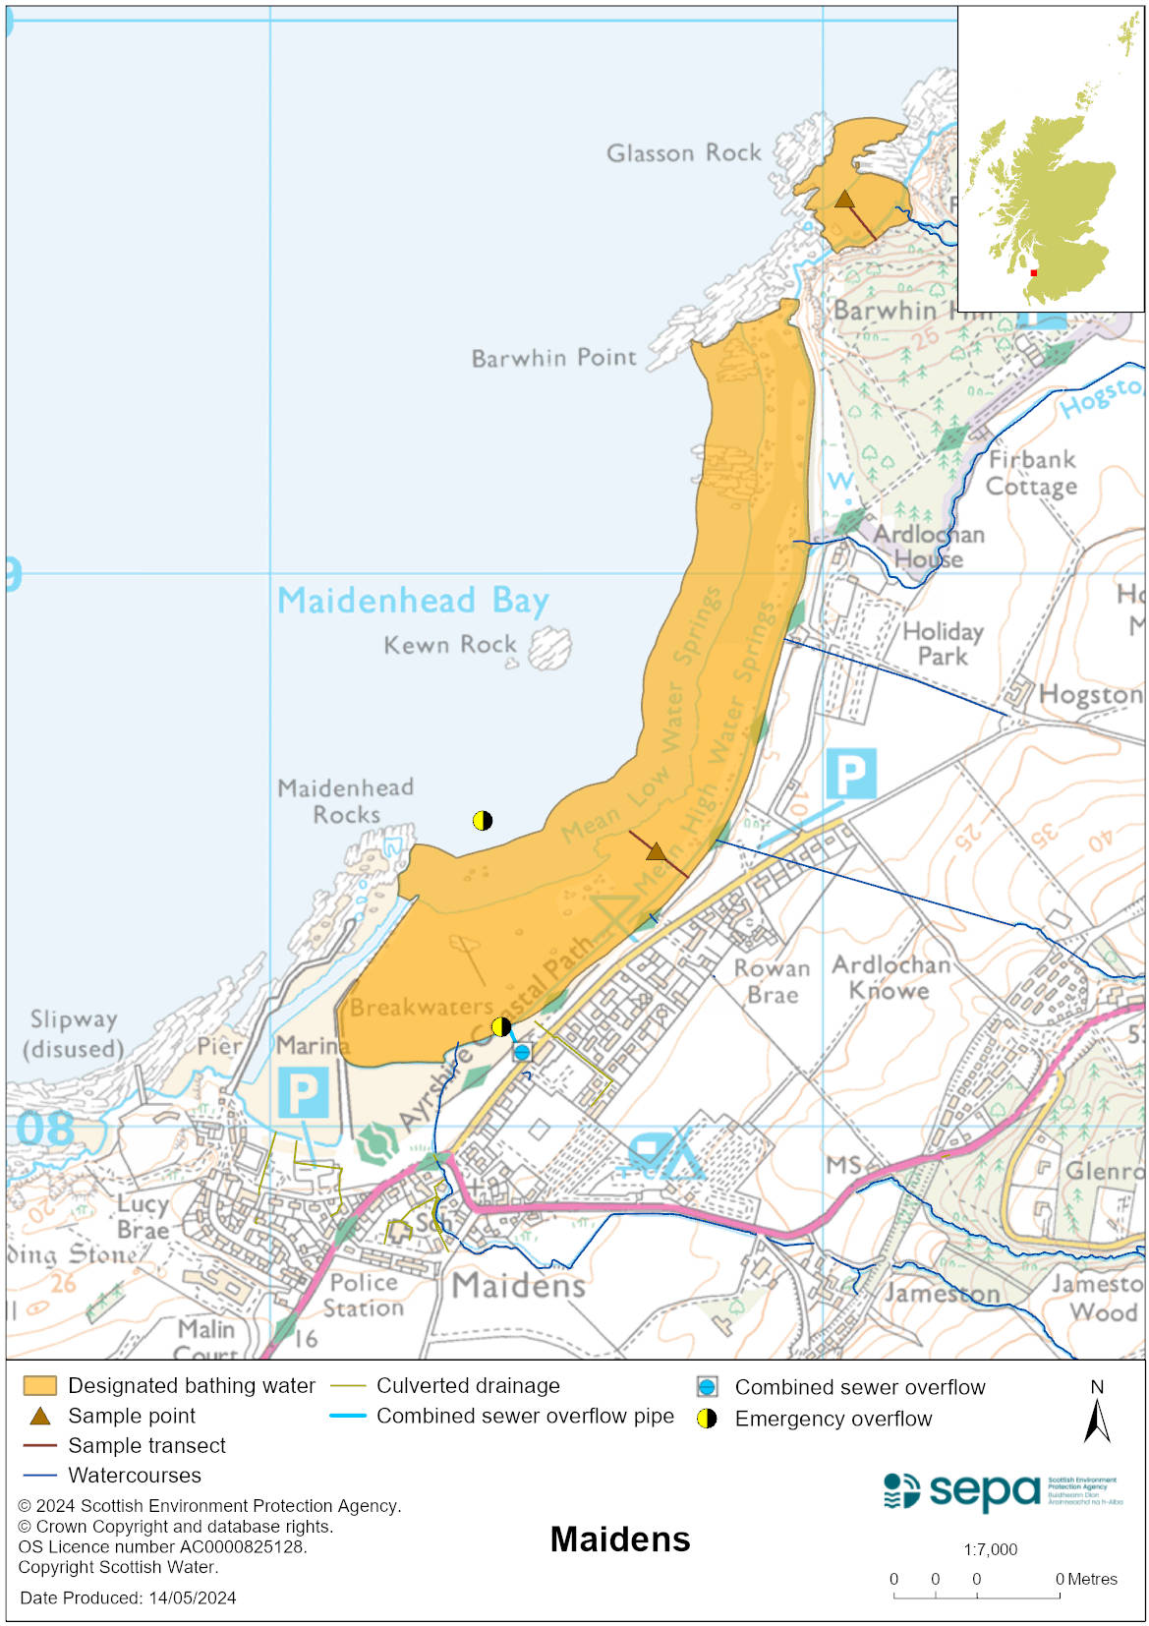

Map 2: Catchment draining into Maidens bathing water
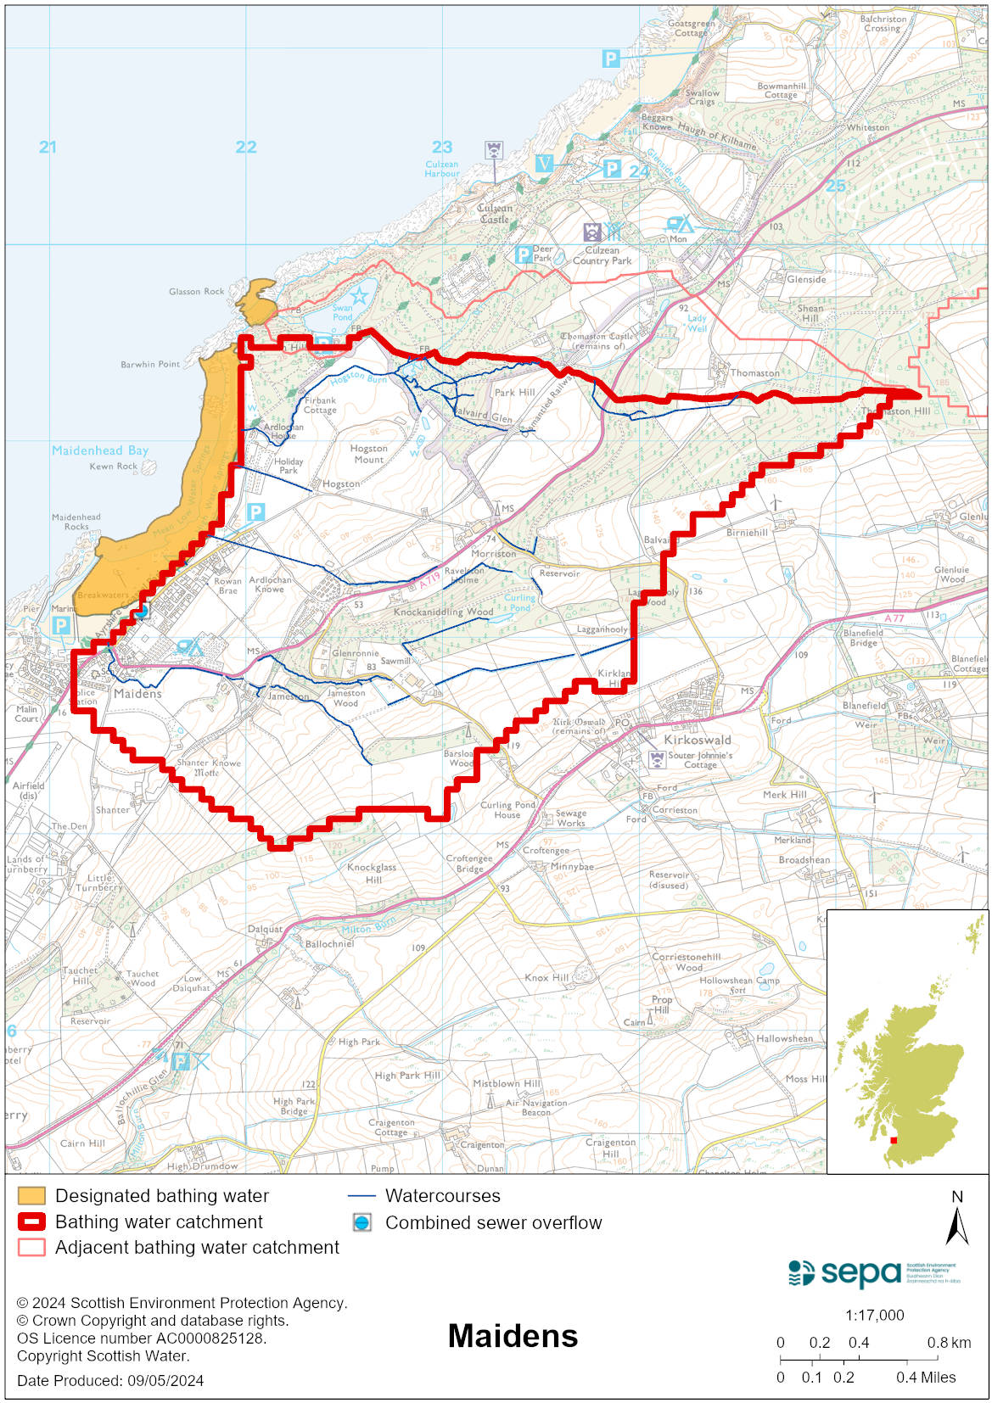

Improving bathing water quality

Sewage
Scottish Water provides most waste water collection and treatment services in Scotland.

Sewage from Maidens village is treated at Girvan sewage treatment works. There is a combined sewer overflow (CSO) with a discharge location to the southern end of the bathing water which can impact the bathing water after heavy rain. There are also two emergency overflows (EOs) which should only discharge under rare, abnormal circumstances.

Agriculture
Diffuse pollution from agricultural sources is the result of rain driven events causing cumulative inputs of pollutants to rivers and streams.

There is potential for agricultural diffuse pollution to occur in Hogstown and other small burns in the area. These are a risk to Maidens bathing water quality, particularly during and after periods of wet weather.

Farm visits to identify diffuse pollution sources in the South Ayrshire Coastal catchment began in 2015. The priority catchment program is now complete. All agricultural compliance work has been completed in this bathing water catchment and all farms are in a compliant state.

SEPA will continue to engage with farmers and the NFUS to remind them of good practice when applying slurries and manures and grazing livestock.

Cyanobacteria (blue-green algae), algae and jellyfish
Marine waters are not at risk of cyanobacteria overproduction. This bathing water is not at risk of excessive growth of macroalgae (seaweed) or phytoplankton.

The possibility of increased jellyfish numbers in the water during summer months is a naturally occurring phenomenon. Most species common to the UK are harmless; the Marine Conservation Society advises to ‘look but don’t touch’.

Pollution incidents
Pollution can be reported via our website online form or by calling our 24 hours a day Pollution Hotline number 0800 80 70 60

If pollution is reported to us, or identified by our routine water quality monitoring program, we will investigate and where necessary work with others to remediate. We may contact other relevant organisations including the local authority, that local health board, Scottish Water and Scottish Ministers.

If there is a risk to human health the local authority is responsible for placing signs at the bathing water. Information will also be available on our website.

Everyone can help to keep the bathing water clean:
- If you visit the beach with your dog clear up any fouling
- Don’t leave litter or feed birds - this encourages unnatural behaviour, and they can pollute the water
- At home, don’t flush wipes or other inappropriate items as these can block pipes and cause sewage spills

Contact details and information sources

SEPA bathing waters homepage

SEPA rainfall data

Scottish Government protected waters homepage

South Ayrshire Council

For information on accessing this document in an alternative format or language, please contact SEPA by emailing equalities@sepa.org.uk
If you are a user of British Sign Language (BSL), the Contact Scotland BSL service gives you access to an online interpreter, enabling you to communicate with us using sign language. contactscotland-bsl.org

