Bathing water profile – Aberdour (Silver Sands)
Bathing water classification

Bathing water description
The Aberdour (Silver Sands) bathing water is to the east of Aberdour, on the north shore of the Firth of Forth. It is a small sandy bay, approximately 600 metres long and popular with walkers. Depending on the tide, the distance to the water’s edge can vary from 10–280 metres. The beach slopes gently towards the water.

Site details:
- Local authority: Fife Council
- Year of designation: 1987
- Water sampling location: NT 20100 85219

Risks to water quality
This bathing water is at risk of short term pollution following heavy rainfall. Bathing is not advised during or 1-2 days after heavy rainfall due to the risk to bathers’ health from water pollution.

Pollution risks include sewer overflows.

Catchment description
The catchment draining into the Aberdour (Silver Sands) bathing water extends to 1.7 km2. The area is predominantly rural (98%) with arable agriculture the major land use. Approximately 1% of the bathing water catchment is urban. There are no main population centres. However, residences in the outskirts of Aberdour and smallholdings are in the catchment. The area also includes two disused quarries.
There are no sizable watercourses within the bathing water catchment.

Map 1: Aberdour (Silver Sands) bathing water
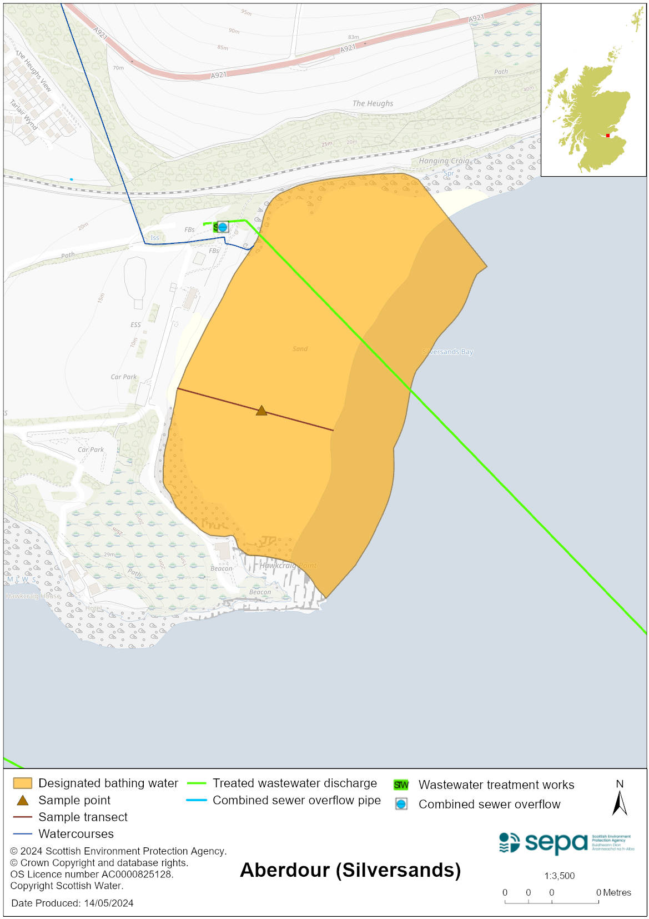

Map 2: Catchment draining into Aberdour (Silver Sands) bathing water
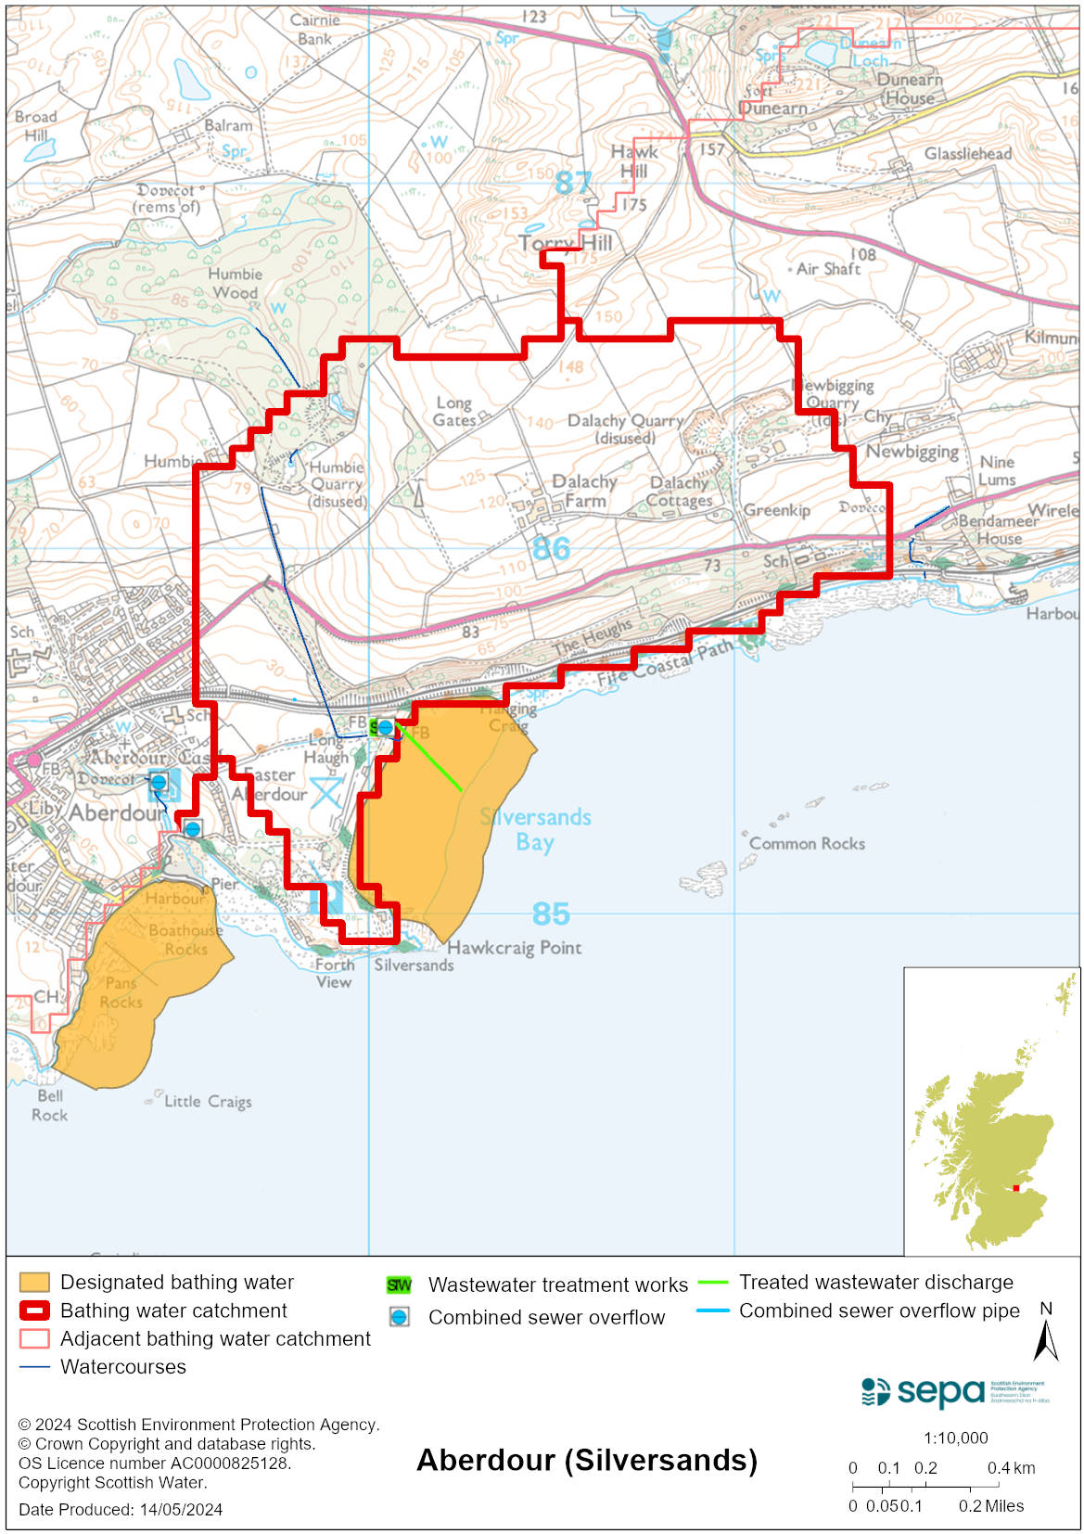

Improving bathing water quality

Sewage
Scottish Water provides most waste water collection and treatment services in Scotland.
Scottish Water has a sewage treatment plant at Aberdour, which discharges to the Firth of Forth via a long sea outfall.

Sewage from Dalgety Bay town is treated outside of the catchment at Dunfermline sewage treatment works, removing a potential risk to bathing water quality.

Agriculture
There are no impacts from agriculture affecting this bathing water.

Cyanobacteria (blue-green algae), algae and jellyfish
Marine waters are not at risk of cyanobacteria overproduction. This bathing water is not at risk of excessive growth of macroalgae (seaweed) or phytoplankton.

The possibility of increased jellyfish numbers in the water during summer months is a naturally occurring phenomenon. Most species common to the UK are harmless; the Marine Conservation Society advises to ‘look but don’t touch’.

Pollution incidents
Pollution can be reported via our website online form or by calling our 24 hours a day Pollution Hotline number 0800 80 70 60

If pollution is reported to us, or identified by our routine water quality monitoring program, we will investigate and where necessary work with others to remediate. We may contact other relevant organisations including the local authority, that local health board, Scottish Water and Scottish Ministers.

If there is a risk to human health the local authority is responsible for placing signs at the bathing water. Information will also be available on our website.

Everyone can help to keep the bathing water clean:
- If you visit the beach with your dog clear up any fouling
- Don’t leave litter or feed birds - this encourages unnatural behaviour, and they can pollute the water
- At home, don’t flush wipes or other inappropriate items as these can block pipes and cause sewage spills

Contact details and information sources

SEPA bathing waters homepage

SEPA rainfall data

Scottish Government protected waters homepage

Fife Council

For information on accessing this document in an alternative format or language, please contact SEPA by emailing equalities@sepa.org.uk
If you are a user of British Sign Language (BSL), the Contact Scotland BSL service gives you access to an online interpreter, enabling you to communicate with us using sign language. contactscotland-bsl.org

