Bathing water profile - Girvan
Bathing water classification

Bathing water description
Girvan bathing water is a 2 km long, flat bay. It is on the South Ayrshire coast next to Girvan town. Most of the beach is sandy with some shingle. The beach is prized for its views of the Ailsa Craig and the Kintyre peninsula. Depending on the tide, the approximate distance to the water’s edge can vary from 30–150 metres. The beach slopes gently towards the water.

Site details:
- Local authority: South Ayrshire Council
- Year of designation: 1987
- Water sampling location: NX 18154 97413

Risks to water quality
This bathing water is at risk of short term pollution following heavy rainfall. Bathing is not advised during or 1-2 days after heavy rainfall due to the risk to bathers’ health from water pollution.

Pollution risks include agricultural run-off and sewer overflows.

Catchment description
The Girvan bathing water catchment extends to 260 km2. The area mostly comprises of rolling countryside. To the south and south-east the land is hillier, rising to the highest peak, Caerloch Dhu. There are several lochs and reservoirs in the catchment which drain into the main river, the Water of Girvan.
The area is mainly rural (98%) with agriculture the major land use. The upland areas support mixed sheep and beef farming. The lowlands are used for intensive dairy farming and some arable farming of potatoes. Approximately 2% of the bathing water catchment is urban. The main population centres are the towns of Girvan and Maybole.

Map 1: Girvan bathing water
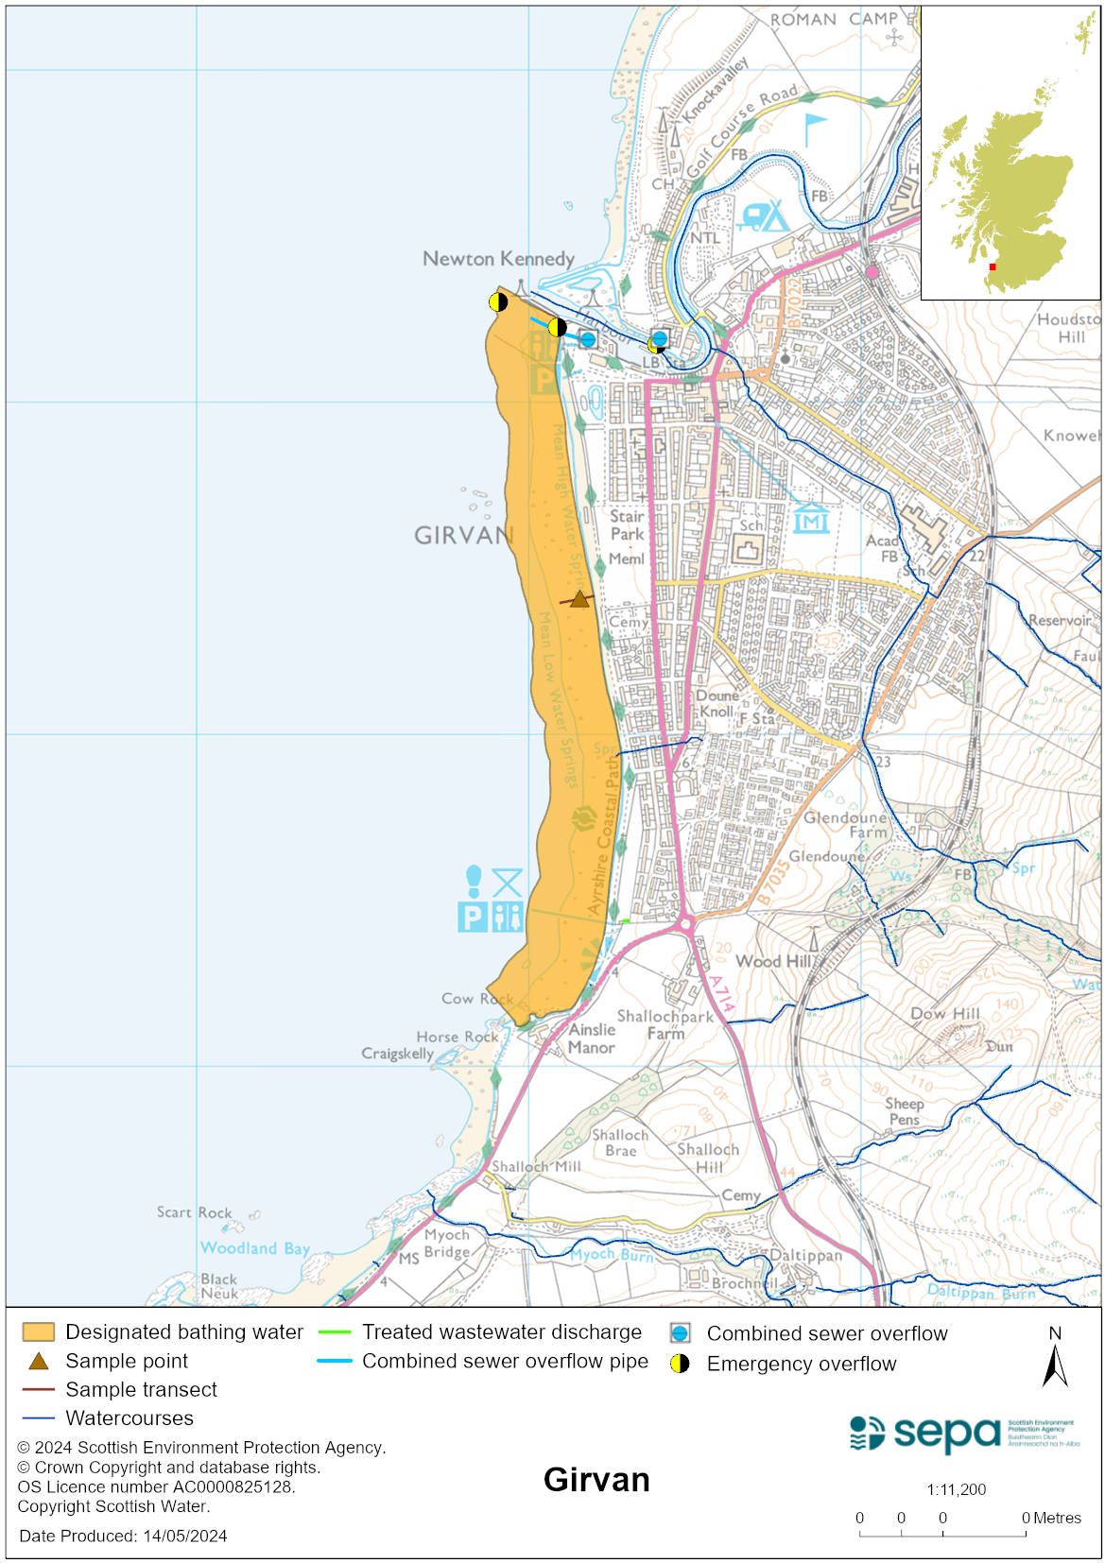

Map 2: Catchment draining into Girvan bathing water
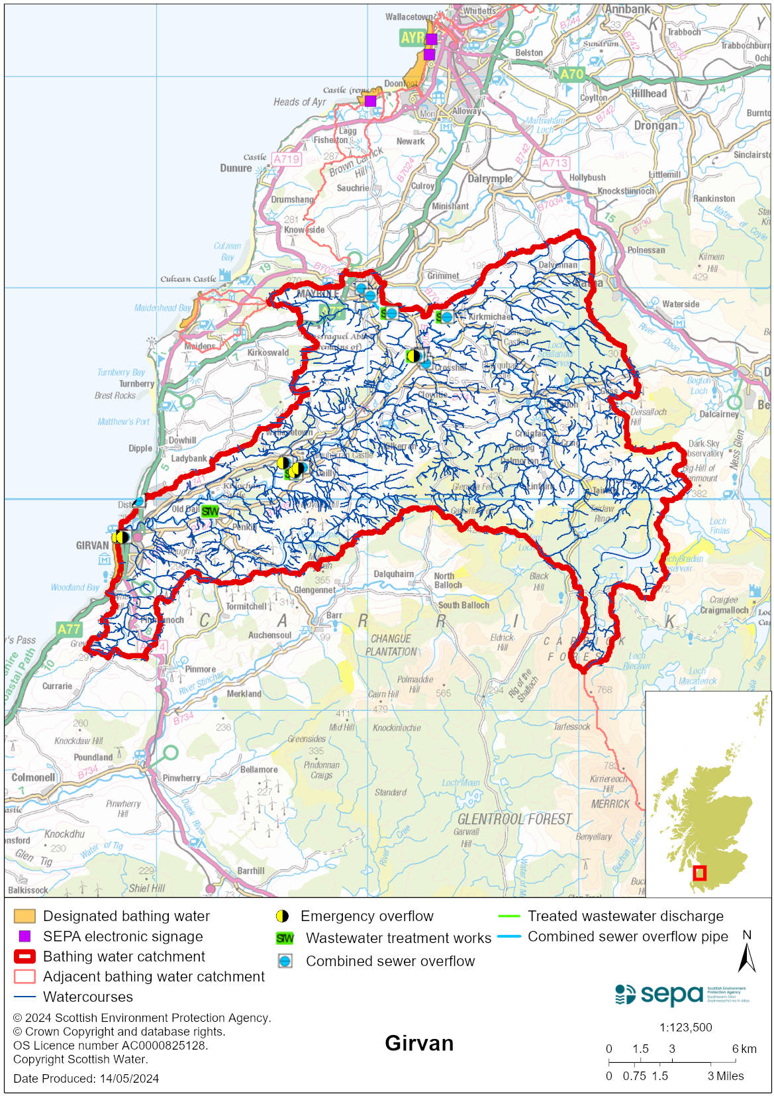

Improving bathing water quality

Sewage
Scottish Water provides most waste water collection and treatment services in Scotland.

The discharge from the Girvan sewage treatment works is remote from the bathing water and is not thought to affect water quality. A Scottish Water study indicated that improvements to their assets would not improve bathing water quality. Discharges from the sewerage systems serving the other towns and villages in the catchment are not considered to have any impact on water quality nor are discharges from private treatment plants.

SEPA is investigating the potential impact of inputs in the Mill burn. Additional sampling is taking place within the 2024 Bathing Water sampling schedule.

Agriculture
Diffuse pollution from agricultural sources is the result of cumulative inputs of pollutants to rivers and streams.

There is potential for agricultural diffuse pollution to occur in the Water of Girvan and other small burns. This could impact on the bathing beach during periods of heavy rain.

Farm visits started in the Girvan catchment during 2015. These visits looked to identify diffuse pollution sources and pathways. Mitigation measures were agreed with land managers to reduce the risk of bacterial pollution on water quality.

SEPA has observed significant changes in land management practice within the catchments and will continue to work with farmers to reduce the risk of pollution to the bathing water.

Cyanobacteria (blue-green algae), algae and jellyfish
Marine waters are not at risk of cyanobacteria overproduction. This bathing water is not at risk of excessive growth of macroalgae (seaweed) or phytoplankton.

The possibility of increased jellyfish numbers in the water during summer months is a naturally occurring phenomenon. Most species common to the UK are harmless; the Marine Conservation Society advises to ‘look but don’t touch’.

Pollution incidents
Pollution can be reported via our website online form or by calling our 24 hours a day Pollution Hotline number 0800 80 70 60

If pollution is reported to us, or identified by our routine water quality monitoring program, we will investigate and where necessary work with others to remediate. We may contact other relevant organisations including the local authority, that local health board, Scottish Water and Scottish Ministers.

If there is a risk to human health the local authority is responsible for placing signs at the bathing water. Information will also be available on our website.

Everyone can help to keep the bathing water clean:
- If you visit the beach with your dog clear up any fouling
- Don’t leave litter or feed birds - this encourages unnatural behaviour, and they can pollute the water
- At home, don’t flush wipes or other inappropriate items as these can block pipes and cause sewage spills

Contact details and information sources

SEPA bathing waters homepage

SEPA rainfall data

Scottish Government protected waters homepage

South Ayrshire Council

For information on accessing this document in an alternative format or language, please contact SEPA by emailing equalities@sepa.org.uk
If you are a user of British Sign Language (BSL), the Contact Scotland BSL service gives you access to an online interpreter, enabling you to communicate with us using sign language. contactscotland-bsl.org

