Bathing water profile – Millport Bay
Bathing water classification

Bathing water description
Millport Bay bathing water is at Millport on southern end of the island of Great Cumbrae, between Marine Parade and Knox’s Port pier. The shore is divided into two smaller bays by rocky outcrops. Kames Bay is a sandy beach and Newtown Bay is a shingle beach. The beaches are prized by locals and tourists alike for the stunning views. It also offers numerous intertidal pools and the famed Crocodile Rock. Depending on the tide, the distance to the water’s edge can vary from 20–200 metres at the widest point (Kames Bay).

Site details:
- Local authority: North Ayrshire Council
- Year of designation: 1999
- Water sampling location: NS 16598 54917

Risks to water quality
This bathing water is subject to short term pollution following heavy rainfall. Bathing is not advised during or 1-2 days after heavy rainfall due to the risk to bathers’ health from water pollution.

Pollution risks include agricultural run-off, sewer overflows and surface water discharges.

Water quality forecasts
As water quality is likely to be impacted by rainfall we make daily predictions of good or poor bathing water quality. We advise against bathing when poor water quality is predicted as there is an increased risk to bathers’ health from water pollution.

These predictions are displayed on the electronic sign at the beach and online between 15 May and 15 September.

Catchment description
The bathing water catchment extends to 4 km2. The area surrounding the bathing water is 5-35 metres above sea level. The highest point in the catchment is in the north (127 metres).
The area is mainly rural (88%) with agriculture the major land use. The main agricultural activity is dairy farming. Approximately 11% of the catchment is urban. The only population centre on the island is Millport.
The only water courses within the catchment are the Mill Burn and an unnamed burn which flow into Kames Bay.

Map 1: Millport Bay bathing water
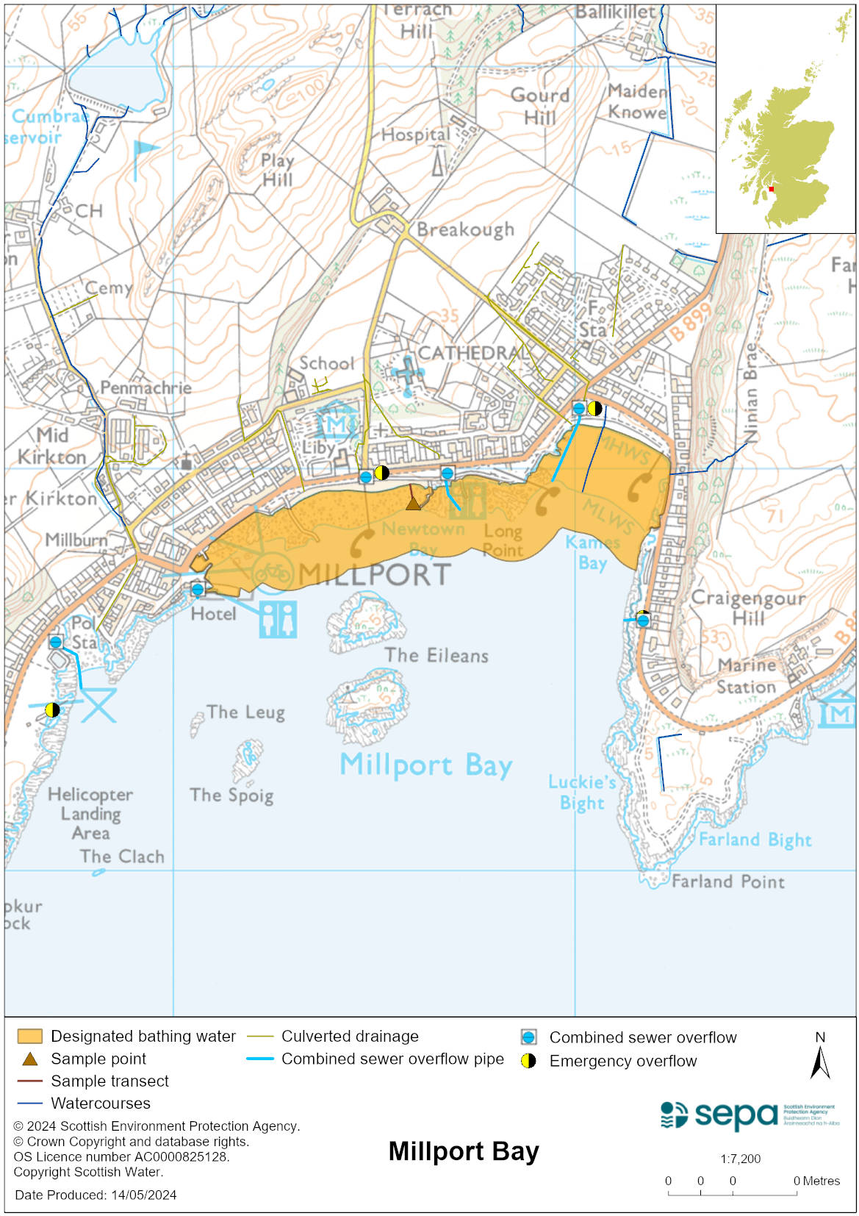

Map 2: Catchment draining into Millport Bay bathing water
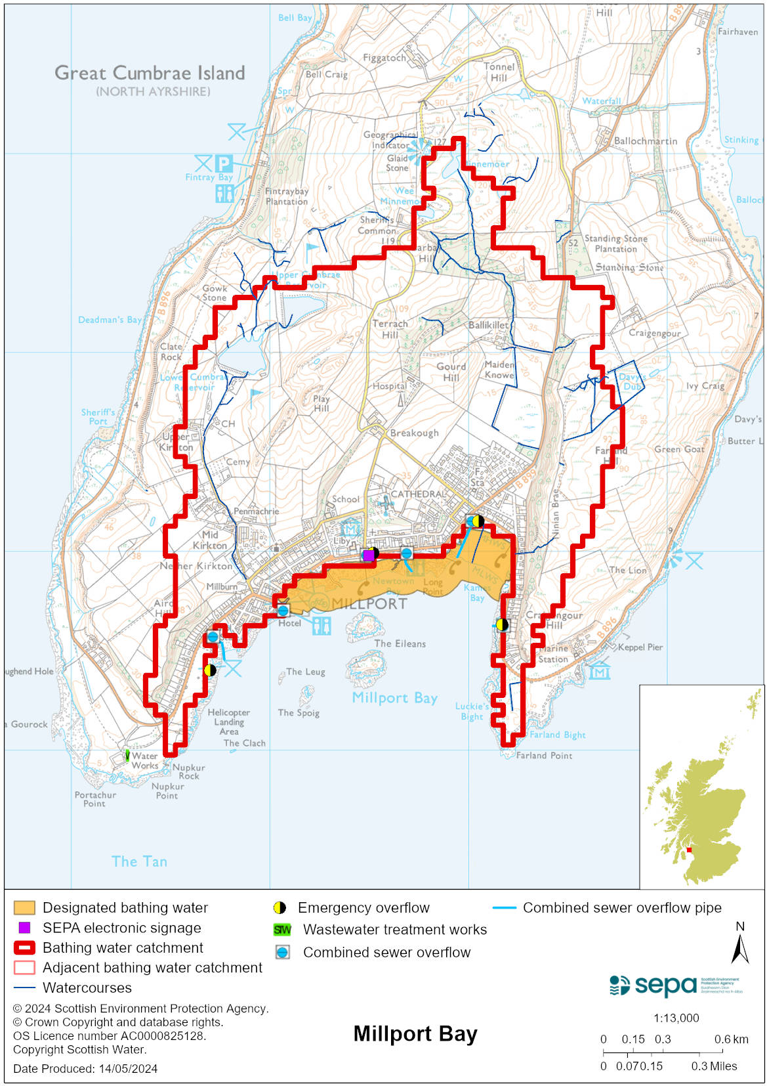

Improving bathing water quality

Sewage
Scottish Water provides most waste water collection and treatment services in Scotland.

There are combined sewer overflows (CSOs) which can impact the bathing water after heavy rain and emergency overflows (EOs) which should only discharge under rare, abnormal circumstances.

Agriculture
Diffuse pollution from agricultural sources is the result of rain driven events causing cumulative inputs of pollutants to rivers and streams.

There are a few farms in the catchment which drain into the bathing water. Targeted efforts have been made to improve management of diffuse pollution with farms operating in a compliant manner.

SEPA will continue to engage with farmers and the NFUS to remind them of good practice when applying slurries and manures and grazing livestock.

Urban
Urban diffuse source pollution comes from contaminated rainwater discharging to rivers and streams. The Mill Burn and an unnamed burn at Kames Bay may be affected by surface water run-off from Millport town. Any impact is localised and is not thought to significantly affect the quality of the bathing water.

Cyanobacteria (blue-green algae), algae and jellyfish
Marine waters are not at risk of cyanobacteria overproduction. This bathing water is not at risk of excessive growth of macroalgae (seaweed) or phytoplankton.

The possibility of increased jellyfish numbers in the water during summer months is a naturally occurring phenomenon. Most species common to the UK are harmless; the Marine Conservation Society advises to ‘look but don’t touch’.

Pollution incidents
Pollution can be reported via our website online form or by calling our 24 hours a day Pollution Hotline number 0800 80 70 60

If pollution is reported to us, or identified by our routine water quality monitoring program, we will investigate and where necessary work with others to remediate. We may contact other relevant organisations including the local authority, that local health board, Scottish Water and Scottish Ministers.

If there is a risk to human health the local authority is responsible for placing signs at the bathing water. Information will also be available on our website.

Everyone can help to keep the bathing water clean:
- If you visit the beach with your dog clear up any fouling
- Don’t leave litter or feed birds - this encourages unnatural behaviour, and they can pollute the water
- At home, don’t flush wipes or other inappropriate items as these can block pipes and cause sewage spills

Contact details and information sources

SEPA bathing waters homepage

SEPA rainfall data

Scottish Government protected waters homepage

North Ayrshire Council

For information on accessing this document in an alternative format or language, please contact SEPA by emailing equalities@sepa.org.uk
If you are a user of British Sign Language (BSL), the Contact Scotland BSL service gives you access to an online interpreter, enabling you to communicate with us using sign language. contactscotland-bsl.org

