Bathing water profile – Ettrick bay
Bathing water classification

Bathing water description
Ettrick Bay bathing water is a wide, sandy bay of about 1.7km in length. It is on the west coast of the Isle of Bute. The nearest town is Rothesay, about 4 km away on the east coast of the island. The beach is mainly composed of coarse sand and is popular with locals and visitors. The beach offers spectacular views of nearby Arran. Depending on the tide, the distance to the water’s edge can vary from 0–500 metres. Small strips of water are usually present on the beach when the tide is out.

Site details:
- Local authority: Argyll and Bute Council
- Year of designation: 1999
- Water sampling location: NS 03724 66058

Risks to water quality
This bathing water is subject to short term pollution following heavy rainfall. Bathing is not advised during or 1-2 days after heavy rainfall due to the risk to bathers’ health from water pollution.

Pollution risks are from agricultural run-off and sewerage sources.

Water quality forecasts
As water quality is likely to be impacted by rainfall we make daily predictions of good or poor bathing water quality. We advise against bathing when poor water quality is predicted as there is an increased risk to bathers’ health from water pollution.

These predictions are displayed on the electronic sign at the beach and online between 15 May and 15 September.

Catchment description
The catchment draining into the bathing water extends to 22.5 km2. This hilly catchment surrounds the bathing water, and a series of peaks can be seen from the beach. The highest of the peaks is Windy Hill in the north, which stands at 278 metres.
The area is mainly rural (99%) with agriculture the major land use. The upland areas support mixed sheep and beef farming. The lowlands are used for intensive dairy farming. The areas of land next to the bathing water are used primarily for silage production and growing crops. The population in the catchment is very low as it does not include a town.
The main rivers within the catchment are the Glenmore Burn, Ettrick Burn, Drumachloy Burn and St Colmac Burn. Several small tributaries also enter the bathing water.

Map 1: Ettrick Bay bathing water
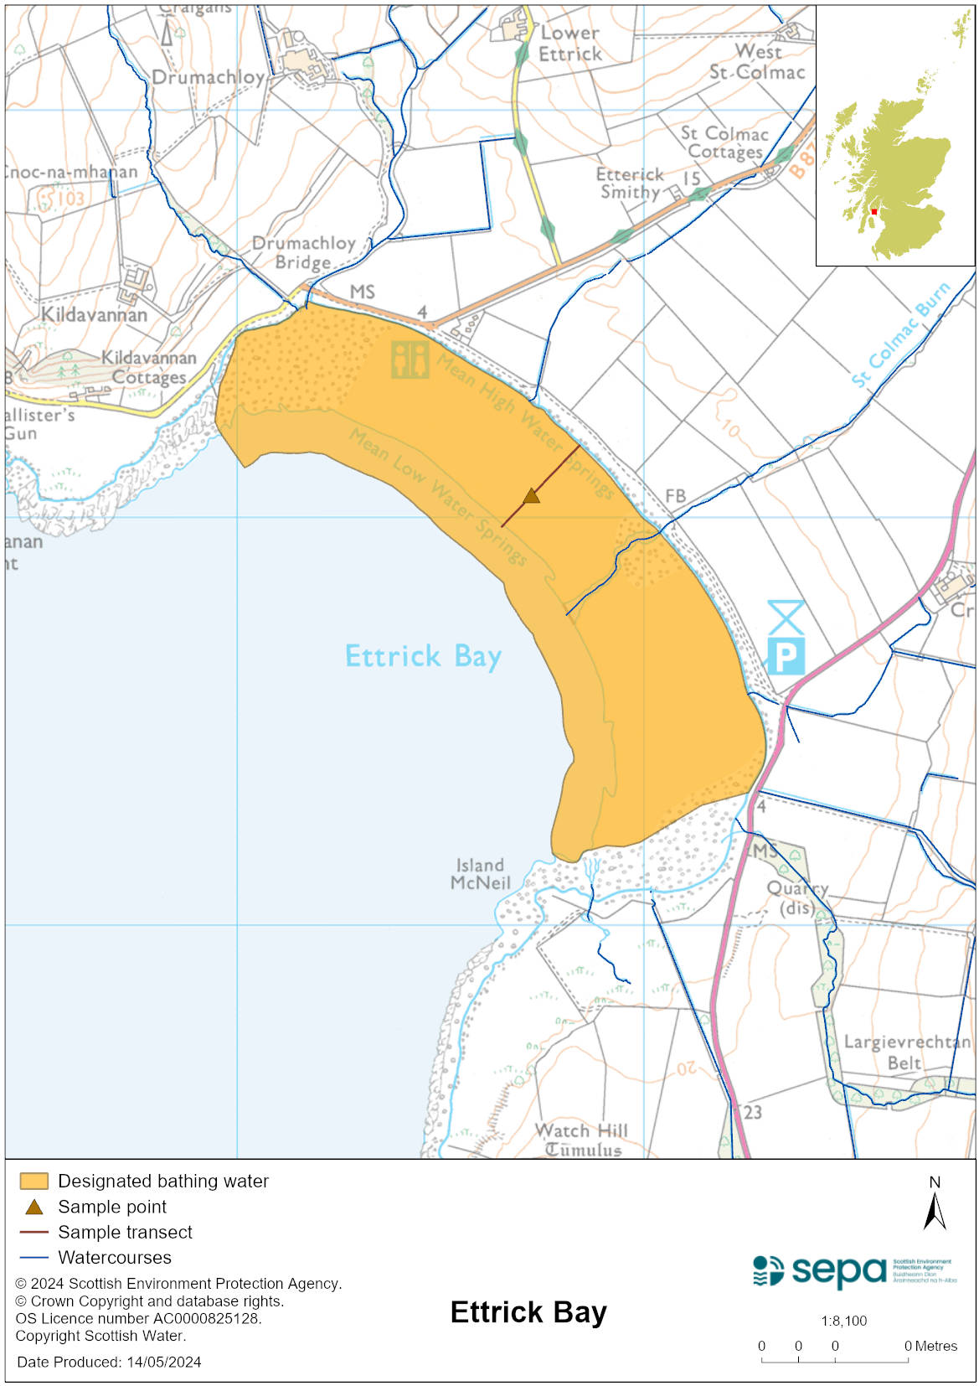

Map 2: Catchment draining into Ettrick Bay bathing water
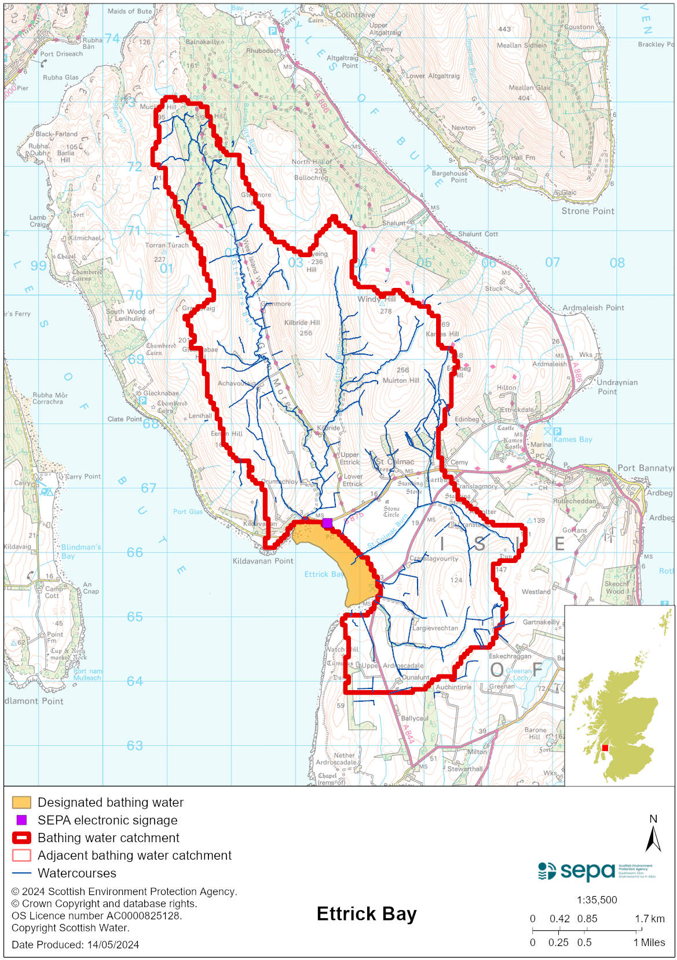

Improving bathing water quality

Sewage
Whilst Scottish Water provides most waste water collection and treatment services in Scotland, there are no Scottish Water assets in the vicinity of this bathing water.

There are a small number of private septic tank discharges within the bathing water catchment which include the public conveniences adjacent to the beach. The sewage system at the nearby tea room discharges to soakaway.

Agriculture
Diffuse pollution from agricultural sources is the result of rain driven events causing cumulative inputs of pollutants to rivers and streams.

There is potential for agricultural diffuse pollution to impact Ettrick Bay bathing water.

SEPA has been working with farmers in this area since 2010 and will continue to work with them to reduce the risk of pollution to the bathing water.

Cyanobacteria (blue-green algae), algae and jellyfish
Marine waters are not at risk of cyanobacteria overproduction. This bathing water is not at risk of excessive growth of macroalgae (seaweed) or phytoplankton.

The possibility of increased jellyfish numbers in the water during summer months is a naturally occurring phenomenon. Most species common to the UK are harmless; the Marine Conservation Society advises to ‘look but don’t touch’.

Pollution incidents
Pollution can be reported via our website online form or by calling our 24 hours a day Pollution Hotline number 0800 80 70 60

If pollution is reported to us, or identified by our routine water quality monitoring program, we will investigate and where necessary work with others to remediate. We may contact other relevant organisations including the local authority, that local health board, Scottish Water and Scottish Ministers.

If there is a risk to human health the local authority is responsible for placing signs at the bathing water. Information will also be available on our website.

Everyone can help to keep the bathing water clean:
- If you visit the beach with your dog clear up any fouling
- Don’t leave litter or feed birds - this encourages unnatural behaviour, and they can pollute the water
- At home, don’t flush wipes or other inappropriate items as these can block pipes and cause sewage spills

Contact details and information sources

SEPA bathing waters homepage

SEPA rainfall data

Scottish Government protected waters homepage

Argyll and Bute Council

For information on accessing this document in an alternative format or language, please contact SEPA by emailing equalities@sepa.org.uk
If you are a user of British Sign Language (BSL), the Contact Scotland BSL service gives you access to an online interpreter, enabling you to communicate with us using sign language. contactscotland-bsl.org

