Bathing water profile - Rosehearty
Bathing water classification

Bathing water description
Rosehearty bathing water is near the town of Rosehearty in Aberdeenshire. The sandy beach is approximately 1 km long. It is between the harbour to the west and rocky outcrops to the east. It is backed by Rosehearty golf course. Depending on the tide, the distance to the water’s edge can vary from 0–360 metres.

Site details:
- Local authority: Aberdeenshire Council
- Year of designation: 1999
- Water sampling location: NJ 93391 67651

Risks to water quality
This bathing water is at risk of short term pollution following heavy rainfall. Bathing is not advised during or 1-2 days after heavy rainfall due to the risk to bathers’ health from water pollution.

Pollution risks include sewer overflows and agricultural run-off.

Catchment description
The Rosehearty bathing water catchment extends to 1.5 km2. The catchment from gentle hills (maximum elevation 65 metres) in the south to the low-lying areas (average elevation 5 metres) along the coast.
There are no main rivers discharging into the bathing water. There is a culverted water course/road drain near the golf course which discharges into the bathing water.
There is a Site of Special Scientific Interest located partially within the catchment. The catchment lies within a Nitrate Vulnerable Zone.

Map 1: Rosehearty bathing water
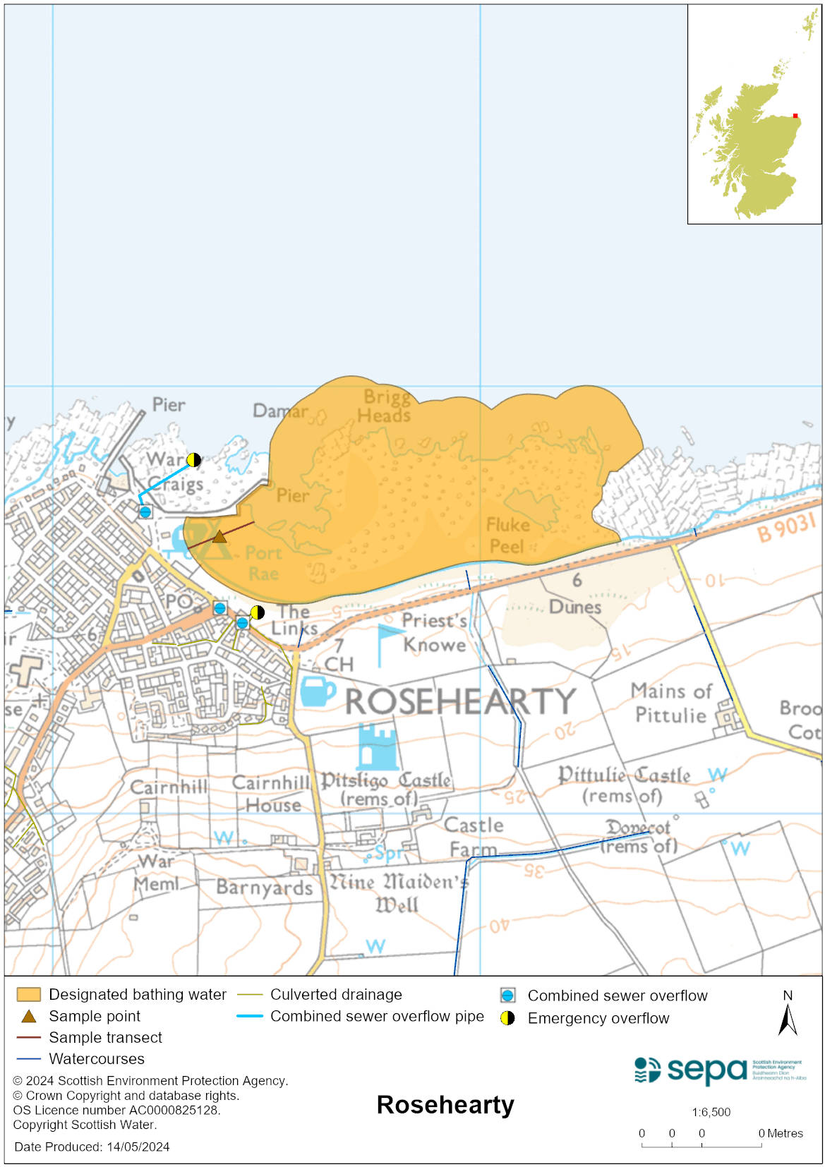

Map 2: Catchment draining into Rosehearty bathing water
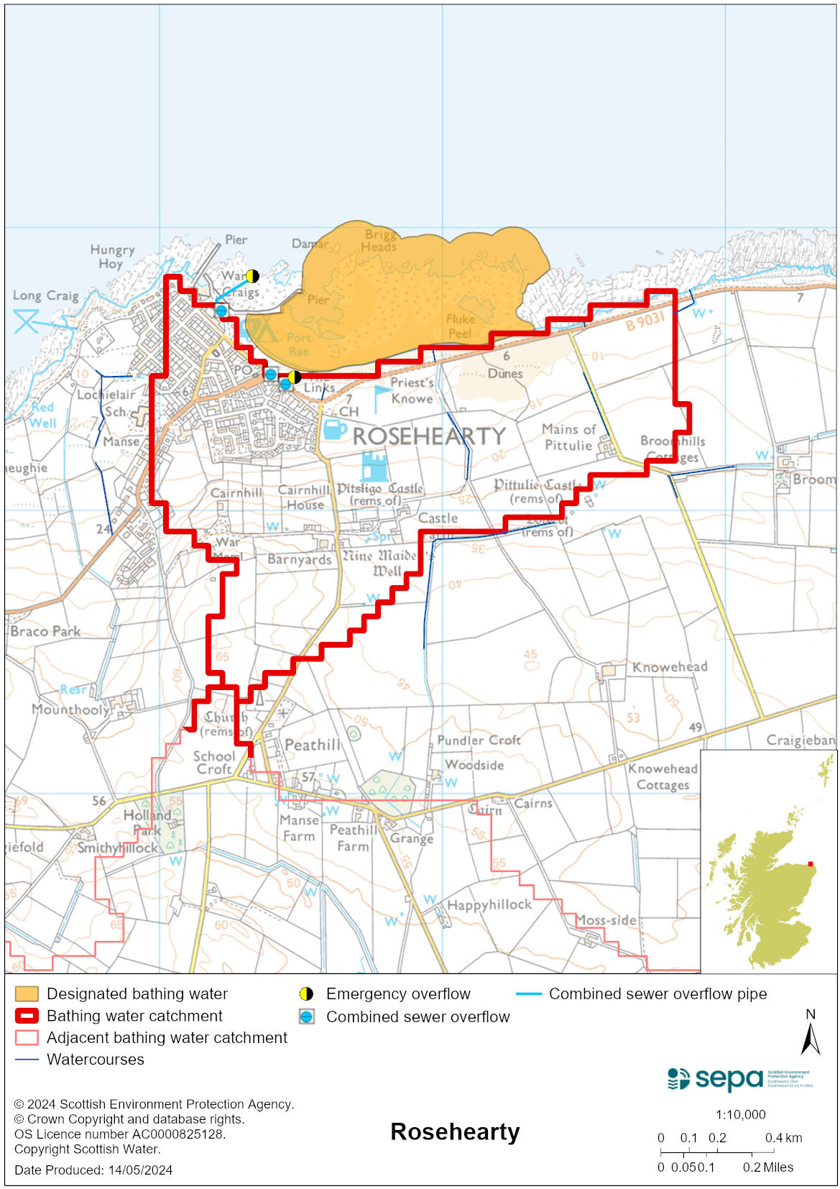

Improving bathing water quality

Sewage
Scottish Water provides most waste water collection and treatment services in Scotland.

Rosehearty pumping station has a combined sewage overflow and an emergency overflow to the west of the bathing water. Under wet weather or emergency conditions this discharge has the potential to affect the bathing water quality.

SEPA and Scottish Water carry out joint inspections of this discharge before the bathing season to verify that appropriate measures are in place to protect the bathing water.

Agriculture
Diffuse pollution from agricultural sources is the result of rain driven events causing cumulative inputs of pollutants to rivers and streams.

The risk to Rosehearty’s bathing water quality occurs during and following heavy rain.

Farm visits were undertaken in the Buchan Coastal catchment during 2014. These visits looked to identify diffuse pollution sources and pathways. Mitigation measures were agreed with land managers to reduce the risk of bacterial pollution on water quality.

SEPA has observed significant changes in land management practice within the catchment and will continue to work with farmers to reduce the risk of pollution to the bathing water.

Cyanobacteria (blue-green algae), algae and jellyfish
Marine waters are not at risk of cyanobacteria overproduction. This bathing water is not at risk of excessive growth of macroalgae (seaweed) or phytoplankton.

The possibility of increased jellyfish numbers in the water during summer months is a naturally occurring phenomenon. Most species common to the UK are harmless; the Marine Conservation Society advises to ‘look but don’t touch’.

Pollution incidents
Pollution can be reported via our website online form or by calling our 24 hours a day Pollution Hotline number 0800 80 70 60

If pollution is reported to us, or identified by our routine water quality monitoring program, we will investigate and where necessary work with others to remediate. We may contact other relevant organisations including the local authority, that local health board, Scottish Water and Scottish Ministers.

If there is a risk to human health the local authority is responsible for placing signs at the bathing water. Information will also be available on our website.

Everyone can help to keep the bathing water clean:
- If you visit the beach with your dog clear up any fouling
- Don’t leave litter or feed birds - this encourages unnatural behaviour, and they can pollute the water
- At home, don’t flush wipes or other inappropriate items as these can block pipes and cause sewage spills

Contact details and information sources

SEPA bathing waters homepage

SEPA rainfall data

Scottish Government protected waters homepage

Aberdeenshire Council

For information on accessing this document in an alternative format or language, please contact SEPA by emailing equalities@sepa.org.uk
If you are a user of British Sign Language (BSL), the Contact Scotland BSL service gives you access to an online interpreter, enabling you to communicate with us using sign language. contactscotland-bsl.org

