Bathing water profile – Kinghorn (Harbour Beach)
Bathing water classification

Bathing water description
The Kinghorn (Harbour Beach) bathing water is next to the town of Kinghorn. The beach is a mixture of sand, rock pools and cliffs. It is about 500 metres long. Depending on the tide, the approximate distance to the water’s edge can vary from 0m to 210m. The beach slopes gently towards the water.

Site details:
- Local authority: Fife Council
- Year of designation: 2008
- Water sampling location: NT 27125 86697

Risks to water quality
This bathing water is subject to short term pollution following heavy rainfall. Bathing is not advised during or 1-2 days after heavy rainfall due to the risk to bathers’ health from water pollution.

Pollution risks include sewer overflows and surface water discharges.

Water quality forecasts
As water quality is likely to be impacted by rainfall we make daily predictions of good or poor bathing water quality. We advise against bathing when poor water quality is predicted as there is an increased risk to bathers’ health from water pollution.

These predictions are displayed on the electronic sign at the beach and online between 15 May and 15 September.

Catchment description
A catchment area of 2 km2 drains into Kinghorn (Harbour Beach) bathing water. Kinghorn Burn and Lady Burn are the main watercourses within the catchment. The area is mainly rural with grassland the major land use. Urban land use is concentrated around Kinghorn town.
Average summer rainfall for the region is 296 mm compared to 331 mm across Scotland as a whole.

Map 1: Kinghorn (Harbour Beach) bathing water
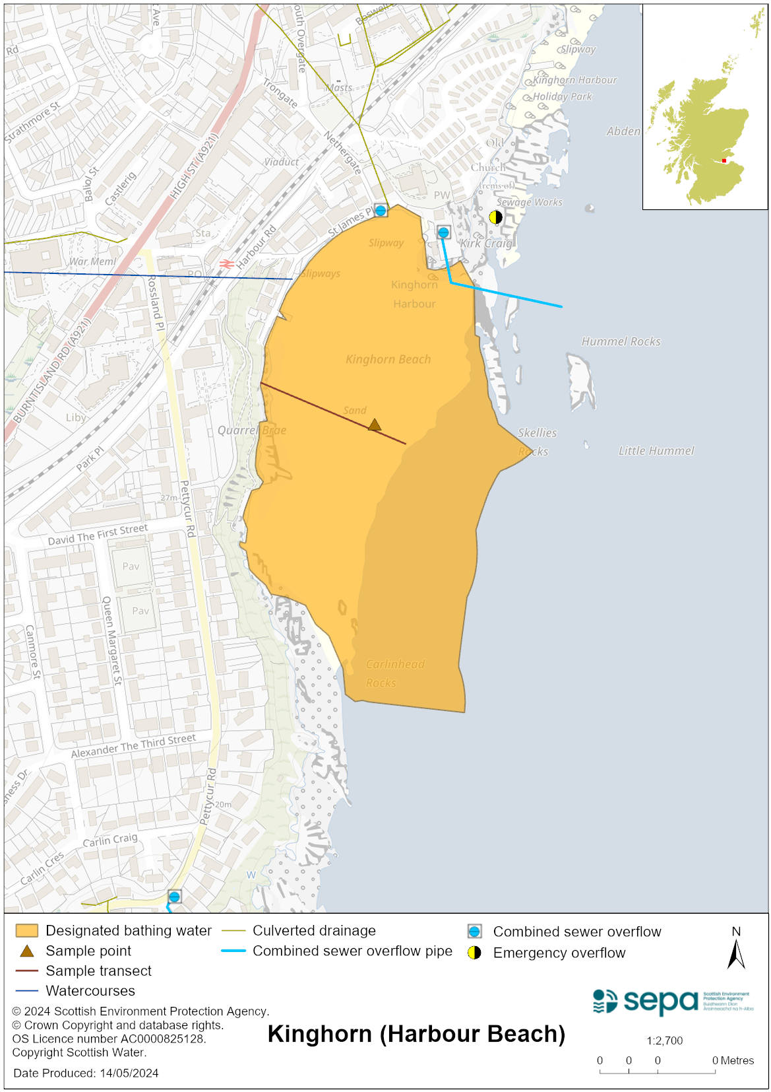

Map 2: Catchment draining into Kinghorn (Harbour Beach) bathing water
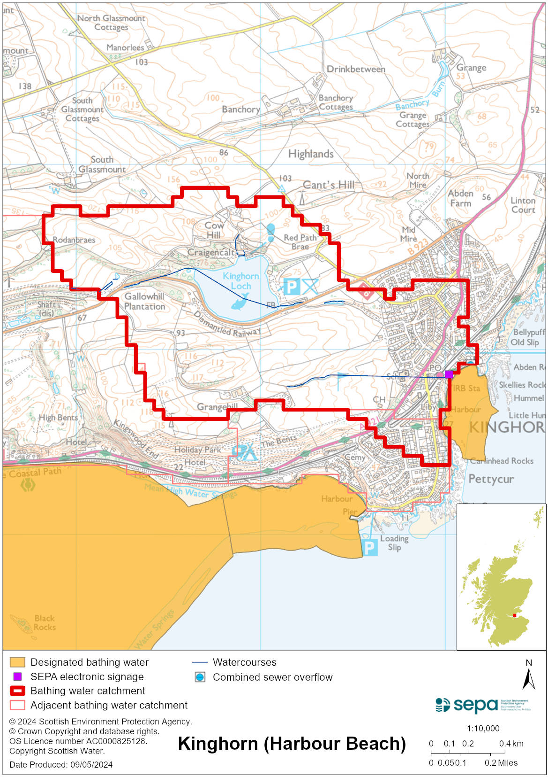

Improving bathing water quality

Sewage
Scottish Water provides most waste water collection and treatment services in Scotland.

Bleaching Hill combined sewage overflow (CSO), which discharged to the Lady Burn, a tributary of the main Kinghorn Burn, was indicated by Scottish Water studies as a key pollution source. This was closed off in September 2018 to prevent spilling and ensure there were no discharges. Scottish Water spent around £700,000 to complete these engineering works well in time for the start of the 2019 bathing season.

SEPA is continuing to work with regulated operators and other stakeholders to further improve bathing water quality at Kinghorn (Harbour) to meet required bathing water standards.

Agriculture
There are no impacts from agriculture affecting this bathing water.

Urban
The North Burn which flows into the sea to the western side of the bathing water is impacted by urban pollution. This can be from surface water run-off from the urban area through which it runs and mis connections.

Cyanobacteria (blue-green algae), algae and jellyfish
Marine waters are not at risk of cyanobacteria overproduction. This bathing water is not at risk of excessive growth of macroalgae (seaweed) or phytoplankton.

The possibility of increased jellyfish numbers in the water during summer months is a naturally occurring phenomenon. Most species common to the UK are harmless; the Marine Conservation Society advises to ‘look but don’t touch’.

Pollution incidents
Pollution can be reported via our website online form or by calling our 24 hours a day Pollution Hotline number 0800 80 70 60

If pollution is reported to us, or identified by our routine water quality monitoring program, we will investigate and where necessary work with others to remediate. We may contact other relevant organisations including the local authority, that local health board, Scottish Water and Scottish Ministers.

If there is a risk to human health the local authority is responsible for placing signs at the bathing water. Information will also be available on our website.

Everyone can help to keep the bathing water clean:
- If you visit the beach with your dog clear up any fouling
- Don’t leave litter or feed birds - this encourages unnatural behaviour, and they can pollute the water
- At home, don’t flush wipes or other inappropriate items as these can block pipes and cause sewage spills

Contact details and information sources

SEPA bathing waters homepage

SEPA rainfall data

Scottish Government protected waters homepage

Fife Council

For information on accessing this document in an alternative format or language, please contact SEPA by emailing equalities@sepa.org.uk
If you are a user of British Sign Language (BSL), the Contact Scotland BSL service gives you access to an online interpreter, enabling you to communicate with us using sign language. contactscotland-bsl.org

