Bathing water profile – Fraserburgh (Tigerhill)
Bathing water classification

Bathing water description
Fraserburgh (Tigerhill) bathing water is on the north coast of Aberdeenshire. It is an extensive sandy beach of approximately 2 km in length. It is backed by dunes and slopes gently towards the water. The beach is popular for recreation, surfing and windsurfing. Depending on the tide, the distance to the water’s edge can vary from 0 to 130m.

Site details:
- Local authority: Aberdeenshire Council
- Year of designation: 1987
- Water sampling location: NK 00510 65640

Risks to water quality
This bathing water is at risk of short term pollution following heavy rainfall. Bathing is not advised during or 1-2 days after heavy rainfall due to the risk to bathers’ health from water pollution.

Pollution risks include agricultural run-off, sewer overflows and surface water discharges.

Catchment description
The catchment draining into the Fraserburgh (Tigerhill) bathing water extends to 16 km2. It varies from gentle hills in the west to the low-lying plains along the coast. The main river within the catchment is the Kessock Burn which flows into the sea at the western end of the bay.
The catchment is mainly rural (93%) with agriculture the major land use. The agricultural land is split between arable farming (60%) and grassland (26%). The area supports mixed farming. Approximately 6% of the catchment is urban. The main population centre is the town of Fraserburgh. Population density outside the town is low and is centred around several small villages.

Map 1: Fraserburgh (Tigerhill) bathing water
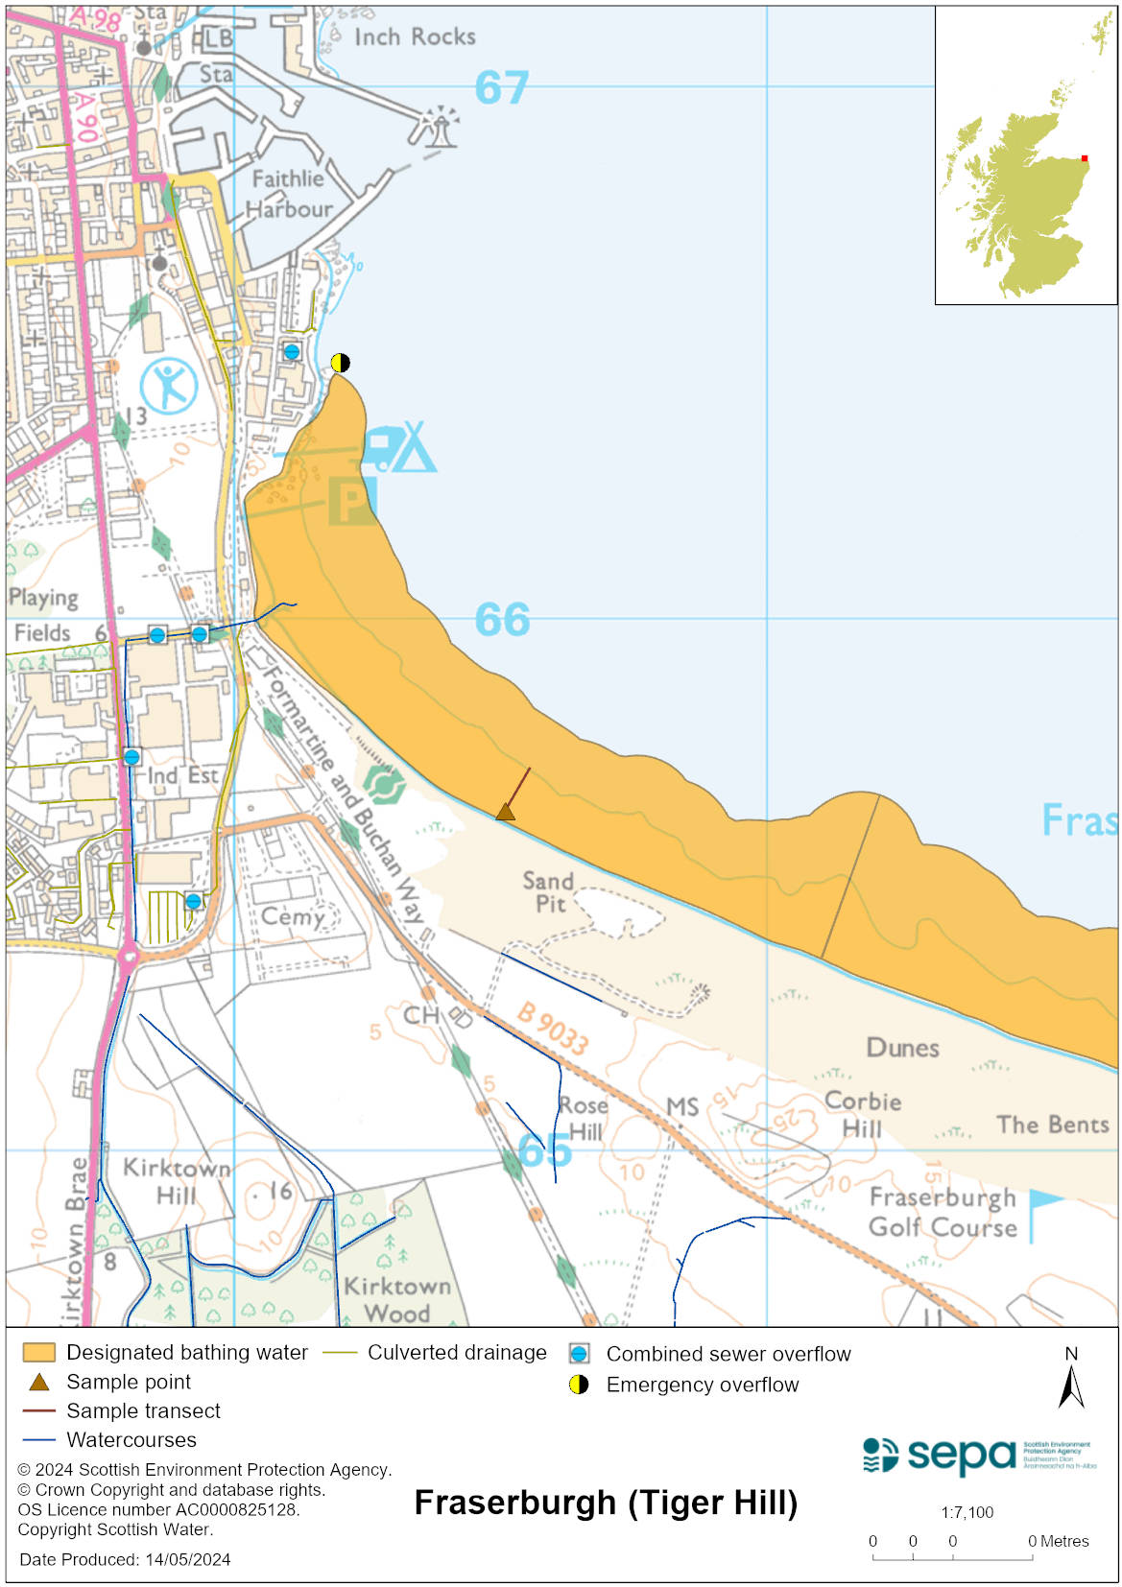

Map 2: Catchment draining into Fraserburgh (Tigerhill) bathing water
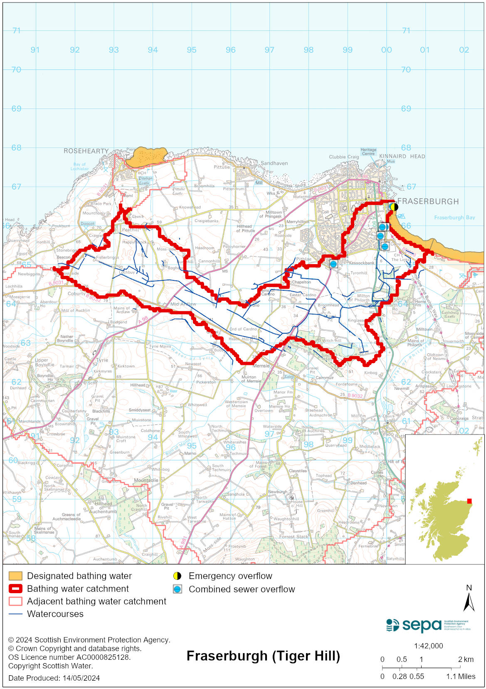

Improving bathing water quality

Sewage
Scottish Water provides most waste water collection and treatment services in Scotland.
Sewage is treated at Fraserburgh sewage treatment works before being discharged. These works are not considered to impact the bathing water quality.
The sewage pumping station at the northern end of the bathing area poses a potential risk to water quality. Work has been carried out by Scottish Water to ensure that spills from this discharge are restricted. This facility is inspected prior to the start of every bathing season.
There are three surface water sewers discharging to the Kessock Burn. An intermittent problem exists with one of these discharges despite several investigations to identify the root of the problem. These surface water sewers have the potential to affect the bathing water quality. There are a number of private septic tanks that discharge to the Kessock Burn which cumulatively have the potential to impact on the bathing water quality.

Agriculture
Diffuse pollution from agricultural sources is the result of rain driven events causing cumulative inputs of pollutants to rivers and streams.

There is potential for agricultural diffuse pollution to occur in the Kessock Burn which could impact on the bathing beach following heavy rain.

Farm visits in this area were undertaken as part of the Buchan Coastal priority catchment campaign during 2015. These visits looked to identify diffuse pollution sources and pathways. Mitigation measures were agreed with land managers to reduce the risk of bacterial pollution on water quality.

SEPA has observed significant changes in land management practice within the catchments and will continue to work with farmers to reduce the risk of pollution to the bathing water.

Urban
Urban diffuse source pollution comes from contaminated rainwater discharging to rivers and streams. The Kessock Burn, which discharges directly into the Fraserburgh (Tigerhill) bathing water, is known to be affected by surface water run-off from the urban area through which it runs and potentially impacts on bathing water quality.

Cyanobacteria (blue-green algae), algae and jellyfish
Marine waters are not at risk of cyanobacteria overproduction. This bathing water is not at risk of excessive growth of macroalgae (seaweed) or phytoplankton.

The possibility of increased jellyfish numbers in the water during summer months is a naturally occurring phenomenon. Most species common to the UK are harmless; the Marine Conservation Society advises to ‘look but don’t touch’.

Pollution incidents
Pollution can be reported via our website online form or by calling our 24 hours a day Pollution Hotline number 0800 80 70 60

If pollution is reported to us, or identified by our routine water quality monitoring program, we will investigate and where necessary work with others to remediate. We may contact other relevant organisations including the local authority, that local health board, Scottish Water and Scottish Ministers.

If there is a risk to human health the local authority is responsible for placing signs at the bathing water. Information will also be available on our website.

Everyone can help to keep the bathing water clean:
- If you visit the beach with your dog clear up any fouling
- Don’t leave litter or feed birds - this encourages unnatural behaviour, and they can pollute the water
- At home, don’t flush wipes or other inappropriate items as these can block pipes and cause sewage spills

Contact details and information sources

SEPA bathing waters homepage

SEPA rainfall data

Scottish Government protected waters homepage

Aberdeenshire Council

For information on accessing this document in an alternative format or language, please contact SEPA by emailing equalities@sepa.org.uk
If you are a user of British Sign Language (BSL), the Contact Scotland BSL service gives you access to an online interpreter, enabling you to communicate with us using sign language. contactscotland-bsl.org

