Bathing water profile – Portobello (West)
Bathing water classification

Bathing water description
Portobello beach is in the small town of Portobello, on the outskirts of Edinburgh. The beach comprises of a long stretch of sand and an associated promenade. The area is popular with dog walkers and families. Another bathing water, Portobello (Central), is to the southeast of Portobello (West). Depending on the tide, the distance to the water’s edge can vary from 0–250 metres. The sandy beach slopes gently towards the water.

Site details:
- Local authority: City of Edinburgh Council
- Year of designation: 1999
- Water sampling location: NT 30314 74632

Risks to water quality
This bathing water is subject to short term pollution following heavy rainfall. Bathing is not advised during or 1-2 days after heavy rainfall due to the risk to bathers’ health from water pollution.

Pollution risks include sewer overflows and surface water discharges.

Water quality forecasts
As water quality is likely to be impacted by rainfall we make daily predictions of good or poor bathing water quality. We advise against bathing when poor water quality is predicted as there is an increased risk to bathers’ health from water pollution.

These predictions are displayed on the electronic sign at the beach and online between 15 May and 15 September.

Catchment description
A catchment area of 32 km2 drains into Portobello (West) bathing water. Land use is urban and rural. Portobello town and the south of Edinburgh are the main urban areas within the catchment.
The main river in the catchment is the Braid Burn/Figgate Burn. It flows into the sea between Portobello (West) and Portobello (Central) bathing waters. Average summer rainfall for the region is 296 mm compared to 331 mm across Scotland as a whole.

Map 1: Portobello (West) bathing water
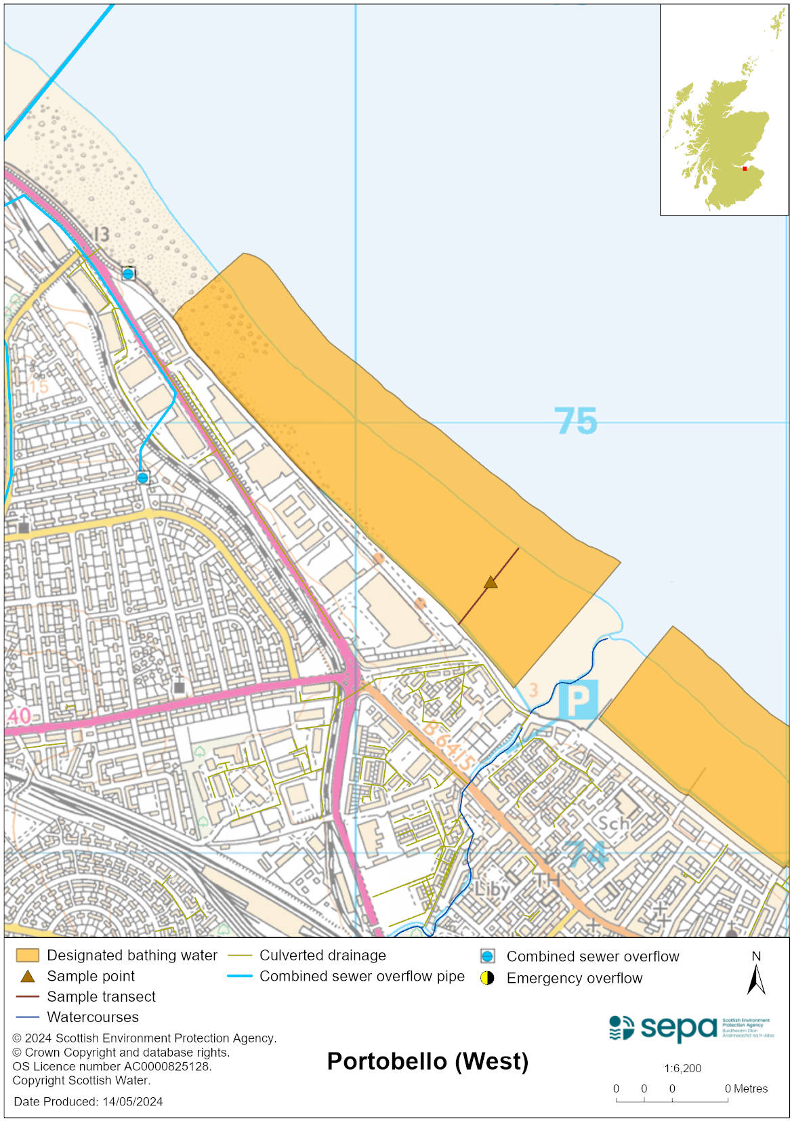

Map 2: Catchment draining into Portobello (West) bathing water
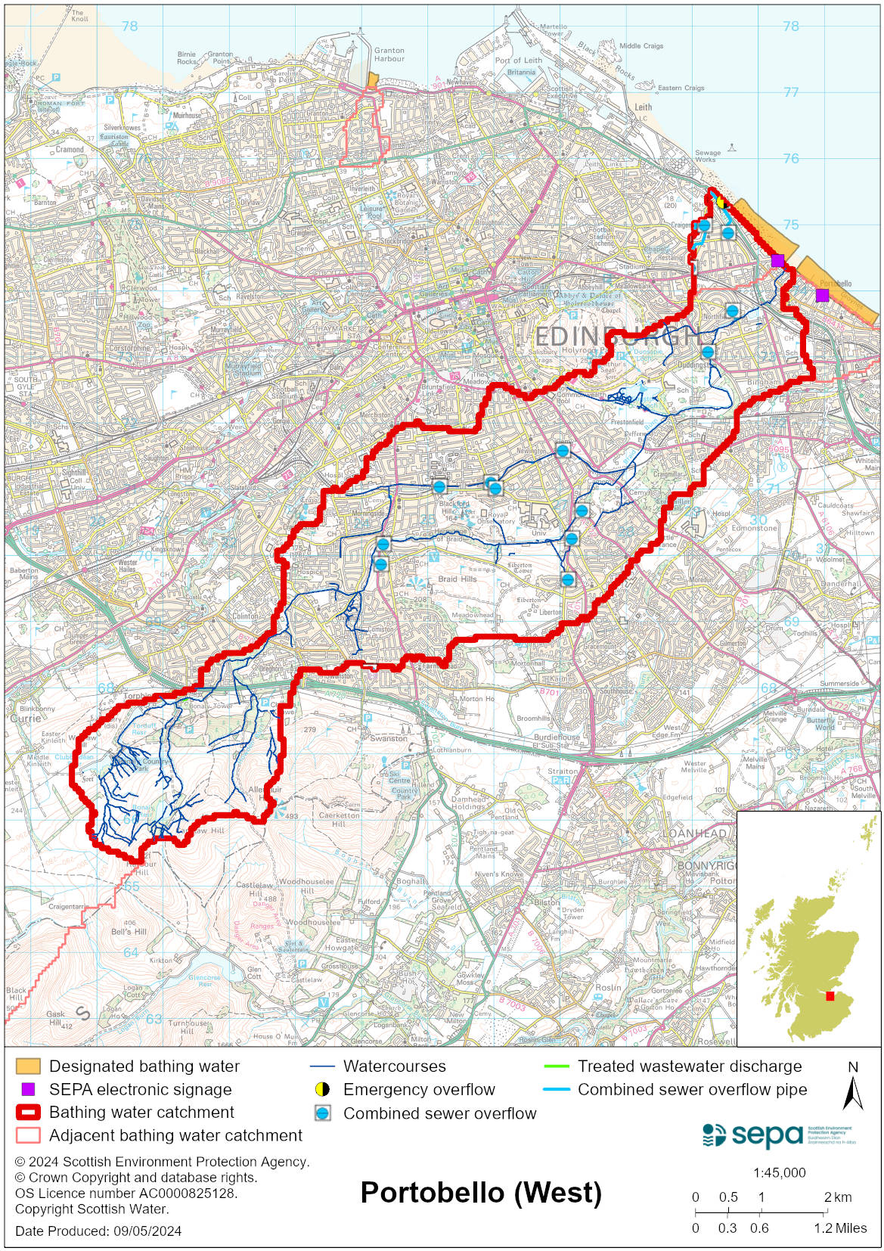

Improving bathing water quality

Sewage
Scottish Water provides most waste water collection and treatment services in Scotland.

Sewage from the Edinburgh area is treated at Edinburgh sewage treatment works before being discharged to the Firth of Forth via a long sea outfall to the North of the works.

There are combined sewer overflows (CSOs) which can impact the bathing water after heavy rain, particularly those discharging to the Braid Burn, the Fillyside group of CSOs and Albert Rd CSO. Since July 2019 there has been a reduction of spills from the Fillyside CSO following remediation of valve in the network to increase the pass forward flow to Seafield sewage treatment works.

There is also an emergency overflow (EO) to the west of the bathing water. This EO should only discharge under rare, abnormal circumstances.

Agriculture
There are no impacts from agriculture affecting this bathing water.

Urban
The Figgate Burn which enters the sea to the east of the bathing water is impacted by urban pollution. This can be from surface water run-off from the urban area through which it runs and mis connections.

Cyanobacteria (blue-green algae), algae and jellyfish
Marine waters are not at risk of cyanobacteria overproduction. This bathing water is not at risk of excessive growth of macroalgae (seaweed) or phytoplankton.

The possibility of increased jellyfish numbers in the water during summer months is a naturally occurring phenomenon. Most species common to the UK are harmless; the Marine Conservation Society advises to ‘look but don’t touch’.

Pollution incidents
Pollution can be reported via our website online form or by calling our 24 hours a day Pollution Hotline number 0800 80 70 60

If pollution is reported to us, or identified by our routine water quality monitoring program, we will investigate and where necessary work with others to remediate. We may contact other relevant organisations including the local authority, that local health board, Scottish Water and Scottish Ministers.

If there is a risk to human health the local authority is responsible for placing signs at the bathing water. Information will also be available on our website.

Everyone can help to keep the bathing water clean:
- If you visit the beach with your dog clear up any fouling
- Don’t leave litter or feed birds - this encourages unnatural behaviour, and they can pollute the water
- At home, don’t flush wipes or other inappropriate items as these can block pipes and cause sewage spills

Contact details and information sources

SEPA bathing waters homepage

SEPA rainfall data

Scottish Government protected waters homepage

City of Edinburgh Council

For information on accessing this document in an alternative format or language, please contact SEPA by emailing equalities@sepa.org.uk
If you are a user of British Sign Language (BSL), the Contact Scotland BSL service gives you access to an online interpreter, enabling you to communicate with us using sign language. contactscotland-bsl.org

