Bathing water profile - Dores
Bathing water classification

Bathing water description
Dores bathing water is situated on the north-east shore of Loch Ness in the Highlands. It is one of only three inland bathing waters in Scotland. It is a relatively small bay, adjacent to the village of Dores. The gravel/sandy beach slopes towards the water. The beach is very popular with tourists, particular in the summer.

Site details:
- Local authority: Highland Council
- Year of designation: 1999
- Water sampling location: NH 59671 35000

Risks to water quality
This bathing water is at risk of short term pollution following heavy rainfall. Bathing is not advised during or 1-2 days after heavy rainfall due to the risk to bathers’ health from water pollution.

Pollution risks include agricultural run-off and sewer overflows.

Catchment description
The Dores bathing water catchment extends to 5 km2. The catchment is steep, ranging from hills in the south and east to the lower lying parts along the loch.
The main rivers within the catchment are the Allt a’ Mhinisteir and Dores Burn. The Allt a’ Mhinisteir is the only water course flowing directly into the bathing water. The Dores Burn flows in just beyond the eastern end of the bathing area.
The area is 98% rural (41% woodland, 15% grassland, 32% heath). The area supports mixed farming. There is no urban development within the catchment. Outside of the catchment, the closest population centre is the village of Dores. The village of Drumnadrochit is 10 km to the south-west on the western side of Loch Ness. The city of Inverness is 10 km to the north-east of the bathing water.

Map 1: Dores bathing water
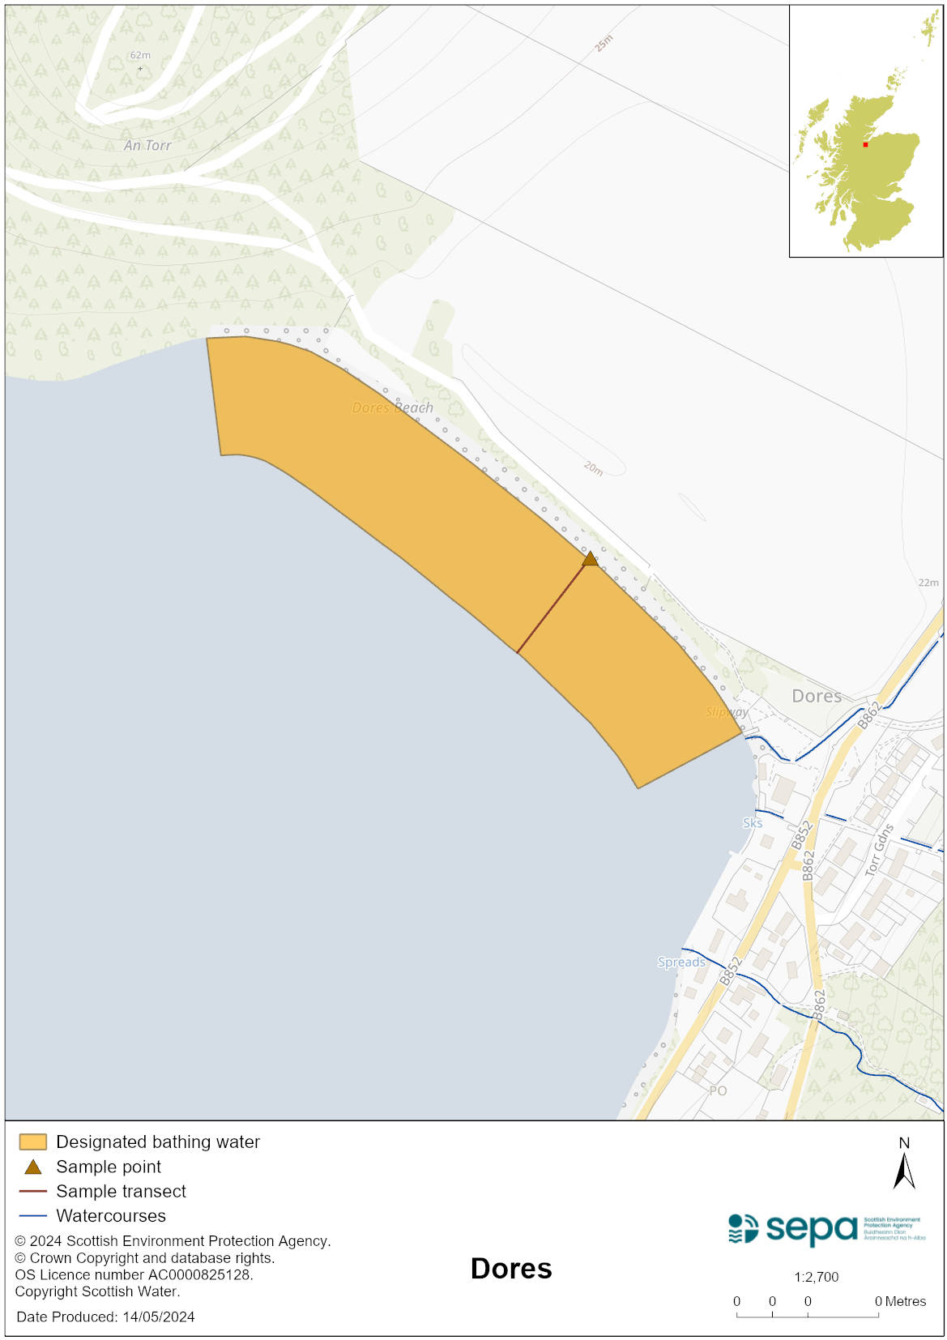

Map 2: Catchment draining into Dores bathing water
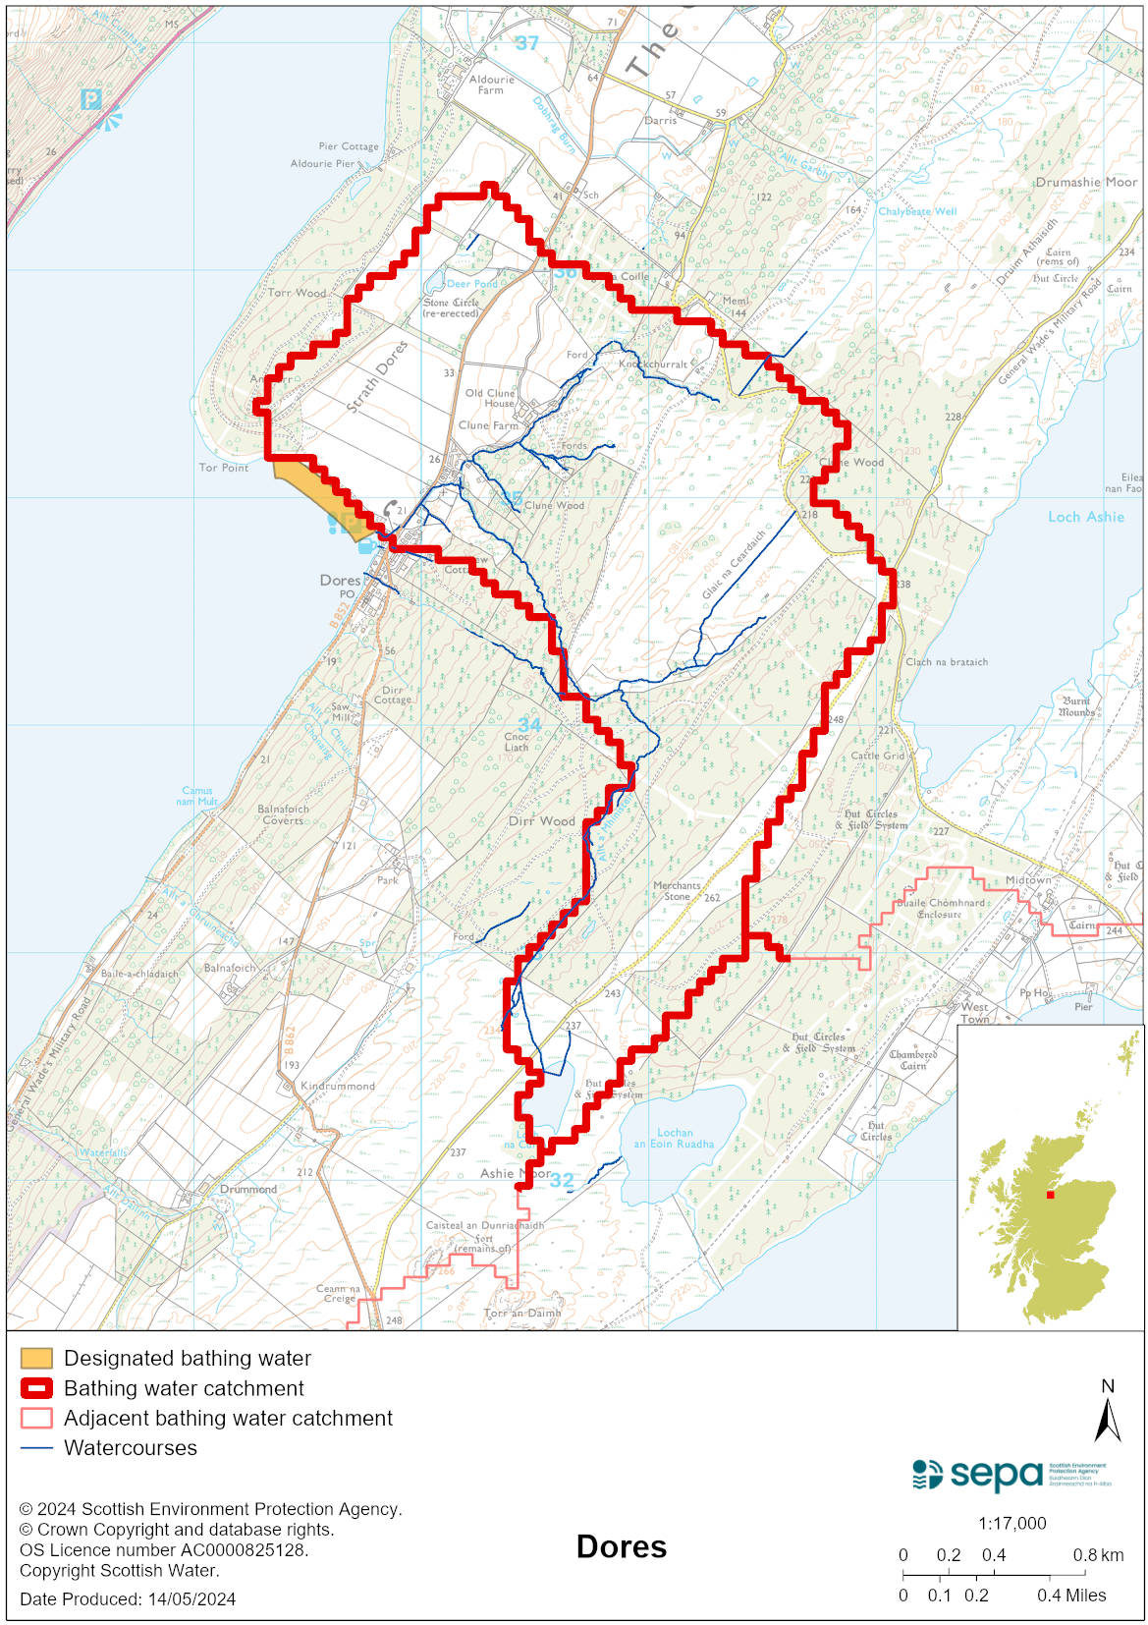

Improving bathing water quality

Sewage
Scottish Water provides most waste water collection and treatment services in Scotland.
The septic tank serving the village of Dores discharges via an extended outfall into Loch Ness. There are septic tanks in the catchment which have the potential to affect water quality at Dores bathing water.

Agriculture
Diffuse pollution from agricultural sources is the result of rain driven events causing cumulative inputs of pollutants to rivers and streams.

There is potential for agricultural diffuse pollution to occur in the River Ness. This is a risk to Dores bathing water quality, particularly during periods of wet weather.

SEPA continues to work with farmers in the area to promote good agricultural practices. Work to address diffuse pollution issues is expected to be completed by 2027.

Cyanobacteria (blue-green algae), algae and jellyfish
Marine waters are not at risk of cyanobacteria overproduction. This bathing water is not at risk of excessive growth of macroalgae (seaweed) or phytoplankton.

The possibility of increased jellyfish numbers in the water during summer months is a naturally occurring phenomenon. Most species common to the UK are harmless; the Marine Conservation Society advises to ‘look but don’t touch’.

Pollution incidents
Pollution can be reported via our website online form or by calling our 24 hours a day Pollution Hotline number 0800 80 70 60

If pollution is reported to us, or identified by our routine water quality monitoring program, we will investigate and where necessary work with others to remediate. We may contact other relevant organisations including the local authority, that local health board, Scottish Water and Scottish Ministers.

If there is a risk to human health the local authority is responsible for placing signs at the bathing water. Information will also be available on our website.

Everyone can help to keep the bathing water clean:
- If you visit the beach with your dog clear up any fouling
- Don’t leave litter or feed birds - this encourages unnatural behaviour, and they can pollute the water
- At home, don’t flush wipes or other inappropriate items as these can block pipes and cause sewage spills

Contact details and information sources

SEPA bathing waters homepage

SEPA rainfall data

Scottish Government protected waters homepage

Highland Council

For information on accessing this document in an alternative format or language, please contact SEPA by emailing equalities@sepa.org.uk
If you are a user of British Sign Language (BSL), the Contact Scotland BSL service gives you access to an online interpreter, enabling you to communicate with us using sign language. contactscotland-bsl.org

