Bathing water profile - Monifieth
Bathing water classification

Bathing water description
Monifieth bathing water is a long, sandy beach on the north shore of the Firth of Tay. At low tide areas of rock and mud are exposed near the waterline. Monifieth is adjacent to Monifieth town and is only 5km from Dundee. Depending on the tide, the distance to the water’s edge can vary from 0-450m. The beach slopes gently towards the water.

Site details
- Local authority: Angus Council
- Year of designation: 2011
- Water sampling location: NO 50000 32000

Risks to water quality
This bathing water is subject to short term pollution following heavy rainfall. Bathing is not advised during or 1-2 days after heavy rainfall due to the risk to bathers’ health from water pollution.

Pollution risks include agricultural run-off and sewer overflows.

Water quality forecasts
As water quality is likely to be impacted by rainfall we make daily predictions of good or poor bathing water quality. We advise against bathing when poor water quality is predicted as there is an increased risk to bathers’ health from water pollution.

These predictions are displayed on the electronic sign at the beach and online between 15 May and 15 September.

Catchment description
The Monifieth bathing water catchment extends to 7.1km2. The catchment is low-lying with a maximum elevation of 110m at Laws Hill at the northern end. The lower half of the catchment is mainly urban and includes the town of Monifieth.
The only river within the catchment is the Monifieth Burn. Outside the catchment is the Dighty Water which enters the coastline 500m west of the bathing water. The Buddon Burn enters the sea just 700m to the east.
The main population centres are Dundee, and the two small coastal towns of Monifieth and Broughty Ferry. Population density outside of the towns is low.
There are several protected areas either fully or partly within the bathing water or catchment. This includes a Special Area of Conservation (SAC), a Special Protection Area, a Site of Special Scientific Interest (SSSI) and a Ramsar site. The Strathmore/Fife area was a Nitrate Vulnerable Zone in 2002.

Map 1: Monifieth bathing water
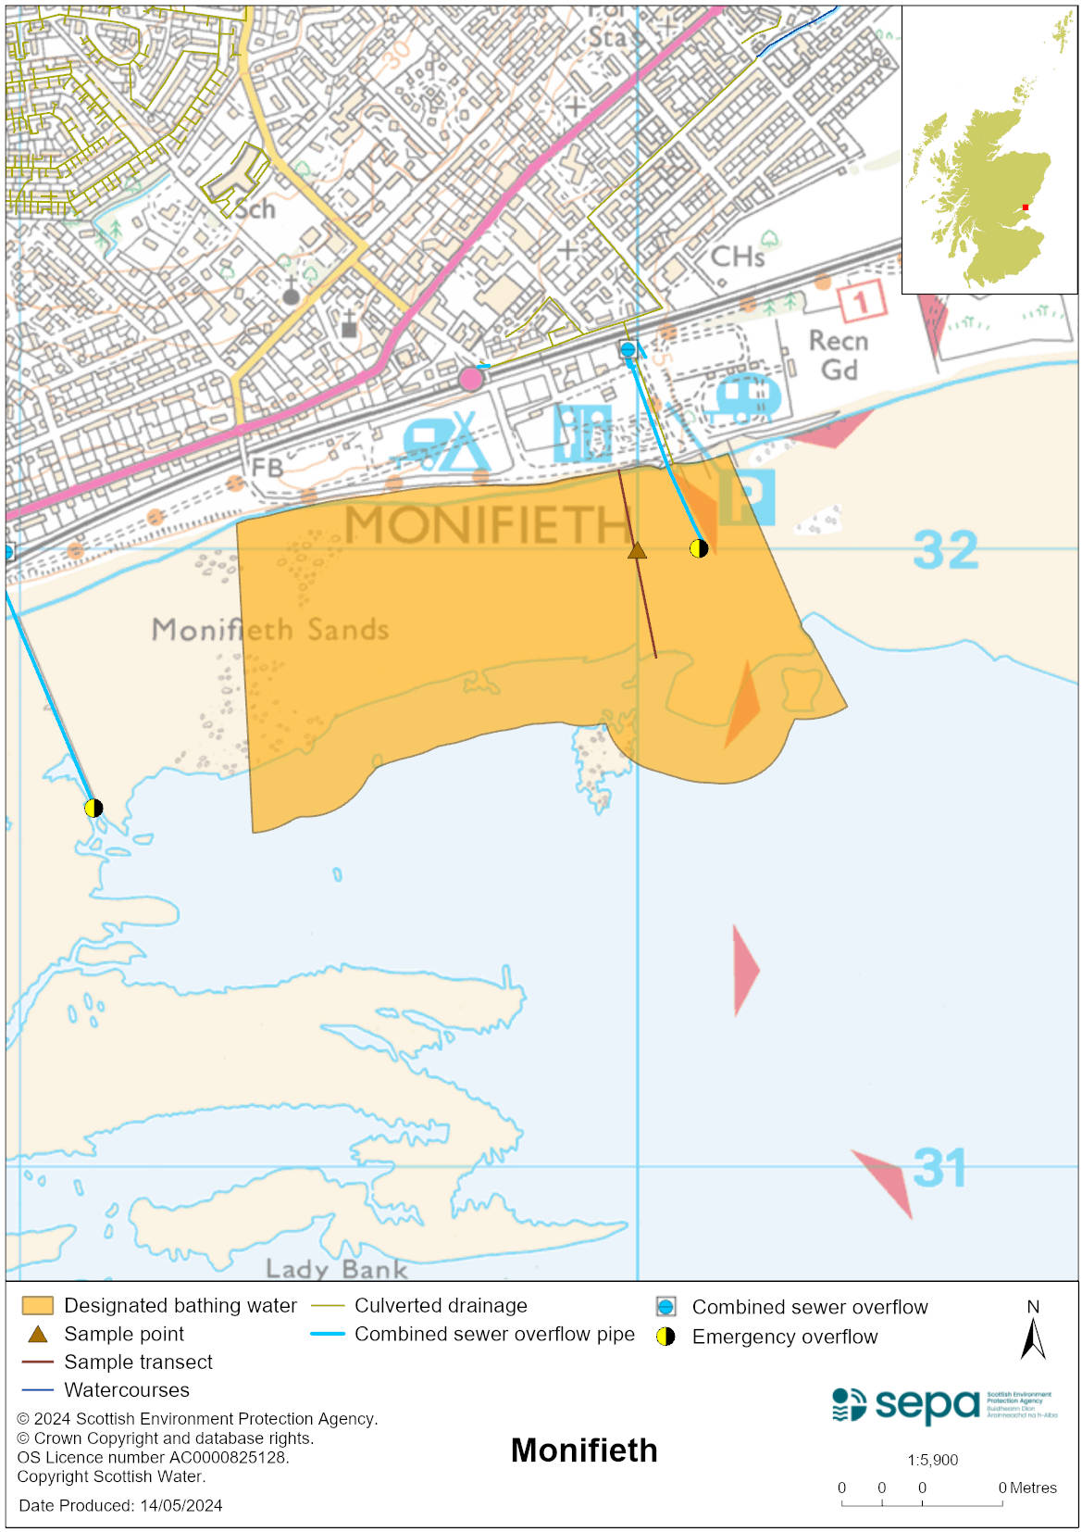

Map 2: Catchment draining into Monifieth bathing water
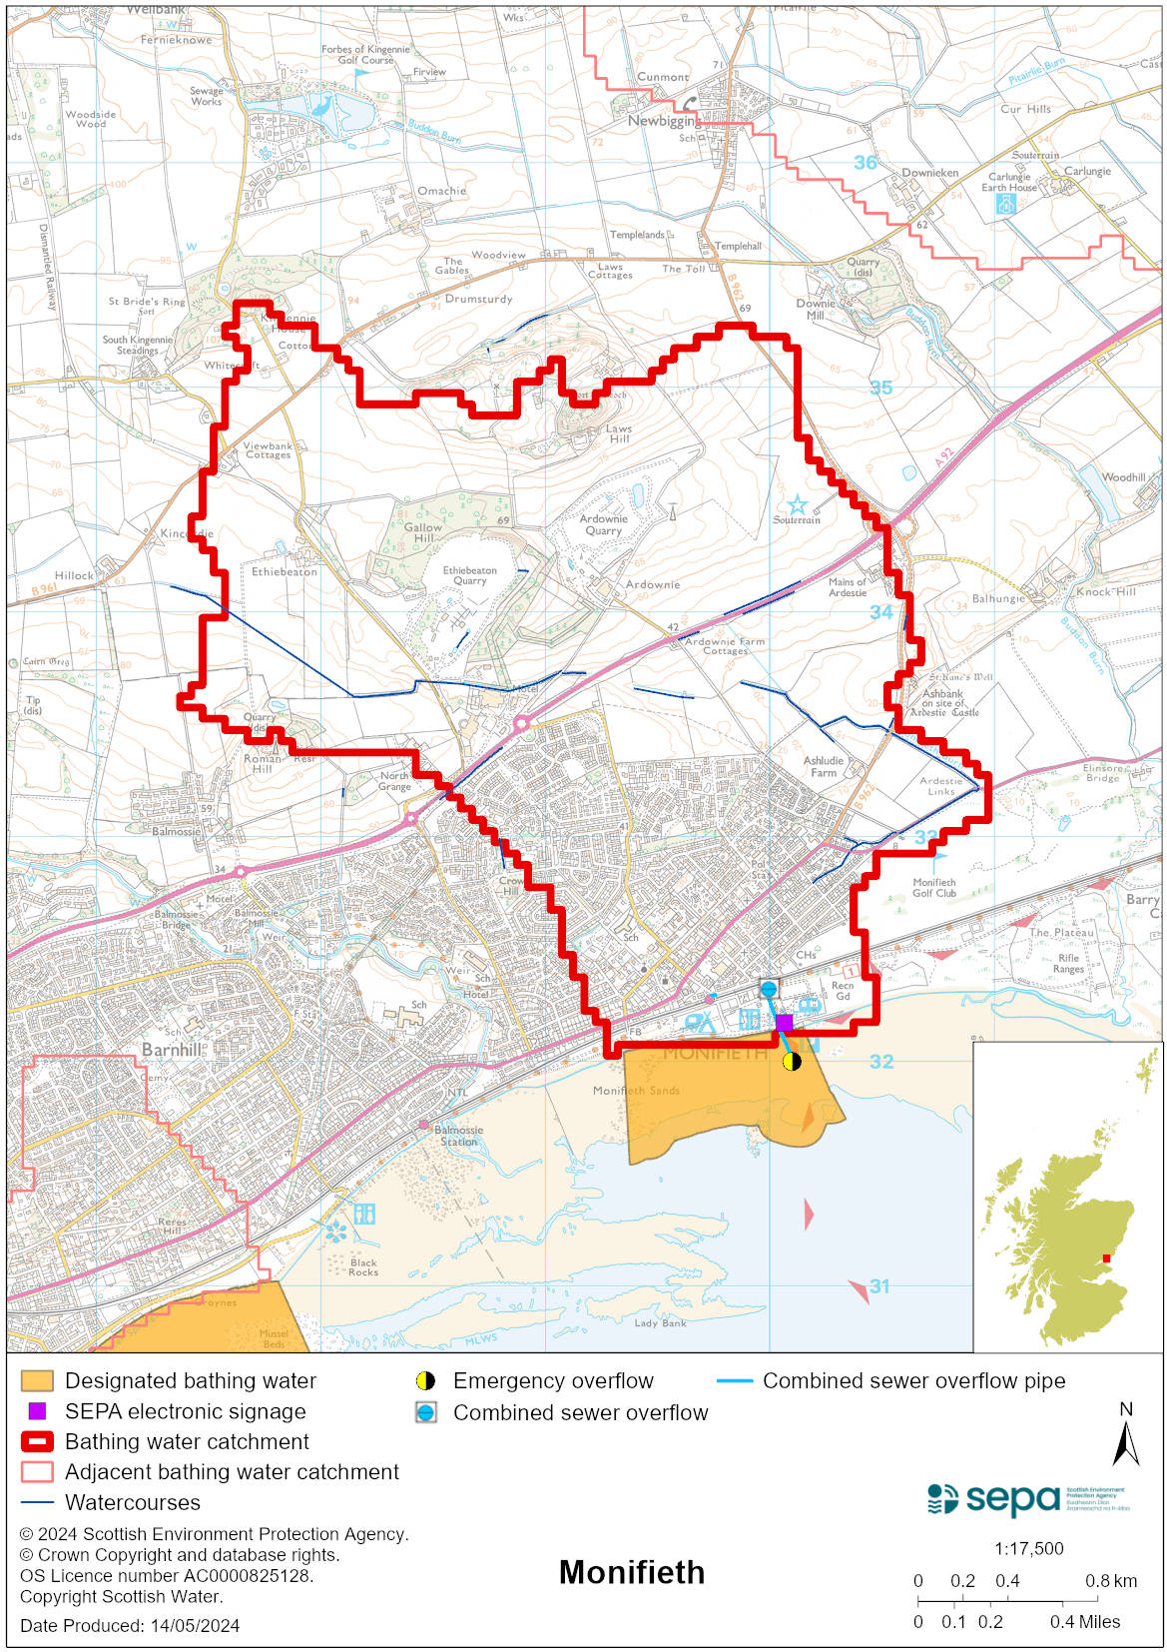

Improving bathing water quality

Sewage
Scottish Water provides most waste water collection and treatment services in Scotland.

Sewage from the Dundee area is treated at Hatton sewage treatment works.

There is a combined sewage overflow (CSO) at Balmossie Mill pumping station which enters the Dighty Water at Panmuirfield, west of the bathing water. The village of Newbigging discharges treated effluent to upper stretches of the Buddon Burn which enters the sea to the west. There is a quarry discharge to Monifieth Burn and some private septic tanks. Under normal conditions the loadings to these burns should not impact upon the bathing water.

Burgh yard pumping station has a combined sewer overflow (CSO) and emergency overflow (EO) with a discharge location to the bathing water. Grange Rd pumping station has a CSO and EO with a discharge location to the west of the designated area. The CSOs may discharge and impact the bathing water during heavy rainfall. The EOs should only discharge under rare, abnormal circumstances.

Agriculture
Diffuse pollution from agricultural sources is the result of rain driven events causing cumulative inputs of pollutants to rivers and streams.

There is potential for agricultural diffuse pollution to occur in Dighty Water. This is a risk to the bathing water quality, particularly during and after periods of wet weather.

Farm visits have been on going in the Monifieth bathing water catchment since 2015.

SEPA will continue to work with rural land managers in these catchments to reduce the risk of pollution to the bathing water.

Cyanobacteria (blue-green algae), algae and jellyfish
Marine waters are not at risk of cyanobacteria overproduction. This bathing water is not at risk of excessive growth of macroalgae (seaweed) or phytoplankton.

The possibility of increased jellyfish numbers in the water during summer months is a naturally occurring phenomenon. Most species common to the UK are harmless; the Marine Conservation Society advises to ‘look but don’t touch’.

Pollution incidents
Pollution can be reported via our website online form or by calling our 24 hours a day Pollution Hotline number 0800 80 70 60

If pollution is reported to us, or identified by our routine water quality monitoring program, we will investigate and where necessary work with others to remediate. We may contact other relevant organisations including the local authority, that local health board, Scottish Water and Scottish Ministers.

If there is a risk to human health the local authority is responsible for placing signs at the bathing water. Information will also be available on our website.

Everyone can help to keep the bathing water clean:
- If you visit the beach with your dog clear up any fouling
- Don’t leave litter or feed birds - this encourages unnatural behaviour, and they can pollute the water
- At home, don’t flush wipes or other inappropriate items as these can block pipes and cause sewage spills

Contact details and information sources

SEPA bathing waters homepage

SEPA rainfall data

Scottish Government protected waters homepage

Angus Council

For information on accessing this document in an alternative format or language, please contact SEPA by emailing equalities@sepa.org.uk
If you are a user of British Sign Language (BSL), the Contact Scotland BSL service gives you access to an online interpreter, enabling you to communicate with us using sign language. contactscotland-bsl.org

