Bathing water profile – Arbroath (West Links)
Bathing water classification

Bathing water description
The Arbroath (West Links) bathing water is a 1.3 km sandy bay to the southwest of Arbroath in Angus. The beach is popular due to a coastal footpath and a nearby recreational area. Depending on the tide, the approximate distance to the water’s edge can vary from 20–200 metres. The sandy beach slopes gently towards the water.

Site details:
- Local authority: Angus Council
- Year of designation: 1987
- Water sampling location: NO 6351 3998

Risks to water quality
This bathing water is at risk of short term pollution following heavy rainfall. Bathing is not advised during or 1-2 days after heavy rainfall due to the risk to bathers’ health from water pollution.

Pollution risks include sewer overflows.

Catchment description
The catchment draining into Arbroath (West Links) bathing water extends to 44 km2. It varies from low-lying areas along the coast to low hills in the west. The catchment is predominantly rural (96%) with arable agriculture the major land use. There is also some beef and sheep farming in the area. Approximately 4% of the bathing water catchment is urban with Arbroath being the main urban area. There are also several small settlements within the catchment.

The main rivers within the bathing water catchment are the Elliot Water, the Geordies Burn and Brothock Water.

Within the catchment is the Elliot Links Site of Special Scientific Interest (SSSI), designated for its sand dunes. The Strathmore/Fife area was designated as a Nitrate Vulnerable Zone in 2002.

Map 1: Arbroath (West Links) bathing water
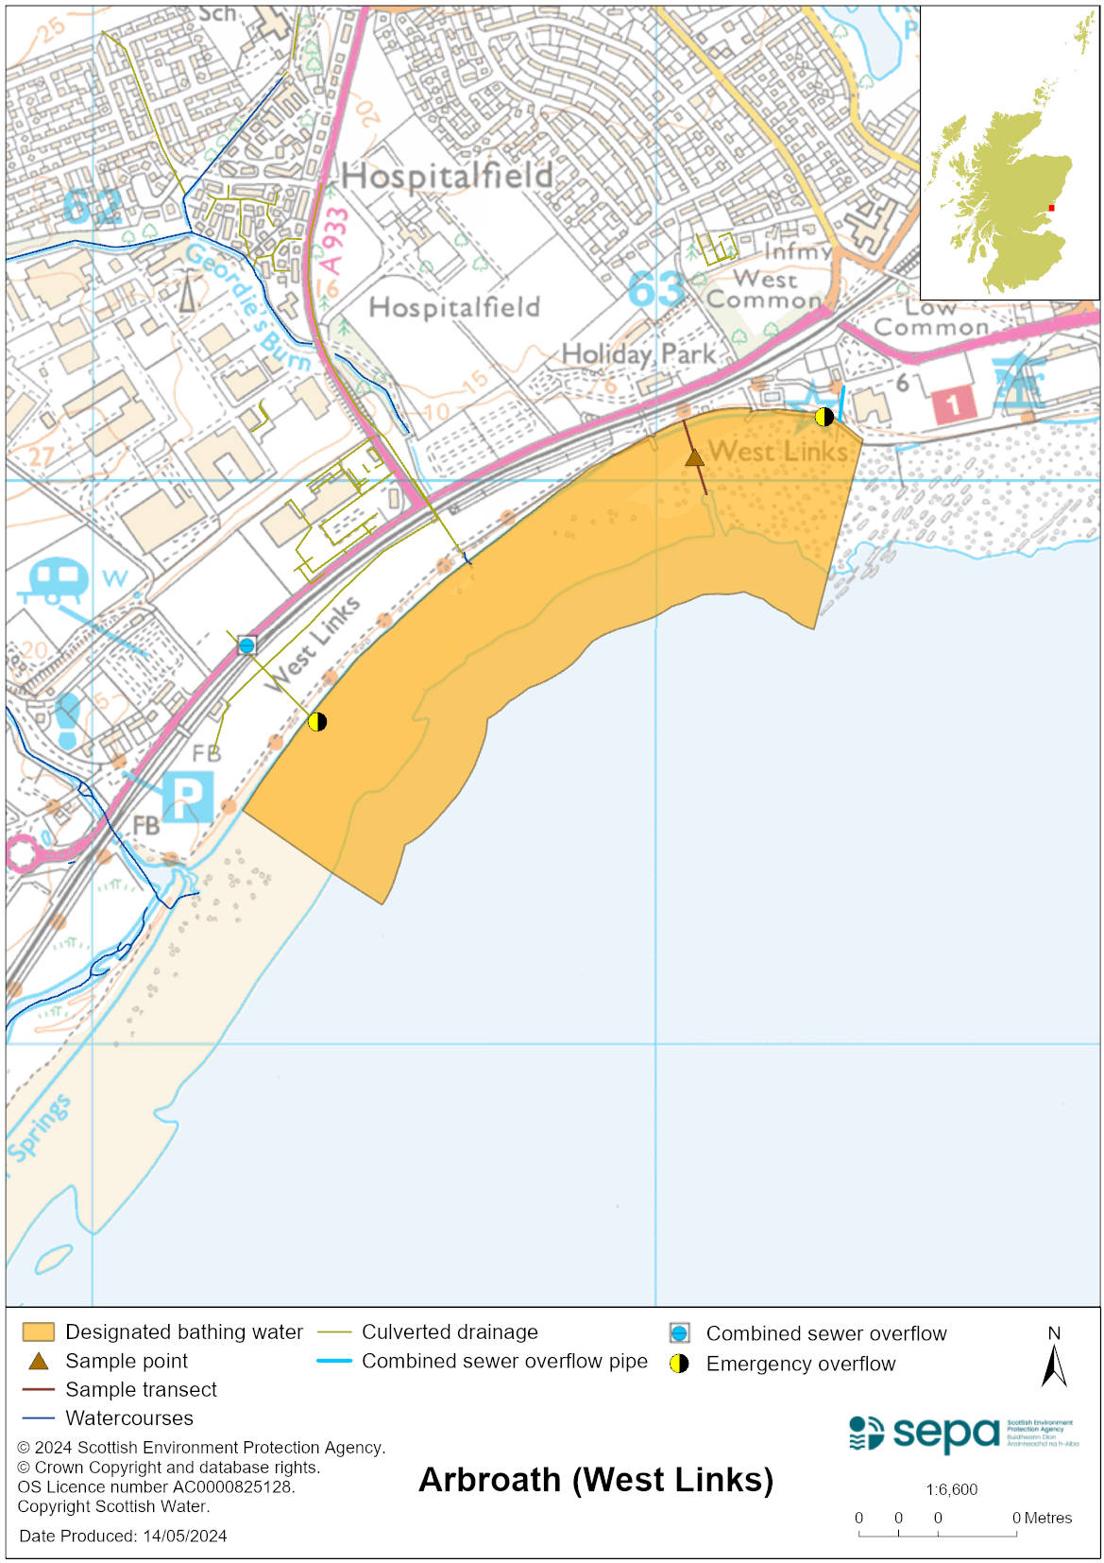

Map 2: Catchment draining into Arbroath (West Links) bathing water
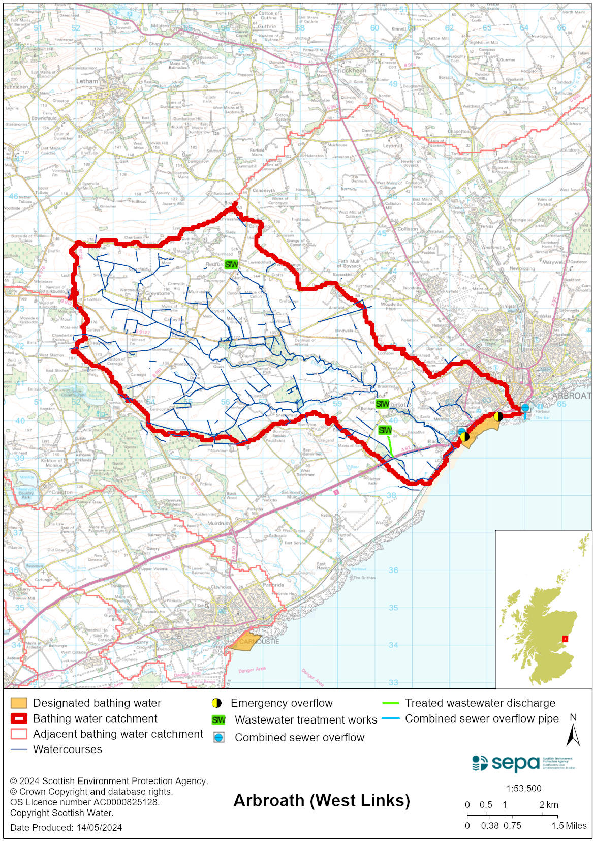

Improving bathing water quality

Sewage
Scottish Water provides most waste water collection and treatment services in Scotland.

Sewage is treated at Hatton sewage treatment works. Inchcape pumping station provides storage for storm sewage storage.

There are combined sewage overflows and/or emergency overflows at four other smaller pumping stations in the area.

Agriculture
There are no impacts from agriculture affecting this bathing water.

Cyanobacteria (blue-green algae), algae and jellyfish
Marine waters are not at risk of cyanobacteria overproduction. This bathing water is not at risk of excessive growth of macroalgae (seaweed) or phytoplankton.

The possibility of increased jellyfish numbers in the water during summer months is a naturally occurring phenomenon. Most species common to the UK are harmless; the Marine Conservation Society advises to ‘look but don’t touch’.

Pollution incidents
Pollution can be reported via our website online form or by calling our 24 hours a day Pollution Hotline number 0800 80 70 60

If pollution is reported to us, or identified by our routine water quality monitoring program, we will investigate and where necessary work with others to remediate. We may contact other relevant organisations including the local authority, that local health board, Scottish Water and Scottish Ministers.

If there is a risk to human health the local authority is responsible for placing signs at the bathing water. Information will also be available on our website.

Everyone can help to keep the bathing water clean:
- If you visit the beach with your dog clear up any fouling
- Don’t leave litter or feed birds - this encourages unnatural behaviour, and they can pollute the water
- At home, don’t flush wipes or other inappropriate items as these can block pipes and cause sewage spills

Contact details and information sources

SEPA bathing waters homepage

SEPA rainfall data

Scottish Government protected waters homepage

Angus Council

For information on accessing this document in an alternative format or language, please contact SEPA by emailing equalities@sepa.org.uk
If you are a user of British Sign Language (BSL), the Contact Scotland BSL service gives you access to an online interpreter, enabling you to communicate with us using sign language. contactscotland-bsl.org

