Bathing water profile – Fraserburgh (Philorth)
Bathing water classification

Bathing water description
Fraserburgh (Philorth) bathing water is on the north coast of Aberdeenshire. It is close to the town of Fraserburgh and near the Waters of Philorth nature reserve. It is an extensive sandy beach, about 2 km long. It is backed by dunes and slopes gently towards the water. The beach is popular for recreation, surfing, and windsurfing. Depending on the tide, the distance to the water’s edge can vary from 0–130 metres.

Site details:
- Local authority: Aberdeenshire Council
- Year of designation: 1999
- Water sampling location: NK 02120 65050

Risks to water quality
This bathing water is at risk of short term pollution following heavy rainfall. Bathing is not advised during or 1-2 days after heavy rainfall due to the risk to bathers’ health from water pollution.

Pollution risks include agricultural run-off.

Catchment description
The catchment draining into this bathing water extends to 66 km2. It varies from higher hills in the west and south to the low-lying plains along the coast. The main river in the bathing water catchment is the Water of Philorth, which flows into to the east of the bathing area.
The catchment is mainly rural (98%), with agriculture the major land use. The agricultural land is split between arable farming (53%) and grassland (34%). About 1% of the catchment is urban. The main population centre is the coastal town of Fraserburgh, approximately 1.5 km west of the bathing water. Population density outside the town is low and centred around many small villages.

Map 1: Fraserburgh (Philorth) bathing water
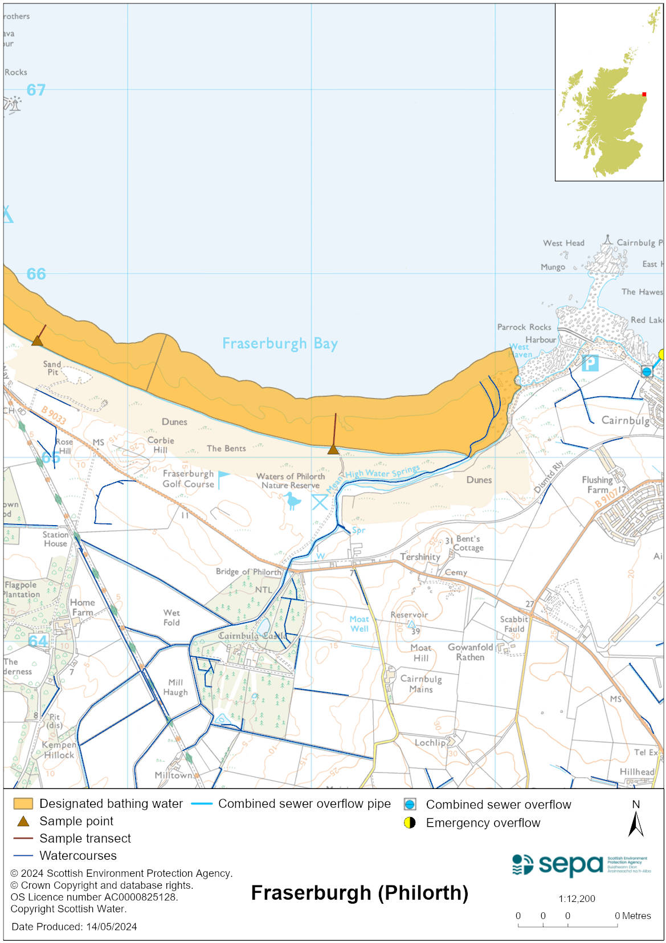

Map 2: Catchment draining into Fraserburgh (Philorth) bathing water
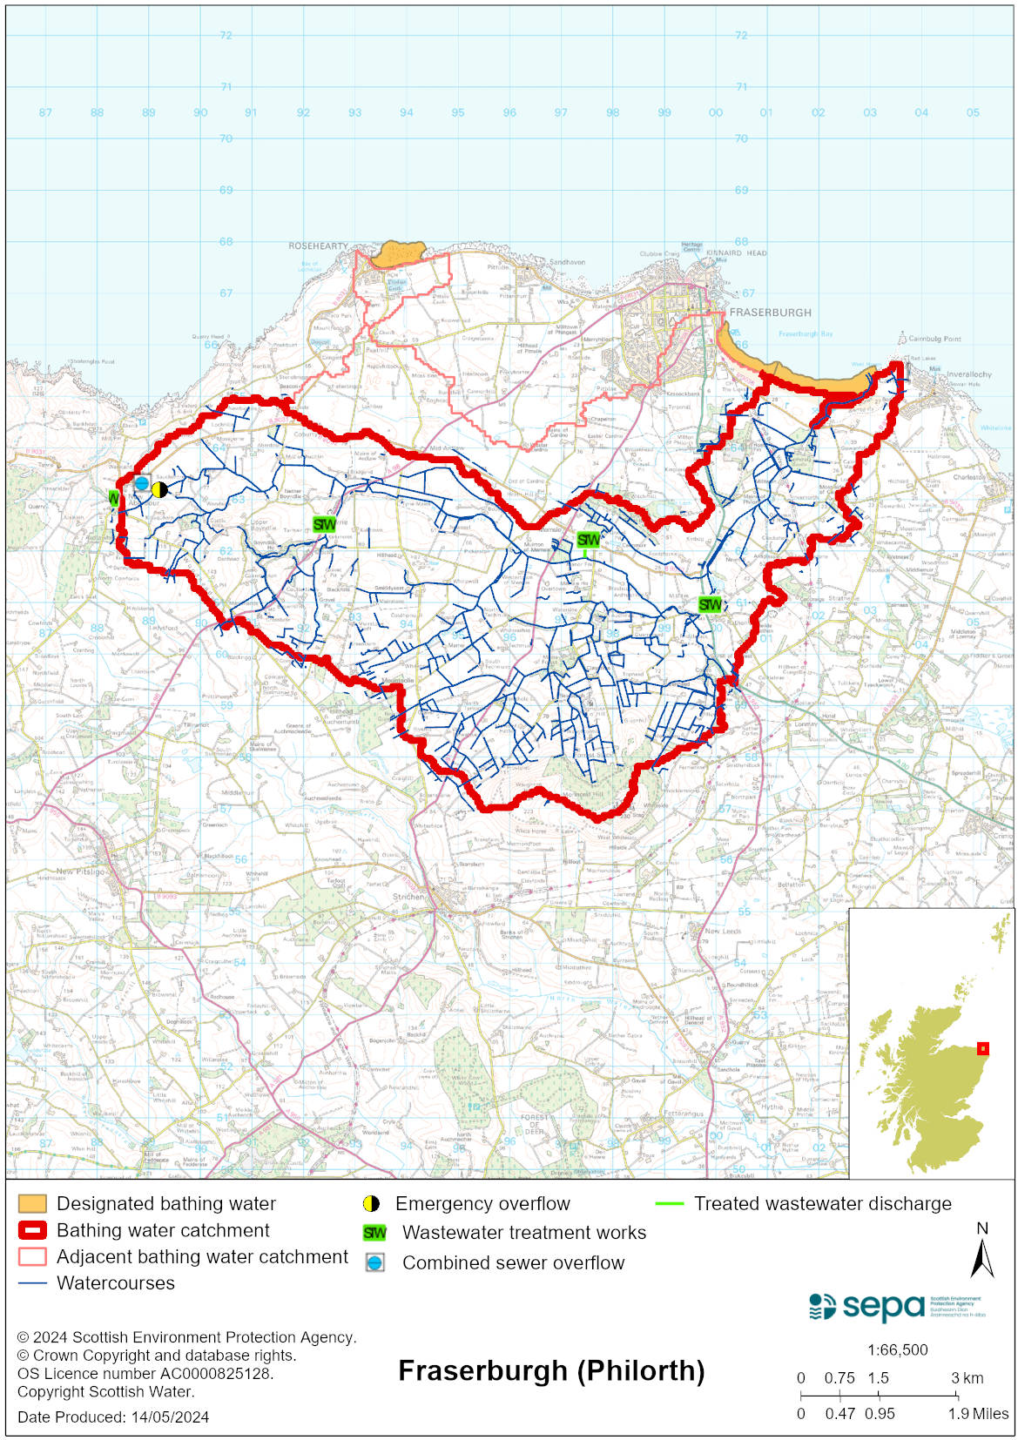

Improving bathing water quality

Sewage
Scottish Water provides most waste water collection and treatment services in Scotland.
Sewage is treated at Fraserburgh sewage treatment works before being discharged. These works are not considered to impact bathing water quality. Whilst there are many septic tank discharges from the Rathen and Memsie settlements, our evidence shows that they do not significantly affect bathing water quality.

Agriculture
Diffuse pollution from agricultural sources is the result of rain driven events causing cumulative inputs of pollutants to rivers and streams.

There is potential for agricultural diffuse pollution to occur in the Water of Philorth which could impact on the bathing beach following heavy rain.

Farm visits in this area were undertaken as part of the Buchan Coastal priority catchment campaign during 2015. These visits looked to identify diffuse pollution sources and pathways. Mitigation measures to reduce the risk of bacterial pollution on water quality were agreed with land managers.

SEPA has observed significant changes in land management practice within the catchments and will continue to work with farmers to reduce the risk of pollution to the bathing water.

Cyanobacteria (blue-green algae), algae and jellyfish
Marine waters are not at risk of cyanobacteria overproduction. This bathing water is not at risk of excessive growth of macroalgae (seaweed) or phytoplankton.

The possibility of increased jellyfish numbers in the water during summer months is a naturally occurring phenomenon. Most species common to the UK are harmless; the Marine Conservation Society advises to ‘look but don’t touch’.

Pollution incidents
Pollution can be reported via our website online form or by calling our 24 hours a day Pollution Hotline number 0800 80 70 60

If pollution is reported to us, or identified by our routine water quality monitoring program, we will investigate and where necessary work with others to remediate. We may contact other relevant organisations including the local authority, that local health board, Scottish Water and Scottish Ministers.

If there is a risk to human health the local authority is responsible for placing signs at the bathing water. Information will also be available on our website.

Everyone can help to keep the bathing water clean:
- If you visit the beach with your dog clear up any fouling
- Don’t leave litter or feed birds - this encourages unnatural behaviour, and they can pollute the water
- At home, don’t flush wipes or other inappropriate items as these can block pipes and cause sewage spills

Contact details and information sources

SEPA bathing waters homepage

SEPA rainfall data

Scottish Government protected waters homepage

Aberdeenshire Council

For information on accessing this document in an alternative format or language, please contact SEPA by emailing equalities@sepa.org.uk
If you are a user of British Sign Language (BSL), the Contact Scotland BSL service gives you access to an online interpreter, enabling you to communicate with us using sign language. contactscotland-bsl.org

