Bathing water profile – Brighouse Bay
Bathing water classification

Bathing water description
Brighouse Bay bathing water is a small, sheltered, sandy beach interspersed with rocky outcrops. The bay is about 300 metres wide. It is close to the village of Borgue, on the south coast of Dumfries and Galloway. Brighouse Bay Golf and Leisure Club is adjacent to the bay. Depending on the tide, the approximate distance to the water’s edge can vary from 0-600 metres. Mud flats are exposed at low tide making the water’s edge difficult to access in certain areas.

Site details:
- Local authority: Dumfries & Galloway Council
- Year of designation: 1999
- Water sampling location: NX 63516 45472

Risks to water quality
This bathing water is subject to short term pollution following heavy rainfall. Bathing is not advised during or 1-2 days after heavy rainfall due to the risk to bathers’ health from water pollution.

Pollution risks include agricultural run-off and sewerage sources.

Water quality forecasts
As water quality is likely to be impacted by rainfall we make daily predictions of good or poor bathing water quality. We advise against bathing when poor water quality is predicted as there is an increased risk to bathers’ health from water pollution.

These predictions are displayed on the electronic sign at the beach and online between 15 May and 15 September.

Catchment description
A catchment area of 8.4 km2 drains into Brighouse Bay bathing water. It is a hilly catchment that includes Cairniehill and the Mull of Ross to the southeast of the bay. Brighouse Burn enters the bay midway along the beach.
Agriculture is the major land use in the catchment. There are several dairy farms with the surrounding land being used as pasture. Urban land use is concentrated around the Borgue and Kirkcudbright population centres.
Average summer rainfall for the region is 356 mm compared to 331 mm across Scotland as a whole.

Map 1: Brighouse Bay bathing water
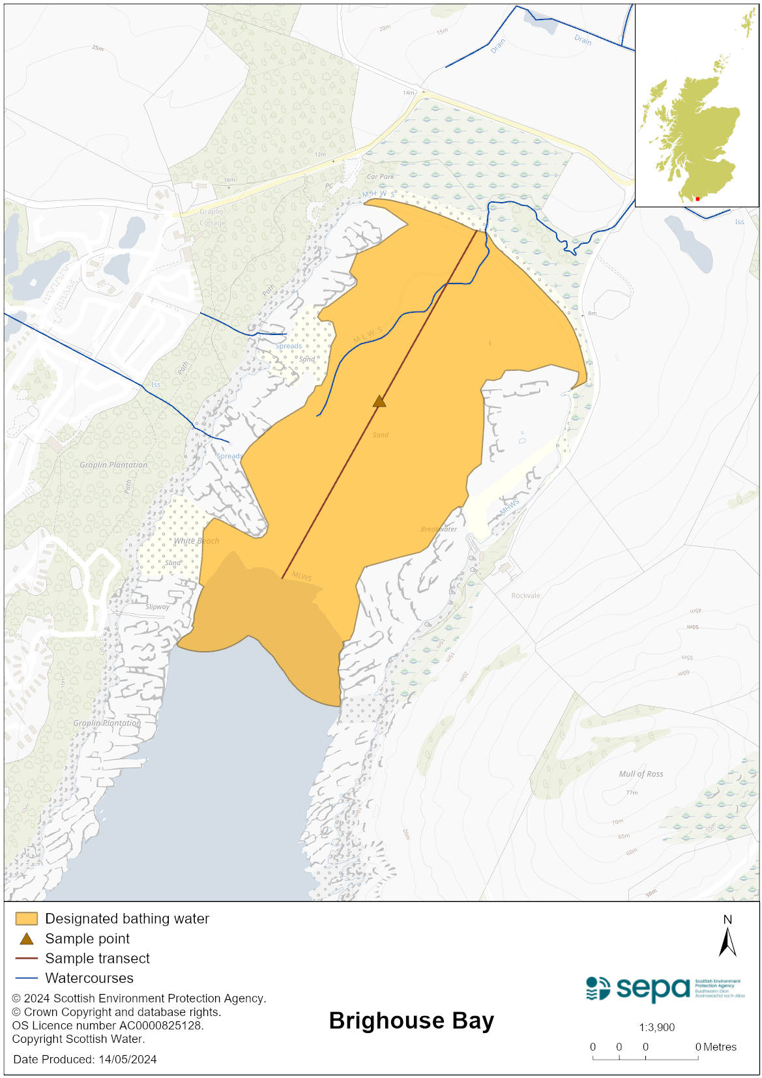

Map 2: Catchment draining into Brighouse Bay bathing water
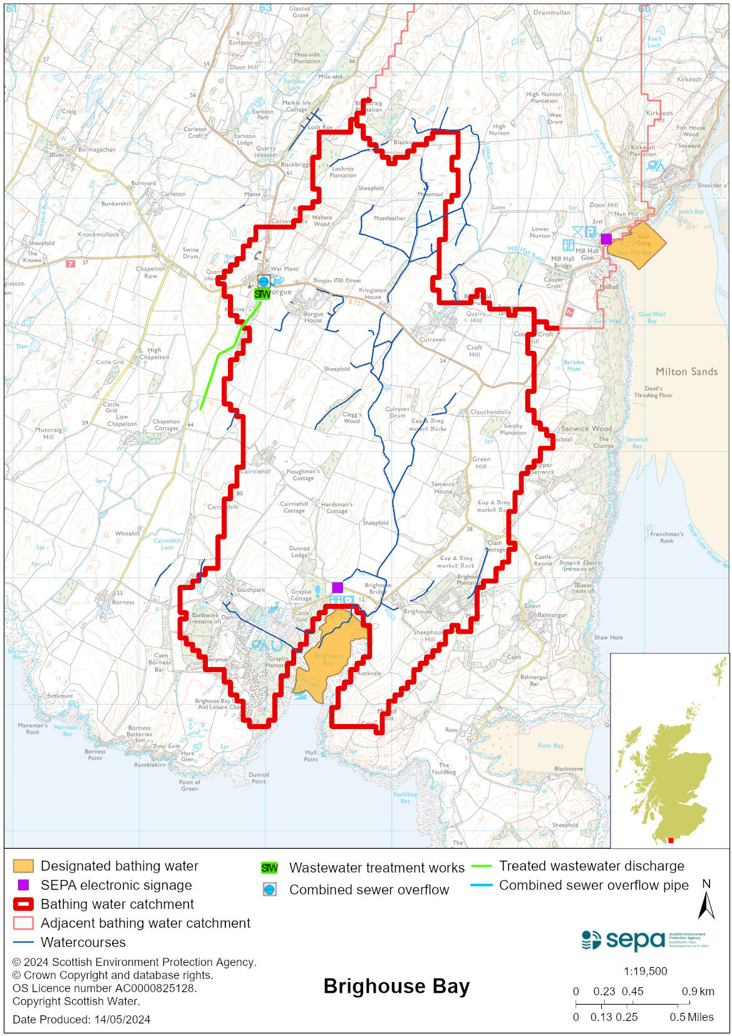

Improving bathing water quality

Sewage
Scottish Water provides most waste water collection and treatment services in Scotland.
There are no Scottish Water assets in the immediate vicinity of this bathing water. There is a combined sewer overflow at Borgue at the top of the Brighouse Burn catchment but it is not thought to affect water quality.

The private sewage treatment works serving the caravan park at Brighouse discharges around a headland out with the bathing water and is not considered to impact on the bathing water. In 2022, sampling of the minor watercourses flowing through the caravan park into the bay was undertaken to assess if there was any impact from the caravan park but no issues were found.

There are private septic tanks which discharge to the Brighouse Burn. The private septic tanks near Borgue are considered to be far enough up the catchment not to have an impact on the bathing water.

Agriculture
Diffuse pollution from agricultural sources is the result of cumulative inputs of pollutants to rivers and streams.

The majority of farms within the Brighouse Bay area support dairy cows, although there are some sheep and beef farms in upland areas. Brighouse Bay is located within the Galloway Coastal catchment. Farm visits to identify diffuse pollution sources took place in May and June 2014 and mitigation measures were agreed. All agricultural compliance work has been completed in this bathing water catchment and all farms are in a compliant state.

SEPA will continue to engage with farmers and the NFUS to remind them of good practice when applying slurries and manures and grazing livestock.

Cyanobacteria (blue-green algae), algae and jellyfish
Marine waters are not at risk of cyanobacteria overproduction. This bathing water is not at risk of excessive growth of macroalgae (seaweed) or phytoplankton.

The possibility of increased jellyfish numbers in the water during summer months is a naturally occurring phenomenon. Most species common to the UK are harmless; the Marine Conservation Society advises to ‘look but don’t touch’.

Pollution incidents
Pollution can be reported via our website online form or by calling our 24 hours a day Pollution Hotline number 0800 80 70 60

If pollution is reported to us, or identified by our routine water quality monitoring program, we will investigate and where necessary work with others to remediate. We may contact other relevant organisations including the local authority, that local health board, Scottish Water and Scottish Ministers.

If there is a risk to human health the local authority is responsible for placing signs at the bathing water. Information will also be available on our website.

Everyone can help to keep the bathing water clean:
- If you visit the beach with your dog clear up any fouling
- Don’t leave litter or feed birds - this encourages unnatural behaviour, and they can pollute the water
- At home, don’t flush wipes or other inappropriate items as these can block pipes and cause sewage spills

Contact details and information sources

SEPA bathing waters homepage

SEPA rainfall data

Scottish Government protected waters homepage

Dumfries and Galloway Council

For information on accessing this document in an alternative format or language, please contact SEPA by emailing equalities@sepa.org.uk
If you are a user of British Sign Language (BSL), the Contact Scotland BSL service gives you access to an online interpreter, enabling you to communicate with us using sign language. contactscotland-bsl.org

