Bathing water profile – Troon (South Beach)
Bathing water classification

Bathing water description
Troon (South Beach) bathing water is located at the most northern point of Ayr Bay, beside the seaside town of Troon and offers spectacular views of the Ailsa Craig and Lady Isle. The beach is approximately 2 km long with rocky outcrops at both the ends of the bay. Sand dunes at the southern end of beach continue along the coastline as far as Prestwick.

The sandy beach slopes gently towards the water and depending on the tide, there can be 0-320 metres before the water’s edge.

Site details:
- Local authority: South Ayrshire Council
- Year of designation: 1987
- Water sampling location: NS 32070 30620

Risks to water quality
This bathing water is subject to short term pollution following heavy rainfall. Bathing is not advised during or 1-2 days after heavy rainfall due to the risk to bathers’ health from water pollution.

Water quality forecasts
As water quality is likely to be impacted by rainfall we make daily predictions of good or poor bathing water quality. We advise against bathing when poor water quality is predicted as there is an increased risk to bathers’ health from water pollution.

These predictions are displayed on the electronic sign at the beach and online between 15 May and 15 September.

Catchment description
A catchment of 4.3km2 drains into Troon (South Beach) bathing water. The catchment has a mixture of urban (50%) and rural (50%) land use. The area close to the beach is mainly urban while the surrounding area is primarily grassland. The main population centre within the catchment is the seaside town of Troon which is immediately adjacent to the bathing water.

There are no direct freshwater inputs into the designated bathing water. The Pow Burn discharges to sea to the south of the bathing water and the Darley Burn into Troon’s north bay. These burns may be prone to elevated bacterial levels during periods of wet weather but are not thought to have a significant effect on the bathing water.

The southern end of the Troon bathing water has been designated as a Site of Special Scientific Interest (SSSI).

Map 1: Troon (South Beach) bathing water
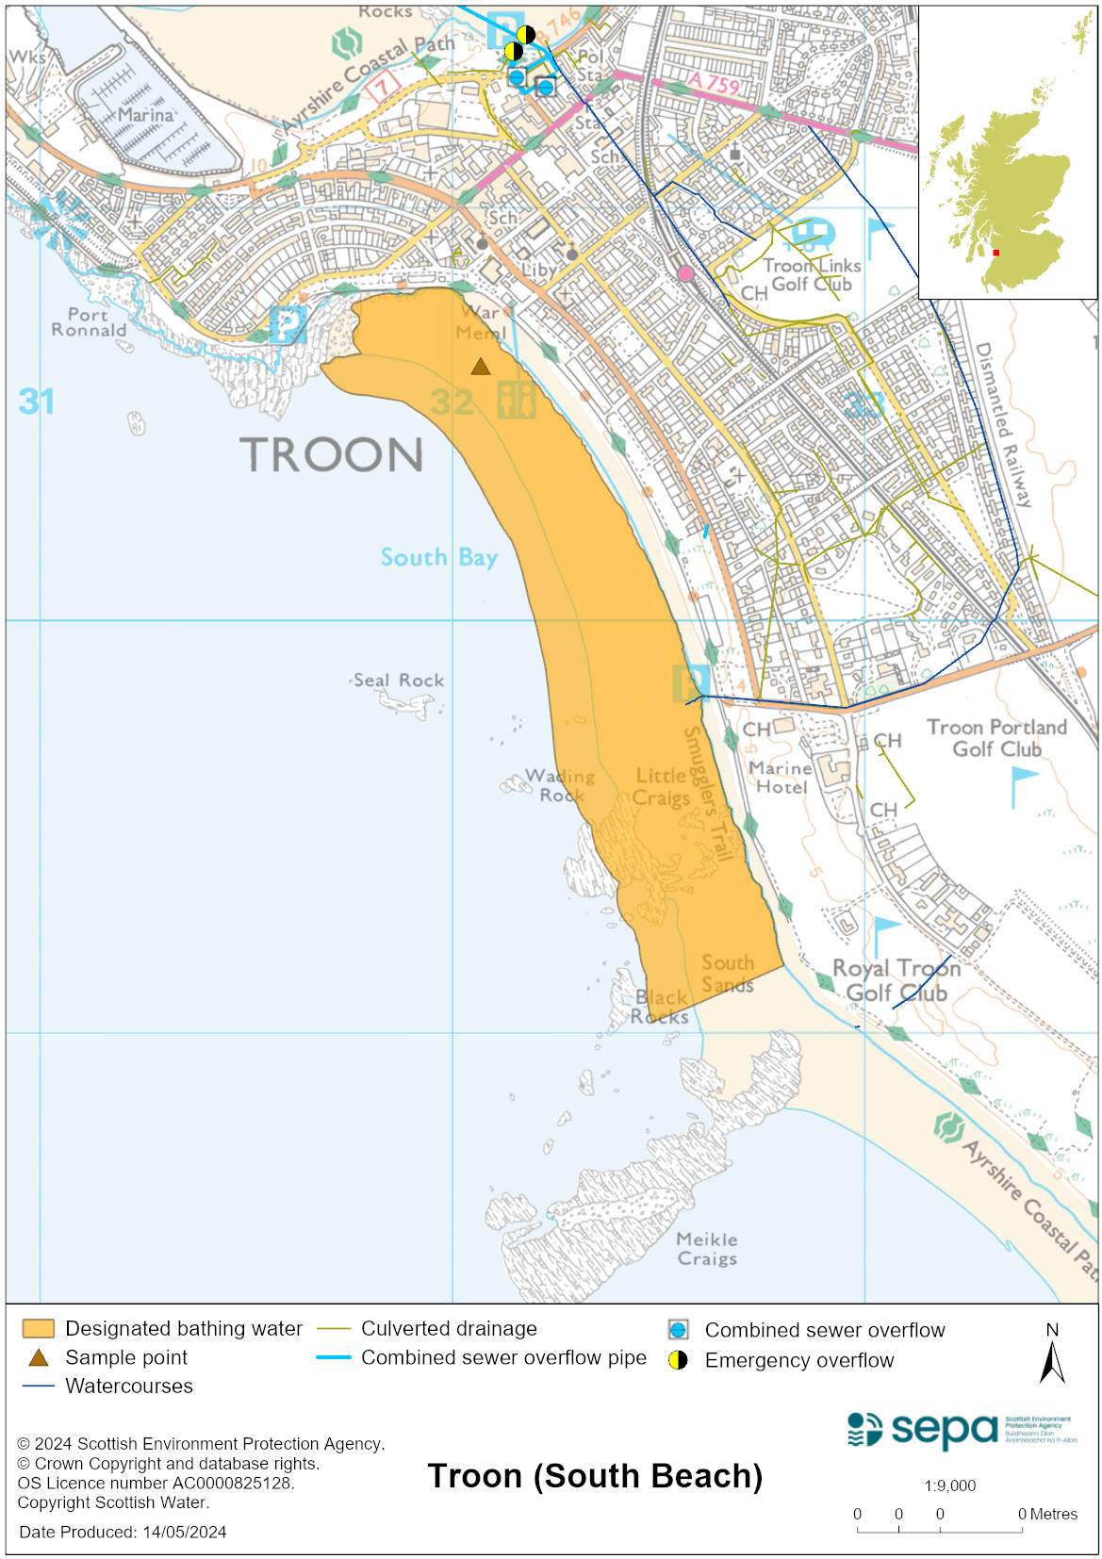

Map 2: Catchment draining into Troon (South Beach) bathing water
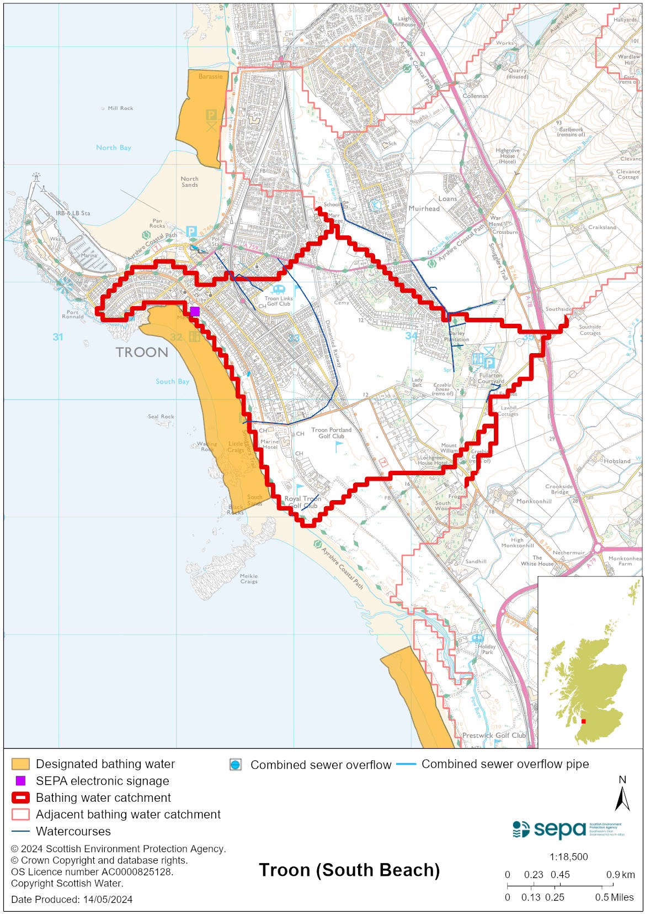

Improving bathing water quality

Sewage
Scottish Water provides most waste water collection and treatment services in Scotland.

There are no continuous or intermittent discharges from the public sewerage system to the designated bathing water or to the immediate environment.

Agriculture
There are no impacts from agriculture affecting this bathing water.

Cyanobacteria (blue-green algae), algae and jellyfish
Marine waters are not at risk of cyanobacteria overproduction. This bathing water is not at risk of excessive growth of macroalgae (seaweed) or phytoplankton.

The possibility of increased jellyfish numbers in the water during summer months is a naturally occurring phenomenon. Most species common to the UK are harmless; the Marine Conservation Society advises to ‘look but don’t touch’.

Pollution incidents
Pollution can be reported via our website online form or by calling our 24 hours a day Pollution Hotline number 0800 80 70 60

If pollution is reported to us, or identified by our routine water quality monitoring program, we will investigate and where necessary work with others to remediate. We may contact other relevant organisations including the local authority, that local health board, Scottish Water and Scottish Ministers.

If there is a risk to human health the local authority is responsible for placing signs at the bathing water. Information will also be available on our website.

Everyone can help to keep the bathing water clean:
- If you visit the beach with your dog clear up any fouling
- Don’t leave litter or feed birds - this encourages unnatural behaviour, and they can pollute the water
- At home, don’t flush wipes or other inappropriate items as these can block pipes and cause sewage spills

Contact details and information sources

SEPA bathing waters homepage

SEPA rainfall data

Scottish Government protected waters homepage

South Ayrshire Council

For information on accessing this document in an alternative format or language, please contact SEPA by emailing equalities@sepa.org.uk
If you are a user of British Sign Language (BSL), the Contact Scotland BSL service gives you access to an online interpreter, enabling you to communicate with us using sign language. contactscotland-bsl.org

