Bathing water profile - Stonehaven
Bathing water classification

Bathing water description
Stonehaven bathing water is located beside the town of Stonehaven. It is bound by rocky outcrops to the north and the harbour area jetty to the south.

The sandy beach slopes gently towards the water and depending on the tide, there can be 0-160 metres before the water’s edge.

Site details:
- Local authority: Aberdeenshire Council
- Year of designation: 1999
- Water sampling location: NO 87650 85820

Risks to water quality
This bathing water is subject to short term pollution following heavy rainfall. Bathing is not advised during or 1-2 days after heavy rainfall due to the risk to bathers’ health from water pollution.

Pollution risks include sewer overflows, agricultural run-off and surface water discharges.

Water quality forecasts
As water quality is likely to be impacted by rainfall we make daily predictions of good or poor bathing water quality. We advise against bathing when poor water quality is predicted as there is an increased risk to bathers’ health from water pollution.

These predictions are displayed on the electronic sign at the beach and online between 15 May and 15 September.

Catchment description
A catchment of 117 km2 drains into the Stonehaven bathing water. Its topography varies from high ground in the west to the low-lying areas along the coast. The area is predominantly rural (97%) with agriculture being the major land use.

The main rivers in the bathing water catchment are the Carron Water and Cowie Water. These rivers both drain into the Stonehaven bathing water. The Carron Water catchment is predominantly agricultural with mixed farming, whereas the Cowie Water catchment is predominantly forested. Only around 2% of the bathing water catchment is urban, with Stonehaven being the main population centre. There is some industrial activity next to the lower reaches of the Cowie Water.

There is one Site of Scientific Interest partially within the bathing water catchment. This designation is not expected to impact on the Stonehaven bathing water quality.

Map 1: Stonehaven bathing water
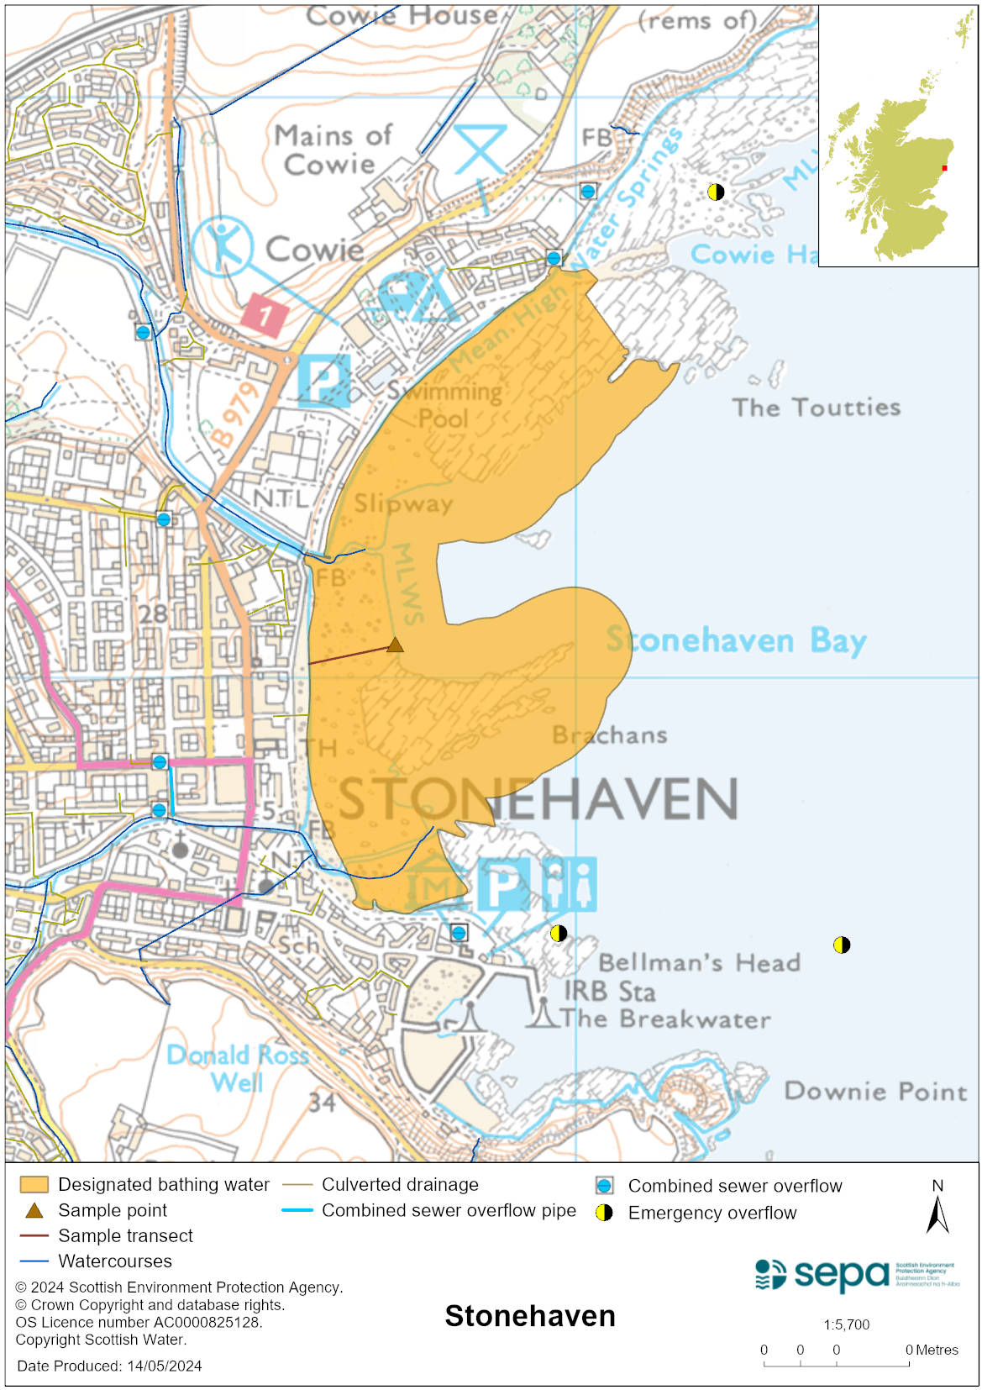

Map 2: Catchment draining into Stonehaven bathing water
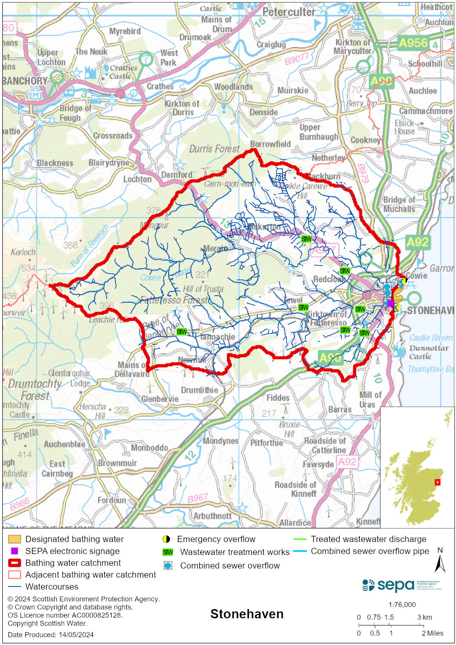

Improving bathing water quality

Sewage
Scottish Water provides most waste water collection and treatment services in Scotland.

Since 2008, sewage effluent from Stonehaven has been connected to the main Aberdeen treatment plant for secondary treatment and disposal via the long sea outfall at Nigg Bay. There are several combined sewer outfalls in Stonehaven town that intermittently discharge into the lower Rivers Carron and Cowie.

Agriculture
Diffuse pollution from agricultural sources is the result of rain driven events causing cumulative inputs of pollutants to rivers and streams.

There is potential for agricultural diffuse pollution to occur in the Kincardine and Angus coastal rivers which could impact on the bathing beach during and following heavy rain.

Farm visits started in the Kincardine and Angus priority catchment in 2014 and are ongoing. These visits look to identify diffuse pollution sources and pathways. Mitigation measures have been agreed with land managers to reduce the risk of bacterial pollution on water quality.

SEPA has observed significant changes in land management practice within the catchment and will continue to work with farmers to reduce the risk of pollution to the bathing water.

Urban
Urban diffuse source pollution comes from contaminated rainwater discharging to rivers and streams. The River Cowie, which discharges into Stonehaven bathing water, is known to be affected by surface water run-off from urban industrial areas through which it runs. It therefore potentially affects the bathing water quality.

Cyanobacteria (blue-green algae), algae and jellyfish
Marine waters are not at risk of cyanobacteria overproduction. This bathing water is not at risk of excessive growth of macroalgae (seaweed) or phytoplankton.

The possibility of increased jellyfish numbers in the water during summer months is a naturally occurring phenomenon. Most species common to the UK are harmless; the Marine Conservation Society advises to ‘look but don’t touch’.

Pollution incidents
Pollution can be reported via our website online form or by calling our 24 hours a day Pollution Hotline number 0800 80 70 60

If pollution is reported to us, or identified by our routine water quality monitoring program, we will investigate and where necessary work with others to remediate. We may contact other relevant organisations including the local authority, that local health board, Scottish Water and Scottish Ministers.

If there is a risk to human health the local authority is responsible for placing signs at the bathing water. Information will also be available on our website.

Everyone can help to keep the bathing water clean:
- If you visit the beach with your dog clear up any fouling
- Don’t leave litter or feed birds - this encourages unnatural behaviour, and they can pollute the water
- At home, don’t flush wipes or other inappropriate items as these can block pipes and cause sewage spills

Contact details and information sources

SEPA bathing waters homepage

SEPA rainfall data

Scottish Government protected waters homepage

Aberdeenshire Council

For information on accessing this document in an alternative format or language, please contact SEPA by emailing equalities@sepa.org.uk
If you are a user of British Sign Language (BSL), the Contact Scotland BSL service gives you access to an online interpreter, enabling you to communicate with us using sign language. contactscotland-bsl.org

