Bathing water profile – Heads of Ayr
Bathing water classification

Bathing water description
Heads of Ayr beach is located between Heads of Ayr cliffs and the rocky outcrops at Greenan Castle. It is owned and managed by the adjacent holiday park. The beach is very popular with tourists and visitors to the holiday park. Depending on the tide, the distance to the water’s edge can vary from 0–300m.

Site details:
- Local authority: South Ayrshire Council
- Year of designation: 2008
- Water sampling location: NS 30202 18902

Risks to water quality
This bathing water is subject to short term pollution following heavy rainfall. Bathing is not advised during or 1-2 days after heavy rainfall due to the risk to bathers’ health from water pollution.

Pollution risks include agricultural run-off and sewer overflows and surface water discharges.

Water quality forecasts
As water quality is likely to be impacted by rainfall we make daily predictions of good or poor bathing water quality. We advise against bathing when poor water quality is predicted as there is an increased risk to bathers’ health from water pollution.

These predictions are displayed on the electronic sign at the beach and online between 15 May and 15 September.

Catchment description
A catchment area of 4 km2 drains into Heads of Ayr bathing water. The maximum elevation within the catchment is around 250 metres, falling to around 10 metres along the coast.
The catchment is mainly rural, with grassland as the major land use. Dairy farming is the main agricultural activity. A small area of the catchment is urban, including Craig Tara Holiday Park next to the coast. The rest of the catchment comprises of rock and sediment.
The main water course in the catchment is the Carwinshoch Burn. It flows into the bay at the southern end of the bathing water.
Average summer rainfall for the region is 392 mm compared to 331 mm across Scotland as a whole.

Map 1: Heads of Ayr bathing water
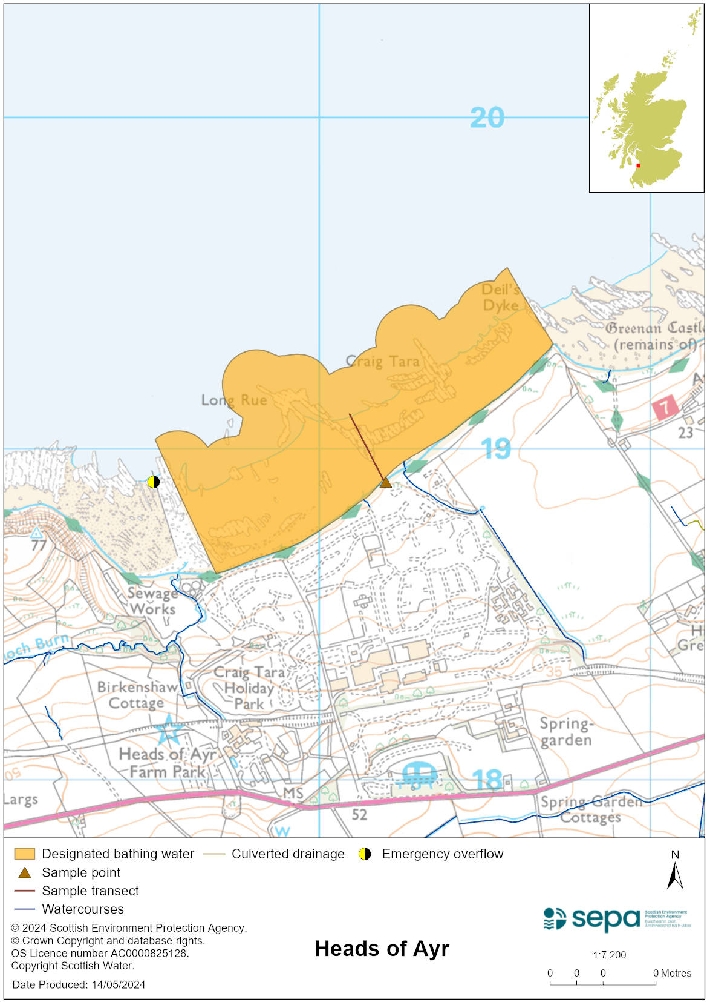

Map 2: Catchment draining into Heads of Ayr bathing water
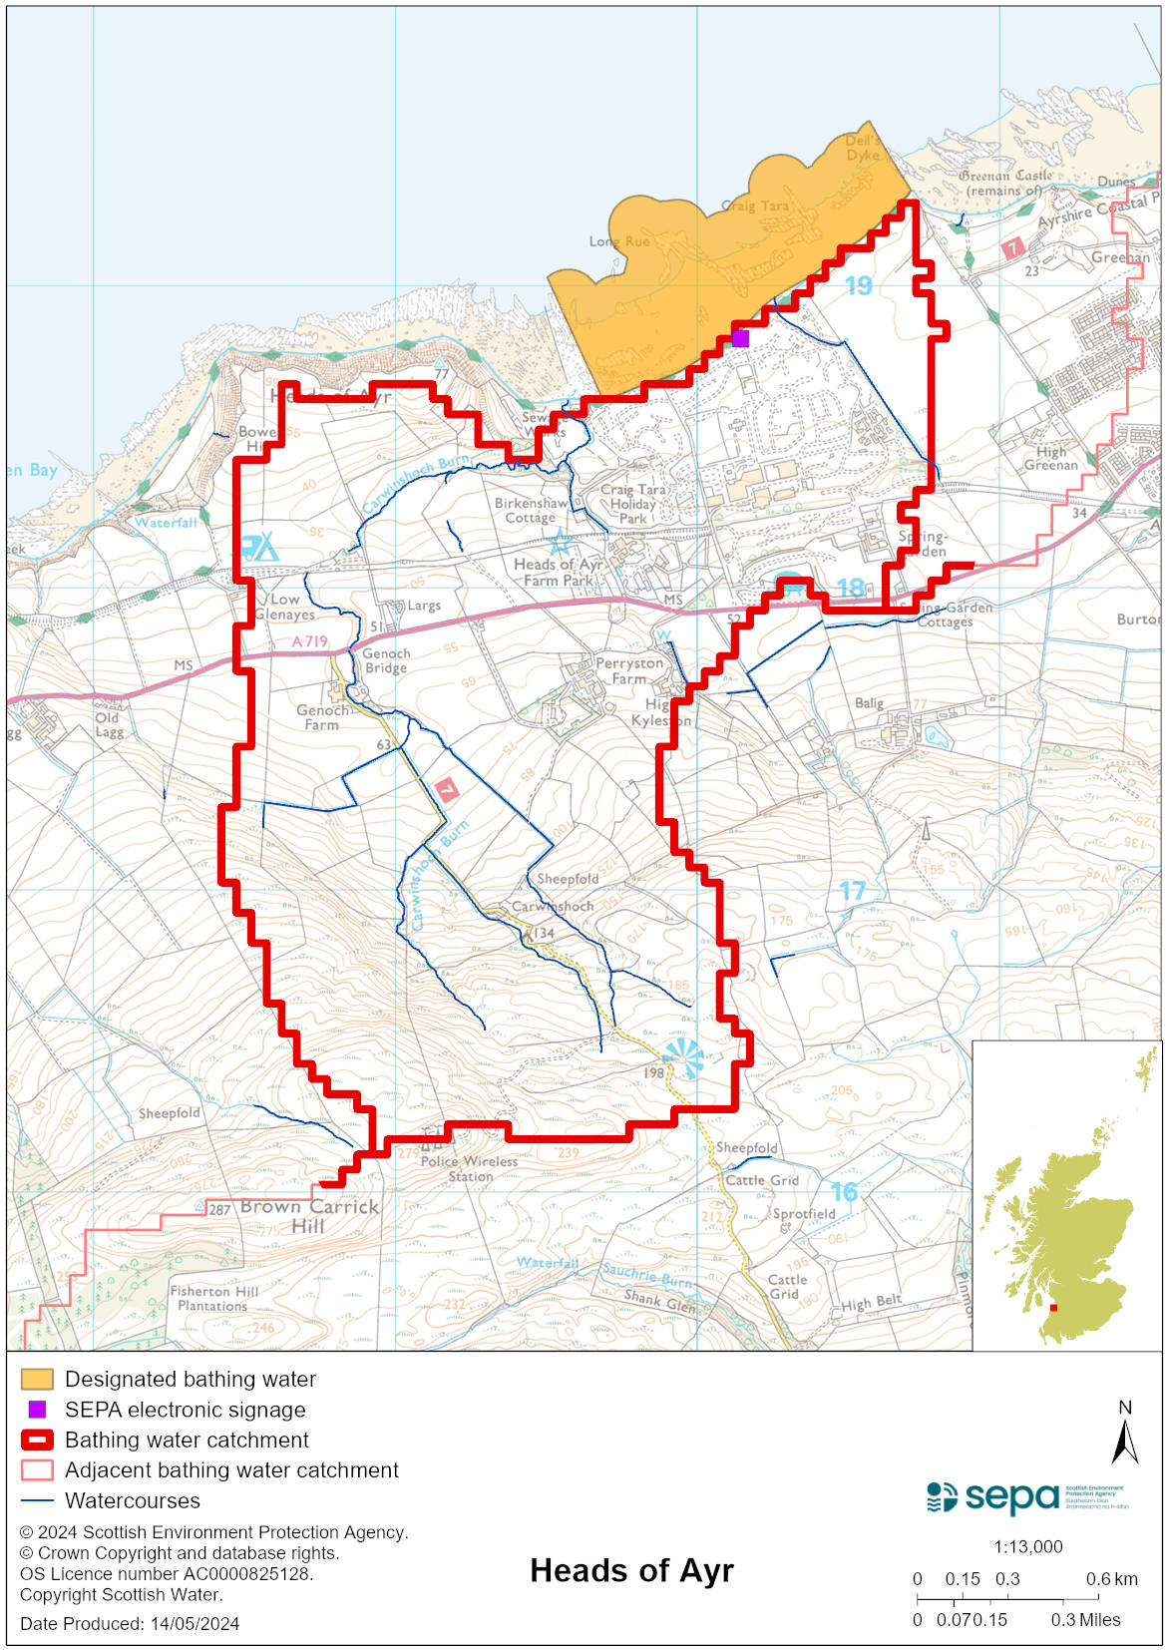

Improving bathing water quality

Sewage
There are private sewage treatment plants and septic tanks within the catchment. This includes a sewage treatment works serving the nearby holiday park. The effluent from the sewage treatment works discharges into the bay via a long sea outfall.

Investment in private sewerage since 2019 have resulted in significant water quality improvement. SEPA is investigating any remaining impacts on Heads of Ayr bathing water.

Agriculture
Diffuse pollution from agricultural sources is the result of cumulative inputs of pollutants to rivers and streams.

There is potential for agricultural diffuse pollution to occur in small tributaries discharging onto the bathing beach. These is a risk to Head of Ayr bathing water quality, particularly during and after periods of wet weather.

Farm visits have been ongoing in this catchment since 2011 and SEPA will continue to work with rural land managers to reduce the risk of pollution to the bathing water. SEPA has observed significant changes in land manager practice resulting in improvements which are known to reduce pollution risk. There has been significant capital expenditure resulting in many rural land managers going beyond regulatory compliance to address issues arising from their farming activities.

Urban
The only urban run-off in the vicinity of this beach is from the nearby holiday park. There has been investment in upgrades to the drainage system at the park. SEPA is monitoring the effectiveness of the work.

Cyanobacteria (blue-green algae), algae and jellyfish
Marine waters are not at risk of cyanobacteria overproduction. This bathing water is not at risk of excessive growth of macroalgae (seaweed) or phytoplankton.

The possibility of increased jellyfish numbers in the water during summer months is a naturally occurring phenomenon. Most species common to the UK are harmless; the Marine Conservation Society advises to ‘look but don’t touch’.

Pollution incidents
Pollution can be reported via our website online form or by calling our 24 hours a day Pollution Hotline number 0800 80 70 60

If pollution is reported to us, or identified by our routine water quality monitoring program, we will investigate and where necessary work with others to remediate. We may contact other relevant organisations including the local authority, that local health board, Scottish Water and Scottish Ministers.

If there is a risk to human health the local authority is responsible for placing signs at the bathing water. Information will also be available on our website.

Everyone can help to keep the bathing water clean:
- If you visit the beach with your dog clear up any fouling
- Don’t leave litter or feed birds - this encourages unnatural behaviour, and they can pollute the water
- At home, don’t flush wipes or other inappropriate items as these can block pipes and cause sewage spills

Contact details and information sources

SEPA bathing waters homepage

SEPA rainfall data

Scottish Government protected waters homepage

South Ayrshire Council

For information on accessing this document in an alternative format or language, please contact SEPA by emailing equalities@sepa.org.uk
If you are a user of British Sign Language (BSL), the Contact Scotland BSL service gives you access to an online interpreter, enabling you to communicate with us using sign language. contactscotland-bsl.org

