Bathing water profile – Wardie Bay
Bathing water classification

Bathing water description
Wardie Bay is a small, urban beach situated beside Granton Harbour on the North Side of Edinburgh. It is easily accessible and is popular with wild swimmers. The sandy beach slopes gently towards the water.

Site details:
- Local authority: City of Edinburgh Council
- Year of designation: 2023
- Water sampling location: NT 2408 7720

Risks to water quality
This bathing water is at risk of short term pollution following heavy rainfall. Bathing is not advised during or 1-2 days after heavy rainfall due to the risk to bathers’ health from water pollution.

Pollution risks include sewer overflows.

Catchment description
A small urban catchment, which sits at the edge of the Granton area of Edinburgh, drains into Wardie Bay bathing water.

There are no direct freshwater inputs into the designated bathing water.

Map 1: Wardie Bay bathing water
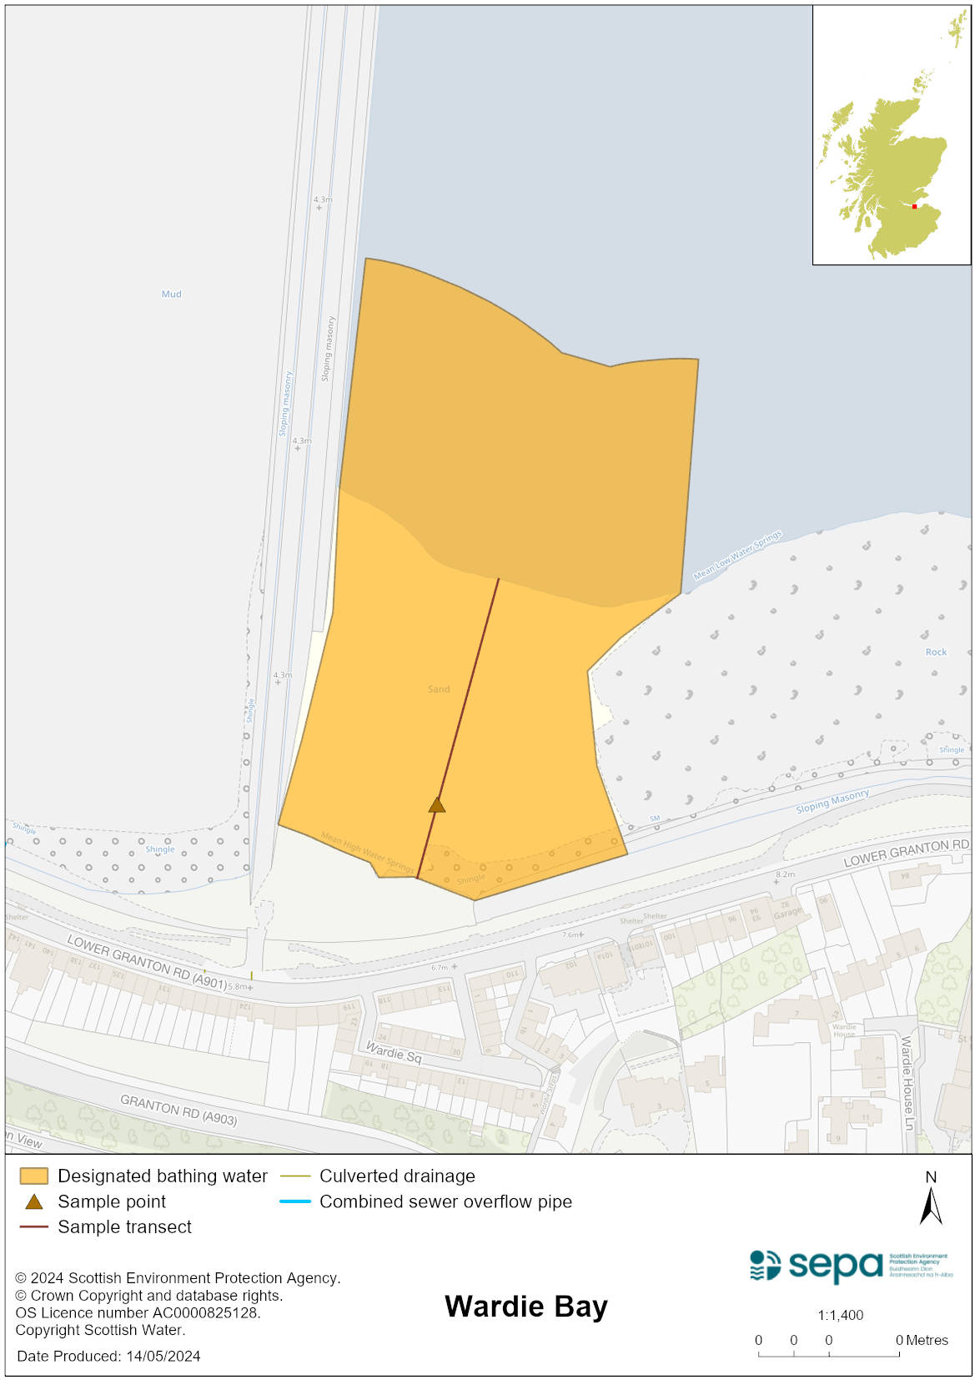

Map 2: Catchment draining into Wardie Bay bathing water
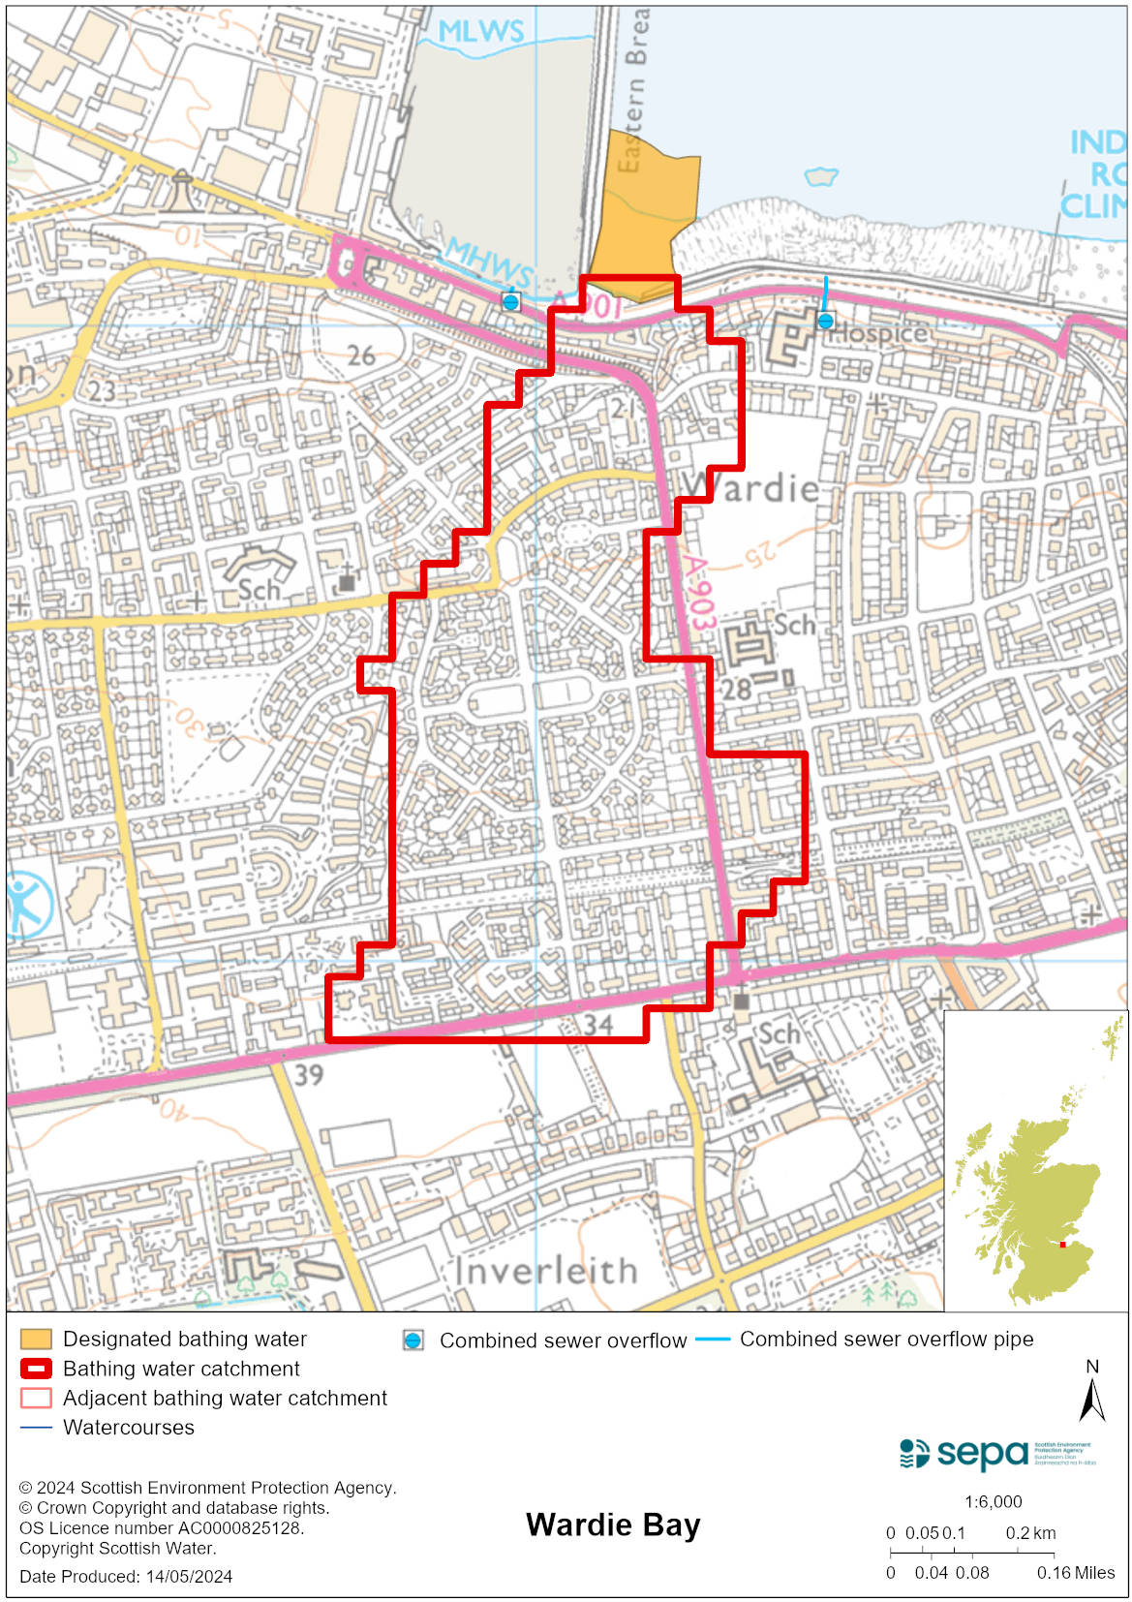

Improving bathing water quality

Sewage
Scottish Water provides most waste water collection and treatment services in Scotland.

Sewage from Edinburgh treated at Edinburgh sewage treatment works before being discharged to the Firth of Forth via a long sea outfall to the North of the works.

There is a combined sewer overflow (CSO) with a discharge location to the east of the bathing water and one with a discharge to the harbour. These may discharge and impact the bathing water during heavy rainfall.

A new pumping station was installed on Lower Granton Road in 2023 to deal with an existing cross connection from 11 properties into the surface water system at Granton Harbour. If the pumping station fails, flows will be directed to Granton Harbour via an emergency overflow (EO). This EO should only discharge under rare, abnormal circumstances.

Agriculture
There are no impacts from agriculture affecting this bathing water.

Cyanobacteria (blue-green algae), algae and jellyfish
Marine waters are not at risk of cyanobacteria overproduction. This bathing water is not at risk of excessive growth of macroalgae (seaweed) or phytoplankton.

The possibility of increased jellyfish numbers in the water during summer months is a naturally occurring phenomenon. Most species common to the UK are harmless; the Marine Conservation Society advises to ‘look but don’t touch’.

Pollution incidents
Pollution can be reported via our website online form or by calling our 24 hours a day Pollution Hotline number 0800 80 70 60

If pollution is reported to us, or identified by our routine water quality monitoring program, we will investigate and where necessary work with others to remediate. We may contact other relevant organisations including the local authority, that local health board, Scottish Water and Scottish Ministers.

If there is a risk to human health the local authority is responsible for placing signs at the bathing water. Information will also be available on our website.

Everyone can help to keep the bathing water clean:
- If you visit the beach with your dog clear up any fouling
- Don’t leave litter or feed birds - this encourages unnatural behaviour, and they can pollute the water
- At home, don’t flush wipes or other inappropriate items as these can block pipes and cause sewage spills

Contact details and information sources

SEPA bathing waters homepage

SEPA rainfall data

Scottish Government protected waters homepage

Edinburgh City Council

For information on accessing this document in an alternative format or language, please contact SEPA by emailing equalities@sepa.org.uk
If you are a user of British Sign Language (BSL), the Contact Scotland BSL service gives you access to an online interpreter, enabling you to communicate with us using sign language. contactscotland-bsl.org

