Bathing water profile - Eyemouth
Bathing water classification

Bathing water description
The bathing water is next to Eyemouth town in the Scottish Borders. It is a small, shallow sandy bay of about 0.3 km in length. The beach is popular with families in the summer. Depending on the tide, the distance to the water’s edge can vary from 0–100 metres.

Site details:
- Local authority: Scottish Borders Council
- Year of designation: 1999
- Water sampling location: NT 94463 64524

Risks to water quality
This bathing water is subject to short term pollution following heavy rainfall. Bathing is not advised during or 1-2 days after heavy rainfall due to the risk to bathers’ health from water pollution.

Pollution risks include agricultural run-off, sewer overflows and surface water discharges.

Water quality forecasts
As water quality is likely to be impacted by rainfall we make daily predictions of good or poor bathing water quality. We advise against bathing when poor water quality is predicted as there is an increased risk to bathers’ health from water pollution.

These predictions are displayed on the electronic sign at the beach and online between 15 May and 15 September.

Catchment description
A catchment area of 120 km2 drains into Eyemouth bathing water. The main rivers in the bathing water catchment are the Eye Water, Ale Water, Horn Burn and the North Burn.
Agriculture is the major land use in the catchment. The upland parts are mostly livestock rearing areas. The lower parts include more arable farming. The catchment comprises the urban area of Eyemouth town.
Average summer rainfall for the region is 296 mm compared to 331 mm across Scotland as a whole.

Map 1: Eyemouth bathing water
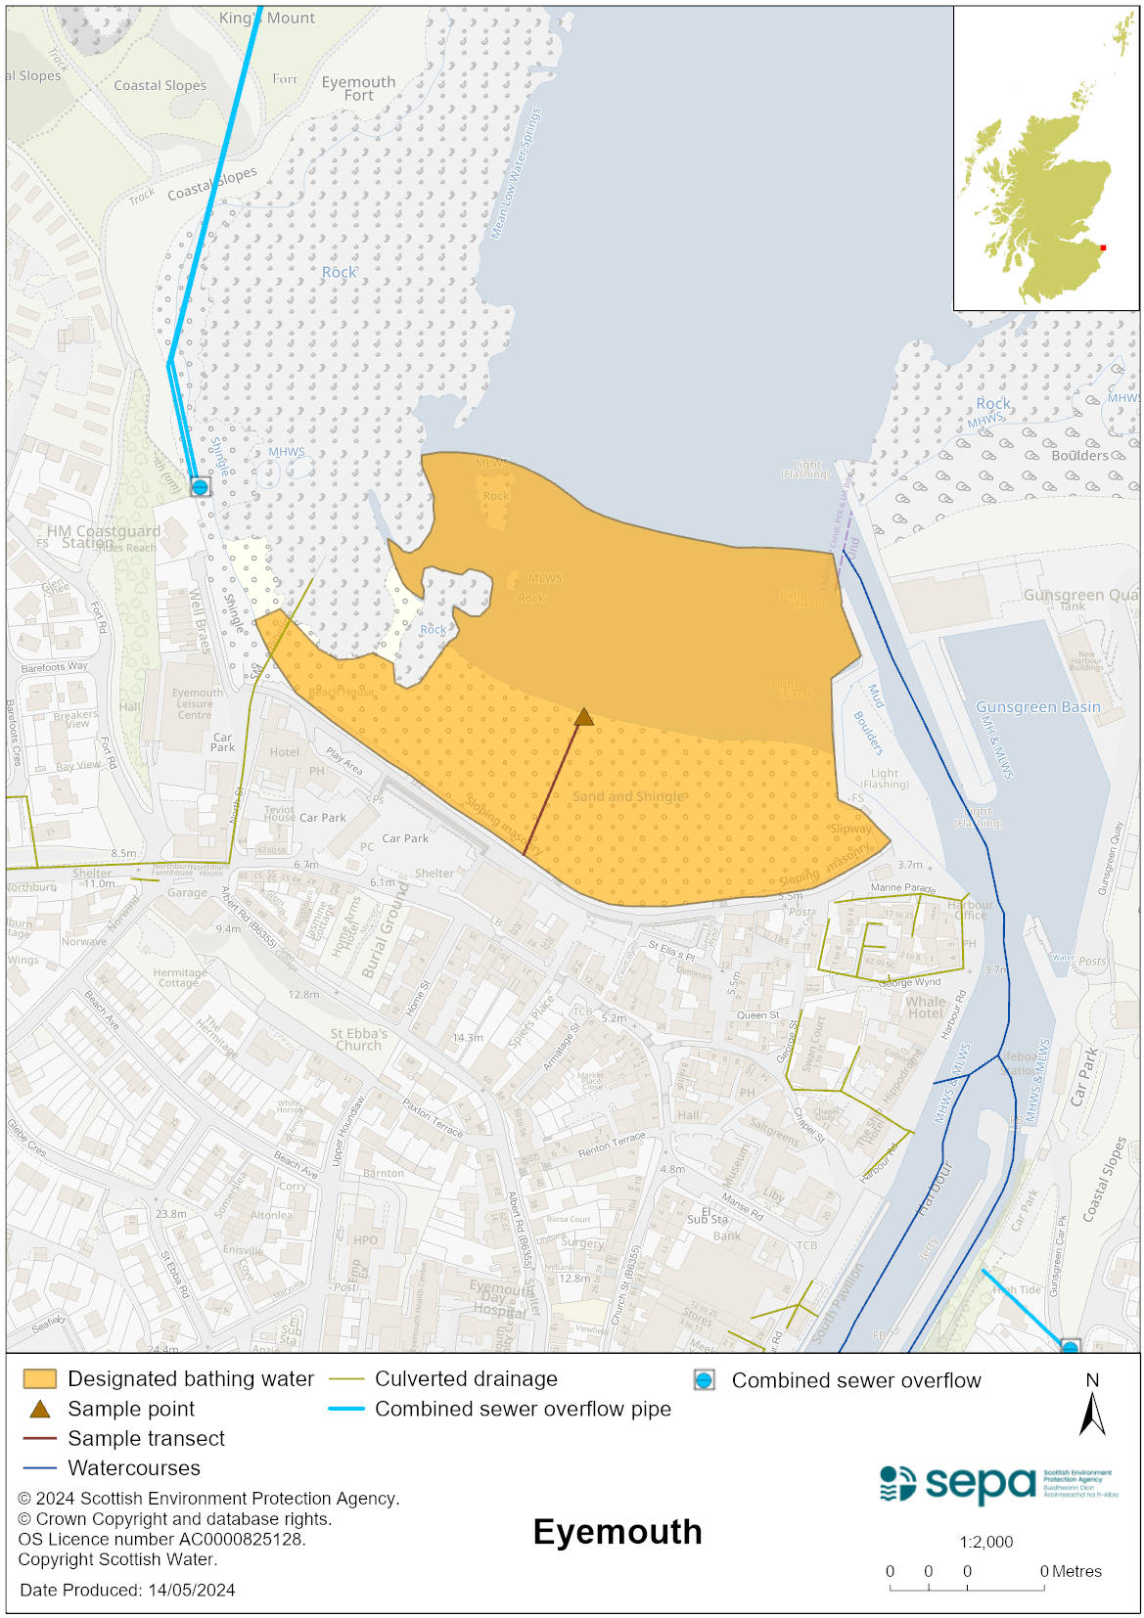

Map 2: Catchment draining into Eyemouth bathing water
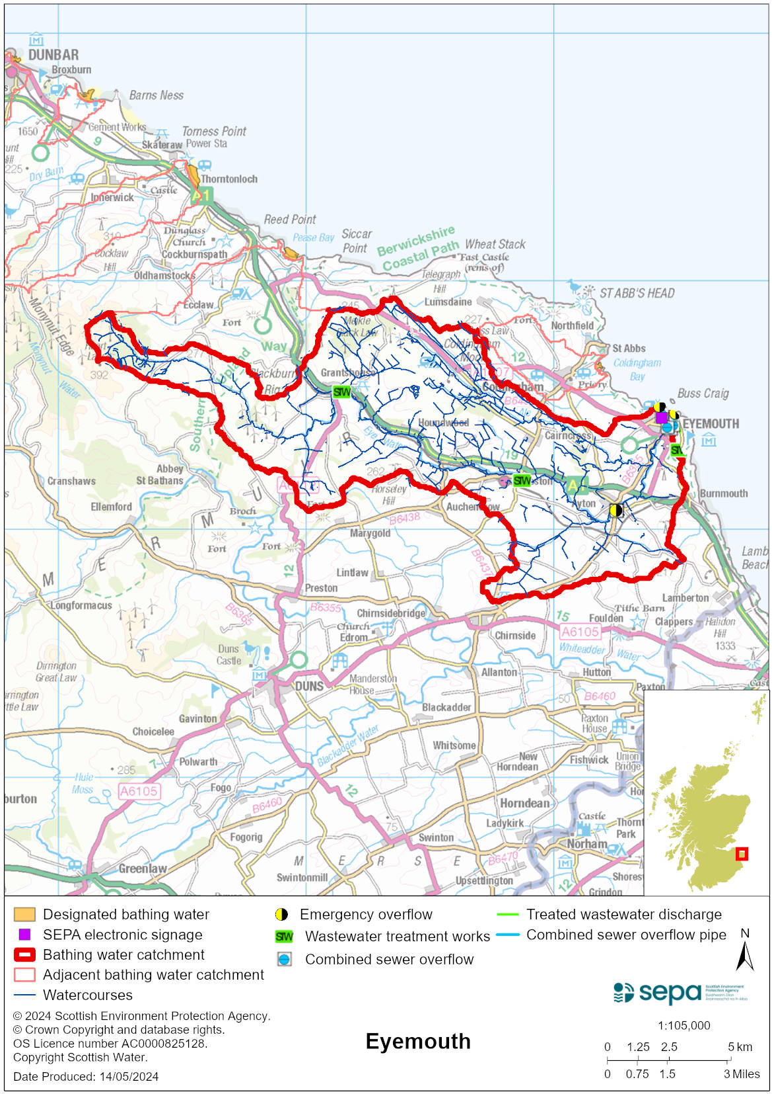

Improving bathing water quality

Sewage
Scottish Water provides most waste water collection and treatment services in Scotland.
Sewage from Eyemouth is treated at Eyemouth sewage treatment works before being discharged to the North Sea via a long sea outfall.
Combined sewer overflows (CSOs) have discharge locations to the Eye Water. These may discharge and impact the bathing water during heavy rainfall.

Agriculture
Diffuse pollution from agricultural sources is the result of cumulative inputs of pollutants to rivers and streams.

Farm visits to identify diffuse pollution sources in the Eye Water catchment began in 2012. Incidences of livestock entering watercourses were recorded and mitigation measures agreed to address this. Large areas along watercourses were fenced off from livestock and alternative water sources provided for them. The priority catchment program is now complete.

Even though all agricultural compliance work has been completed in this bathing water catchment and all farms are in a compliant state, SEPA will continue to engage with farmers and the NFUS to remind them of good practice when applying slurries and manures and grazing livestock.

Urban
The North Burn flows into the sea to the western side of the bathing water. It is known to be impacted from mis connections and surface water run-off from the urban area through which it runs. This can affect bathing water quality.

Cyanobacteria (blue-green algae), algae and jellyfish
Marine waters are not at risk of cyanobacteria overproduction. This bathing water is not at risk of excessive growth of macroalgae (seaweed) or phytoplankton.

The possibility of increased jellyfish numbers in the water during summer months is a naturally occurring phenomenon. Most species common to the UK are harmless; the Marine Conservation Society advises to ‘look but don’t touch’.

Pollution incidents
Pollution can be reported via our website online form or by calling our 24 hours a day Pollution Hotline number 0800 80 70 60

If pollution is reported to us, or identified by our routine water quality monitoring program, we will investigate and where necessary work with others to remediate. We may contact other relevant organisations including the local authority, that local health board, Scottish Water and Scottish Ministers.

If there is a risk to human health the local authority is responsible for placing signs at the bathing water. Information will also be available on our website.

Everyone can help to keep the bathing water clean:
- If you visit the beach with your dog clear up any fouling
- Don’t leave litter or feed birds - this encourages unnatural behaviour, and they can pollute the water
- At home, don’t flush wipes or other inappropriate items as these can block pipes and cause sewage spills

Contact details and information sources

SEPA bathing waters homepage

SEPA rainfall data

Scottish Government protected waters homepage

Scottish Borders Council

For information on accessing this document in an alternative format or language, please contact SEPA by emailing equalities@sepa.org.uk
If you are a user of British Sign Language (BSL), the Contact Scotland BSL service gives you access to an online interpreter, enabling you to communicate with us using sign language. contactscotland-bsl.org

