Bathing water profile - Machrihanish
Bathing water classification

Bathing water description
Machrihanish Bay is a 5 km long quiet rural sandy beach on the Mull of Kintyre Peninsula. It is close to the small village of Machrihanish and adjoins the golf course via a sand dune system. There is a car park at either end of the bay. Access to the beach is via a gate at the village. The beach is prized for its unspoilt golden sands. It is popular with locals, surfers and other water sports enthusiasts. Depending on the tide, the distance to the water’s edge can vary from 30–100 metres. The beach slopes gently towards the water. There are powerful rip currents and submerged rocks on part of the beach.

Site details:
- Local authority: Argyll and Bute Council
- Year of designation: 1999
- Water sampling location: NR 64100 20900

Risks to water quality
This bathing water is at risk of short term pollution following heavy rainfall. Bathing is not advised during or 1-2 days after heavy rainfall due to the risk to bathers’ health from water pollution.

Pollution risks include agricultural run-off and sewer overflows.

Catchment description
The bathing water catchment extends to 66 km2. The land area adjacent to the bathing water is flat and low-lying. It has been subjected to extensive drainage works over the years. Beyond this area, the land rises to approximately 200 metres.
The main river within the catchment is the Machrihanish or Backs Water.
The catchment is 98% rural with 74% grassland. The upland areas support mixed sheep and beef farming. The lowlands are used for intensive dairy farming. Most farms grow a small acreage of barley for feed and straw. Approximately 2% of the catchment comprises of bog, standing water and inland rock. Population density within the catchment is low. The village of Machrihanish is at the southern end of the bathing water. The area also includes Campbeltown Airport and both Machrihanish and Machrihanish Dunes golf clubs.
The bathing water includes the Machrihanish Dunes Site of Special Scientific Interest (SSSI).

Map 1: Machrihanish bathing water
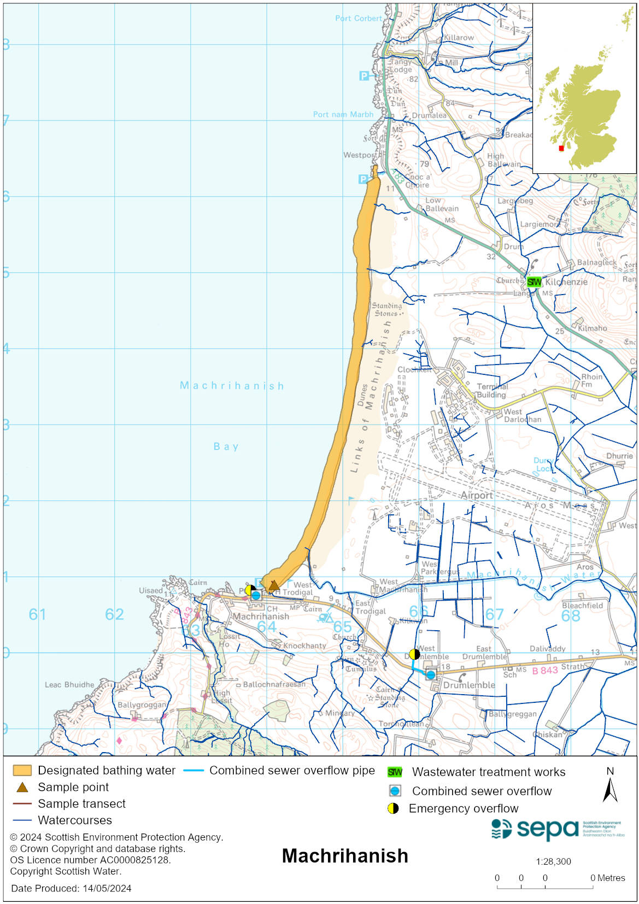

Map 2: Catchment draining into Machrihanish bathing water
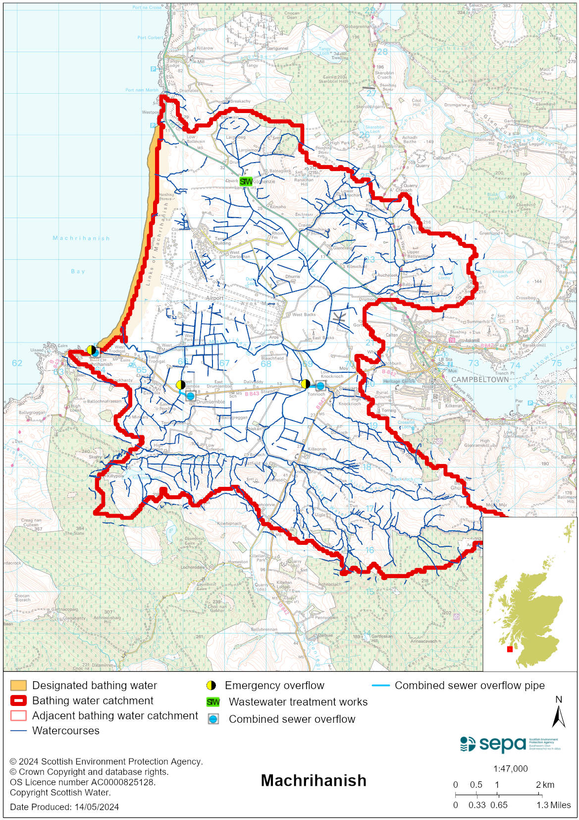

Improving bathing water quality

Sewage
Scottish Water provides most waste water collection and treatment services in Scotland.

There is a Scottish Water pumping station to the south of the bathing water with a combined sewage overflow (CSO) and emergency overflow (EO). The CSO may make screened discharges during heavy rainfall which may impact the bathing water. The EO should only discharge under rare, abnormal circumstances.

Agriculture
Diffuse pollution from agricultural sources is the result of rain driven events causing cumulative inputs of pollutants to rivers and streams.

There is potential for agricultural diffuse pollution to occur in small tributaries discharging onto the bathing beach. These are a risk to Machrihanish’s bathing water quality, particularly during and after periods of wet weather.

Farm visits have been on going in Kintyre area since 2022.

SEPA will continue to work with rural land managers in these catchments to reduce the risk of pollution to the bathing water.

Cyanobacteria (blue-green algae), algae and jellyfish
Marine waters are not at risk of cyanobacteria overproduction. This bathing water is not at risk of excessive growth of macroalgae (seaweed) or phytoplankton.

The possibility of increased jellyfish numbers in the water during summer months is a naturally occurring phenomenon. Most species common to the UK are harmless; the Marine Conservation Society advises to ‘look but don’t touch’.

Pollution incidents
Pollution can be reported via our website online form or by calling our 24 hours a day Pollution Hotline number 0800 80 70 60

If pollution is reported to us, or identified by our routine water quality monitoring program, we will investigate and where necessary work with others to remediate. We may contact other relevant organisations including the local authority, that local health board, Scottish Water and Scottish Ministers.

If there is a risk to human health the local authority is responsible for placing signs at the bathing water. Information will also be available on our website.

Everyone can help to keep the bathing water clean:
- If you visit the beach with your dog clear up any fouling
- Don’t leave litter or feed birds - this encourages unnatural behaviour, and they can pollute the water
- At home, don’t flush wipes or other inappropriate items as these can block pipes and cause sewage spills

Contact details and information sources

SEPA bathing waters homepage

SEPA rainfall data

Scottish Government protected waters homepage

Argyll and Bute Council

For information on accessing this document in an alternative format or language, please contact SEPA by emailing equalities@sepa.org.uk
If you are a user of British Sign Language (BSL), the Contact Scotland BSL service gives you access to an online interpreter, enabling you to communicate with us using sign language. contactscotland-bsl.org

