Bathing water profile - Seamill
Bathing water classification

Bathing water description
Seamill bathing water is situated next to the small town of West Kilbride. The sandy beach is popular with both locals and summer visitors.
Depending on the tide, there can be 20-200 metres of beach before the water’s edge.

Site details:
- Local authority: North Ayrshire Council
- Year of designation: 2008
- Water sampling location: NS 19802 47319

Risks to water quality
This bathing water is subject to short term pollution following heavy rainfall. Bathing is not advised during or 1-2 days after heavy rainfall due to the risk to bathers’ health from water pollution.

Pollution risks include agricultural run-off, sewer overflows and surface water discharges.

Water quality forecasts
As water quality is likely to be impacted by rainfall we make daily predictions of good or poor bathing water quality. We advise against bathing when poor water quality is predicted as there is an increased risk to bathers’ health from water pollution.

These predictions are displayed on the electronic sign at the beach and online between 15 May and 15 September.

Catchment description
A catchment area of just over 10.5 km2 drains into the Seamill bathing water. It is a hilly catchment, with elevations ranging from around 10 metres along the coast, rising to around 330 metres in the north-east of the catchment. The area is mostly rural (86%) with grassland being the major land use. Approximately 13% of the bathing water catchment is urban. The main population centre is the small town of West Kilbride. The population density outside of West Kilbride is generally low but includes Seamill, a village just south of the bathing beach. There is a large hotel development in Seamill which contributes to bathing beach usage.

Map 1: Seamill bathing water
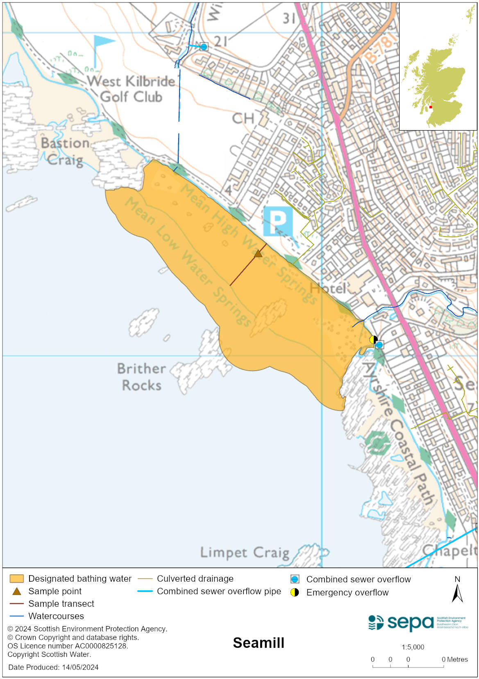

Map 2: Catchment draining into Seamill bathing water
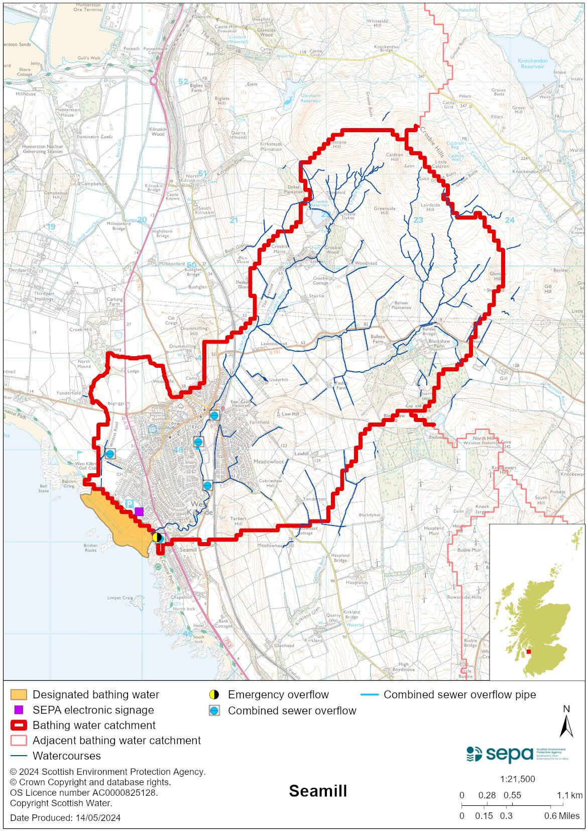

Improving bathing water quality

Sewage
Scottish Water provides most waste water collection and treatment services in Scotland.

There are no continuous discharges from the public sewerage system to the designated bathing water or to the immediate environment. Under normal circumstances, all sewage from the town is treated at Stevenston sewage treatment works. There are three combined sewer overflows that discharge storm sewage to the Kilbride Burn during and after rainfall. Several surface water outfalls also discharge urban run-off to the burn. There is also a combined sewer overflow which discharges into the Wildcat Burn. The combined sewer and emergency outfalls associated with West Kilbride sewage pumping station discharge to the Firth of Clyde via a long sea outfall.

Sewage from private septic tanks situated beyond the town discharge into the Kilbride Burn. Septic tanks on Portencross Road discharge into the Wildcat Burn.

Agriculture
Diffuse pollution from agricultural sources is the result of rain driven events causing cumulative inputs of pollutants to rivers and streams.
There is potential for agricultural diffuse pollution to occur in the rural tributaries in proximity to Seamill which could impact on the bathing beach during and following heavy rain.
Farm visits started in the North Ayrshire Coastal priority catchment in 2013 and are ongoing. These visits look to identify diffuse pollution sources and pathways. Mitigation measures have been agreed with land managers to reduce the risk of bacterial pollution on water quality.
SEPA has observed significant changes in land management practice within the catchment and will continue to work with farmers to reduce the risk of pollution to the bathing water.

Urban
Urban diffuse source pollution comes from contaminated rainwater discharging to rivers and streams. Urban run-off from West Kilbride is washed into the Kilbride Burn.

Cyanobacteria (blue-green algae), algae and jellyfish
Marine waters are not at risk of cyanobacteria overproduction. This bathing water is not at risk of excessive growth of macroalgae (seaweed) or phytoplankton.

The possibility of increased jellyfish numbers in the water during summer months is a naturally occurring phenomenon. Most species common to the UK are harmless; the Marine Conservation Society advises to ‘look but don’t touch’.

Pollution incidents
Pollution can be reported via our website online form or by calling our 24 hours a day Pollution Hotline number 0800 80 70 60

If pollution is reported to us, or identified by our routine water quality monitoring program, we will investigate and where necessary work with others to remediate. We may contact other relevant organisations including the local authority, that local health board, Scottish Water and Scottish Ministers.

If there is a risk to human health the local authority is responsible for placing signs at the bathing water. Information will also be available on our website.

Everyone can help to keep the bathing water clean:
- If you visit the beach with your dog clear up any fouling
- Don’t leave litter or feed birds - this encourages unnatural behaviour, and they can pollute the water
- At home, don’t flush wipes or other inappropriate items as these can block pipes and cause sewage spills

Contact details and information sources

SEPA bathing waters homepage

SEPA rainfall data

Scottish Government protected waters homepage

North Ayrshire Council

For information on accessing this document in an alternative format or language, please contact SEPA by emailing equalities@sepa.org.uk
If you are a user of British Sign Language (BSL), the Contact Scotland BSL service gives you access to an online interpreter, enabling you to communicate with us using sign language. contactscotland-bsl.org

